

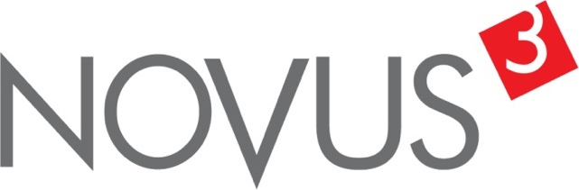

Spatial Feature Report

T: +27 12 364 2546 | E: info@novus3.co.za Postnet Suite 471, Private Bag X15,

Menlo Park, 0102**www.novus3.co.za**

engineered solutions

Disclaimer

This document contains data that was obtained from a live CP3 system at the moment the data was requested. The data is updated by users of the CP3 System and unless the system is locked for changes, this data may change on a daily basis. The reader is therefore cautioned not to place inappropriate reliance on the data unless there is certainty on the status of the data in terms of how recently it has been updated, how “clean” the data is (is there a quality control and/or verification process that was followed by the licensee of the CP3 system to ensure that data is checked and verified from time-to-time) and whether the correct baseline was queried. This report therefore provides a “snapshot in time”. Consequently, the document may be less relevant at a different time, or using a different financial baseline to query from.

At all times, all rights, title and interest in and to this material remains vested in the owner of this document and are copyrighted and protected by regulatory provisions. These materials may not be copied, reproduced, modified, published, uploaded, posted to websites or otherwise distributed in any way, without our prior written permission from the Licensee and Licensor (Nvous3 (Pty) Ltd) of the CP3 Software. The owner of this document does not grant any right to reproduce the materials. All our rights in this regard are and remain reserved.

Table of Contents

**No table of contents entries found.** (Right-click -> Update Field)

Spatial Query Report

This document was created *2022-04-29-19_48* from the **City of Tshwane Metropolitan Municipality** CP3 system.

The baseline **'2021/22 Planning + Rollover (20200901)'** with description: **'Duplicated from the 2020/21 Planning + Final Annexure A (20200625) Baseline'** was used. The spatial feature that was selected for the purpose of this report was: **'City of Tshwane Wards'**.

This is a spatial feature report for the *City of Tshwane Metropolitan Municipality.* The data contained in this report was sourced directly from the municipality's live CP3 system. The information in this report therefore reflects the data as it was on *2022-04-29* when this report was requested. Any subsequent updates to the data contained the CP3 System related to the applicable baseline from which this reports was drawn, would therefore not reflect in this report.   
  
For the *City of Tshwane Metropolitan Municipality, the following spatial features are available for the purpose of developing* 'Spatial Query Reports' (similar to this report):

* City of Tshwane mSCOA Regional Segment
* City of Tshwane Regions
* City of Tshwane Wards



We hope you find this useful! Sincerely, *The Novus3 Team.*

# Introduction

The baseline that was queried for this report contains *1461* projects of which a total of *55 (3.76%)* projects do not have any recorded intersection (overlap) with City of Tshwane Wards. The following spatial features are available for queries using this API profile:

* City of Tshwane mSCOA Regional Segment
* City of Tshwane Regions
* City of Tshwane Wards

The probable reasons for the 55 non intersecting projects reported are that:

* these projects simply do not have a location associated with them yet (most frequently the case with 'no-intersect' projects) or;
* the location that was captured for some of these projects, may have been in the wrong place (e.g. outside the boundaries of Tshwane - this is very rarely the reason).

It is important to take note of the 3.76% projects that do not intersect with City of Tshwane Wards feature when appraising this report.

The 3.76% of non-intersecting projects is a relative low percentage and therefore not much cause of concern for this particular report.

Figure 1.1: Intersecting vs Non-Intersecting Projects

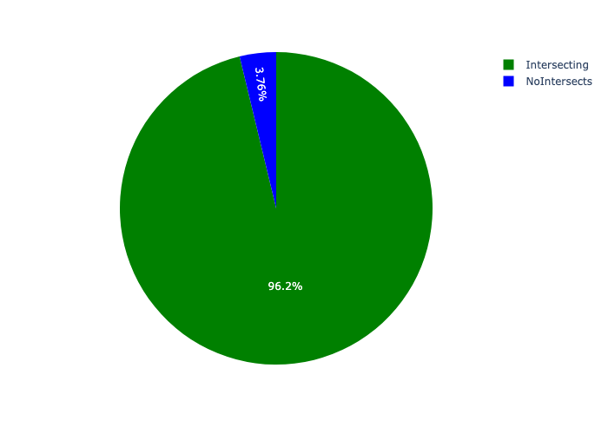

# Total Number of Projects and Total Capital Demand per City of Tshwane Ward - All Years

Table 2.1 below provides a concise summary of key statistical insights regarding the number of projects that are requesting funding in each of the City of Tshwane Wards.

Table 2.1: City of Tshwane Wards Analysis - Number of Projects

|  |  |  |  |
| --- | --- | --- | --- |
| Description | Info (1) | Info (2) | Info (3) |
| Number of projects in all City of Tshwane Wards - Overview | Total in all City of Tshwane Wards: 1406 projects | Average per City of Tshwane Wards: 13.1 projects | 75th percentile of projects across all City of Tshwane Wards: 16.0 projects |
| The highest number of projects | City of Tshwane Wards: In Ward 58 | Number of projects in Ward 58: 85 | Percentage of total in Ward 58: 6.05% |
| The lowest number of projects: | City of Tshwane Wards: In Ward 72 | Number of projects in Ward 72: 1 | Percentage of total in Ward 72: 0.07% |
| The 5 City of Tshwane Wards that collectively have with the highest number of projects | City of Tshwane Wards: In Ward 98, Ward 100, Ward 96, Ward 50 and Ward 58 | Number of projects in Ward 98, Ward 100, Ward 96, Ward 50 and Ward 58 together: 266 | Percentage of total in Ward 98, Ward 100, Ward 96, Ward 50 and Ward 58 together: 18.92% |

Table 2.1 below provides a concise summary of key statistical insights regarding the total capital demand per City of Tshwane Ward.

Table 2.1: City of Tshwane Wards Analysis - Capital Demand (R)

|  |  |  |  |
| --- | --- | --- | --- |
| Description | Info (1) | Info (2) | Info (3) |
| Capital demand in all City of Tshwane Wards - Overview | Total capital demand in all City of Tshwane Wards: R48,877,051,173 | The average capital demand per City of Tshwane Wards: R456,794,871 | The 75th percentile of capital demand for City of Tshwane Wards: R523,295,945 |
| The highest capital demand | City of Tshwane Wards: In Ward 96 | Capital Demand in Ward 96: R5,160,755,906 | Percentage of total in Ward 96: 10.56% |
| The lowest capital demand | City of Tshwane Wards: In Ward 72 | Capital Demand in Ward 72: R3,826 | Percentage of total in Ward 72: 0.00% |
| The 5 City of Tshwane Wards that collectively have collective the highest capital demand: | City of Tshwane Wards: In Ward 50, Ward 102, Ward 100, Ward 58 and Ward 96 | Capital Demand in Ward 50, Ward 102, Ward 100, Ward 58 and Ward 96 together: R14,210,793,031 | Percentage of total in Ward 50, Ward 102, Ward 100, Ward 58 and Ward 96 together: 29.07% |

The number of projects per City of Tshwane Ward and the capital demand per City of Tshwane Ward needs to be looked at together for better insight. Figures 2.1 and 2.2 assist with further graphical insight into some of the numbers that are provided in Tables 2.1 and 2.2.

Figure 2.1: The single City of Tshwane Ward with the highest value (Nr of Projects & Capital Demand) vs the rest

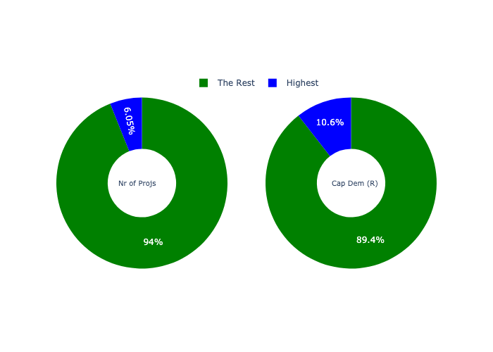

The highest number of projects in a single City of Tshwane Ward is in **Ward 58.** *That is 85 projects and this is 6.05% of the total number of projects.*The highest capital demand in a single City of Tshwane Ward is in **Ward 96.** *That is R5,160,755,906 and this amounts to 10.56% of the total capital demand.*

Figure 2.2: The 5 City of Tshwane Wards with the highest values (Nr of Projects & Capital Demand) vs the rest

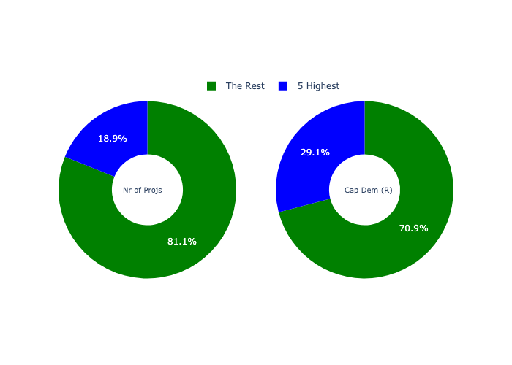

The 5 City of Tshwane Wards that collectively have with the highest number of projects are in **Ward 98, Ward 100, Ward 96, Ward 50 and Ward 58.** *That is 266 projects and this is 18.92% of the total number of projects.*The 5 City of Tshwane Wards that collectively have the highest capital demand are in **Ward 50, Ward 102, Ward 100, Ward 58 and Ward 96.** *That is 29.07% and this amounts to R14,210,793,031 of the total capital demand.*

The following figures provide a bar graph representation of the number of projects per City of Tshwane Ward with the colour of the bars representing the level of capital demand in each of these City of Tshwane Wards.

Figure 2.3.1: Projects and Capital Demand per City of Tshwane Ward (1/3)

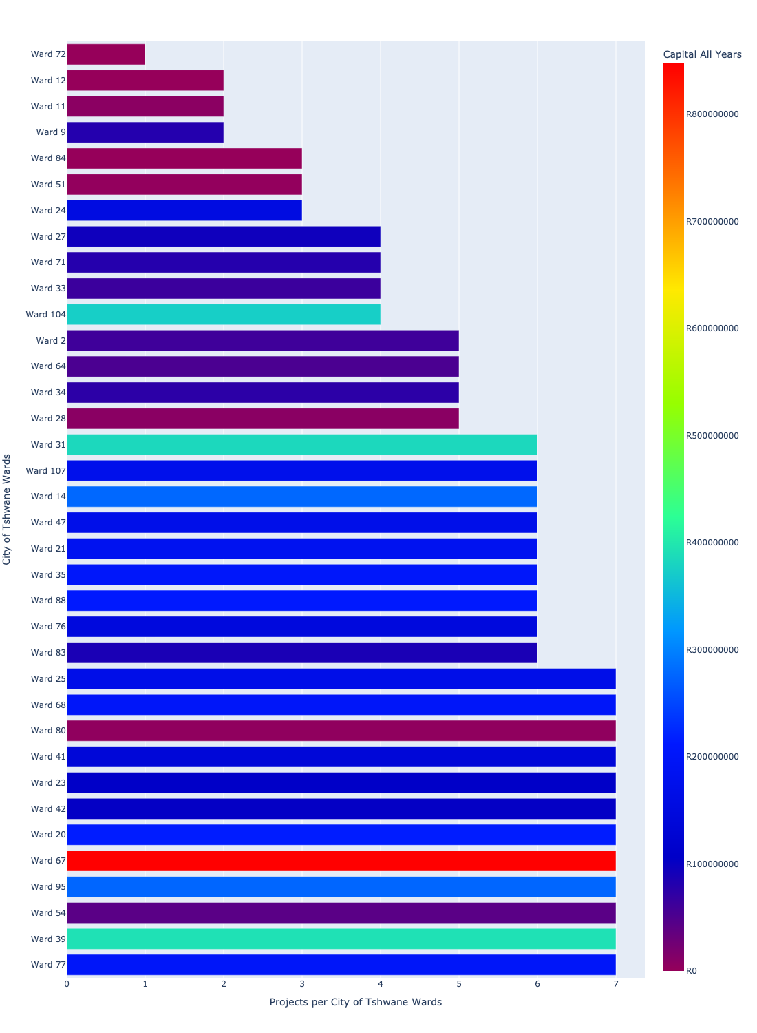

Figure 2.3.2: Projects and Capital Demand per City of Tshwane Ward (2/3)

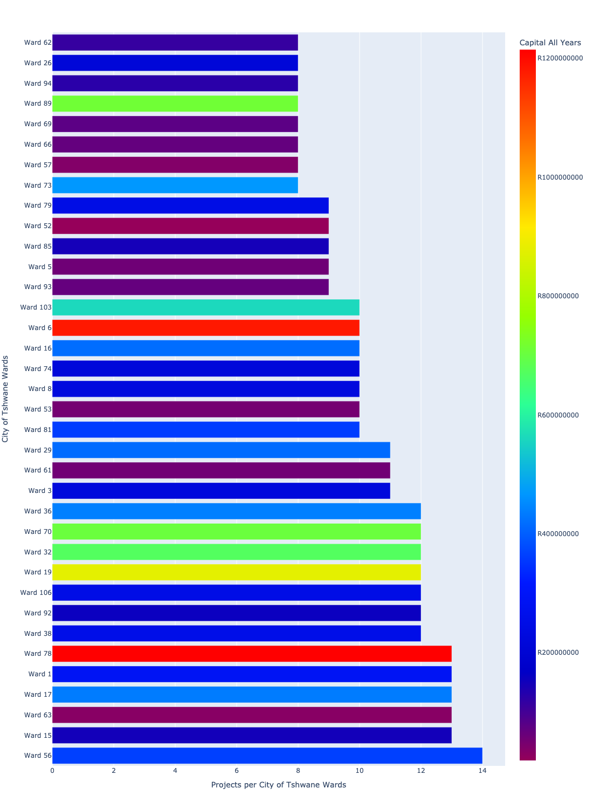

Figure 2.3.3: Projects and Capital Demand per City of Tshwane Ward (3/3)

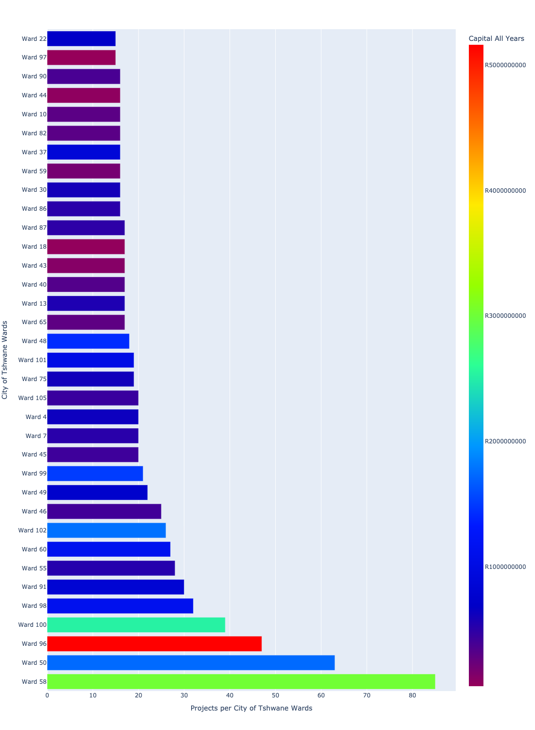

# Total Capital Demand per City of Tshwane Ward - All Years

There are different funding sources from which capital is requested. For the financial baseline that was selected for this report query (2021/22 Planning + Rollover (20200901)), the breakdown of capital demand for City of Tshwane Metropolitan Municipality per funding source is shown in Figure 3.1 below.

Figure 3.1: Capital Demand Per Funding Source

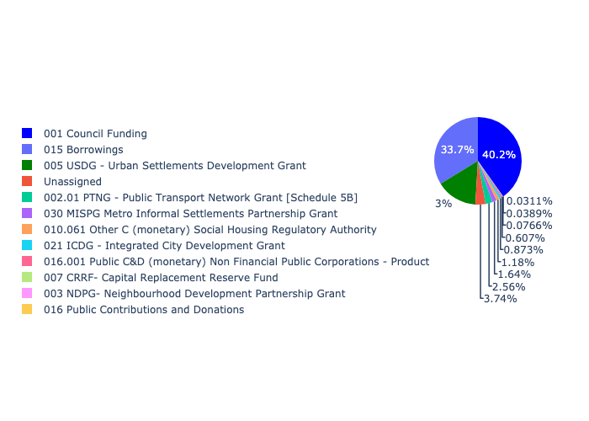

For the financial baseline that was selected for this report query (2021/22 Planning + Rollover (20200901)), the breakdown of capital demand for City of Tshwane Metropolitan Municipality per department is shown in Figure 3.2 below.

Figure 3.2: Capital Demand Per City of Tshwane Metropolitan Municipality Department

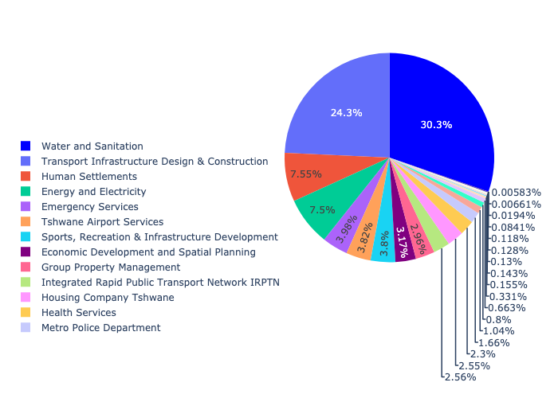

The following figures provide a histogram representation of the capital demand per City of Tshwane Ward. A colour breakdown is provided of each year's sub-total that contribute towards the overall total capital demand of each City of Tshwane Ward. Note that the capital demand beyond the first three years representing the Medium Term Expenditure Framework (MTREF - years 2022, 2023 and 2024) are generally more sparsely and less diligently populated, therefore less reliance should be vested on these outer years when appraising the overall capital demand. The reason for this is usually because of National Treasury's requirement for annual budget submissions spanning only over the MTREF (i.e. the next three years).

Figure 3.3.1: Capital Demand per City of Tshwane Ward - All Years (1/3)

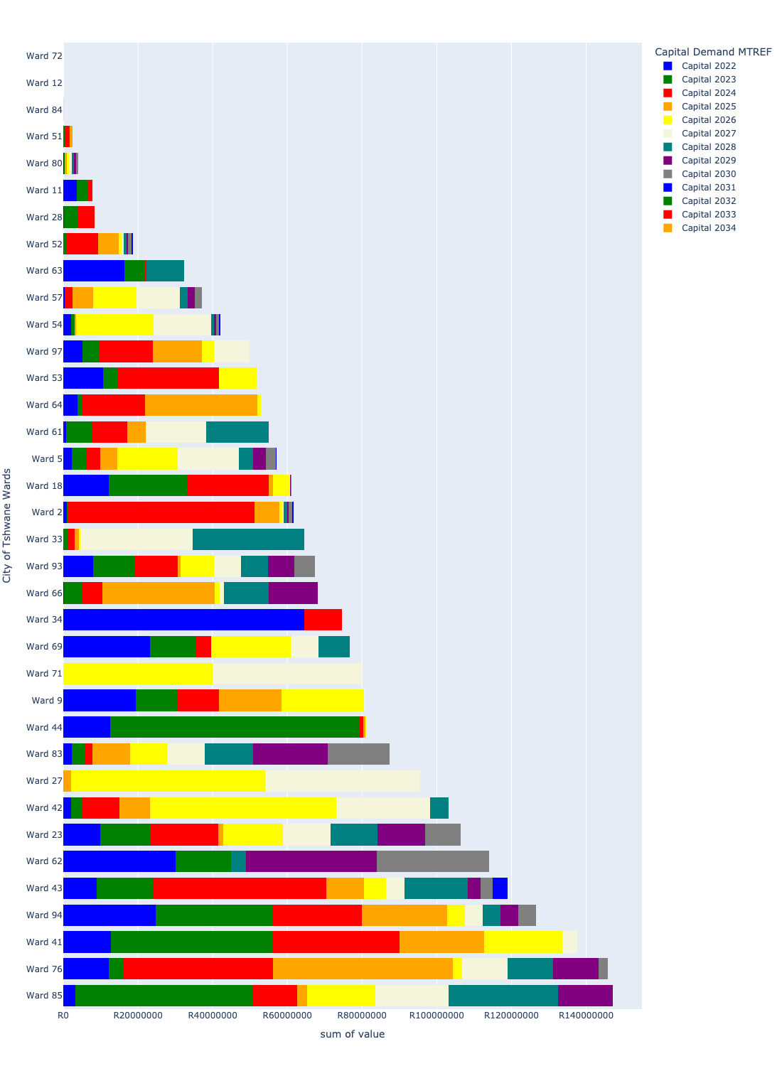

Figure 3.3.2: Capital Demand per City of Tshwane Ward - All Years (2/3)

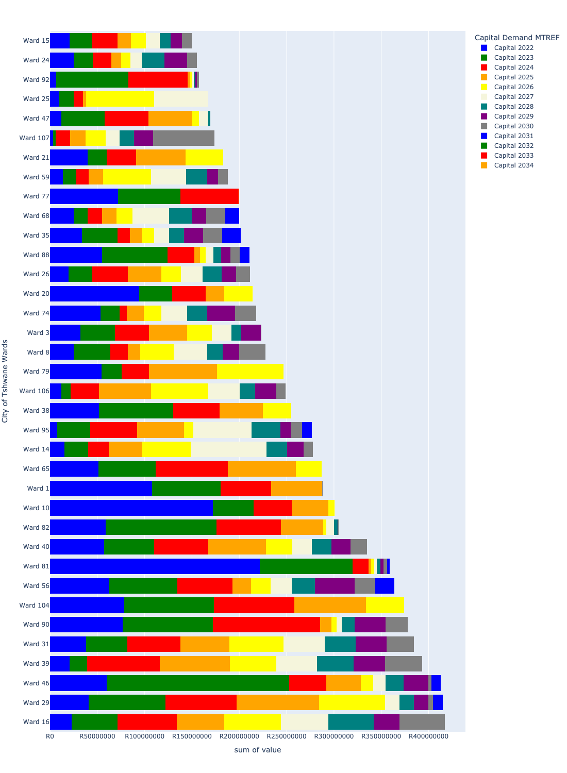

Figure 3.3.3: Capital Demand per City of Tshwane Ward - All Years (3/3)

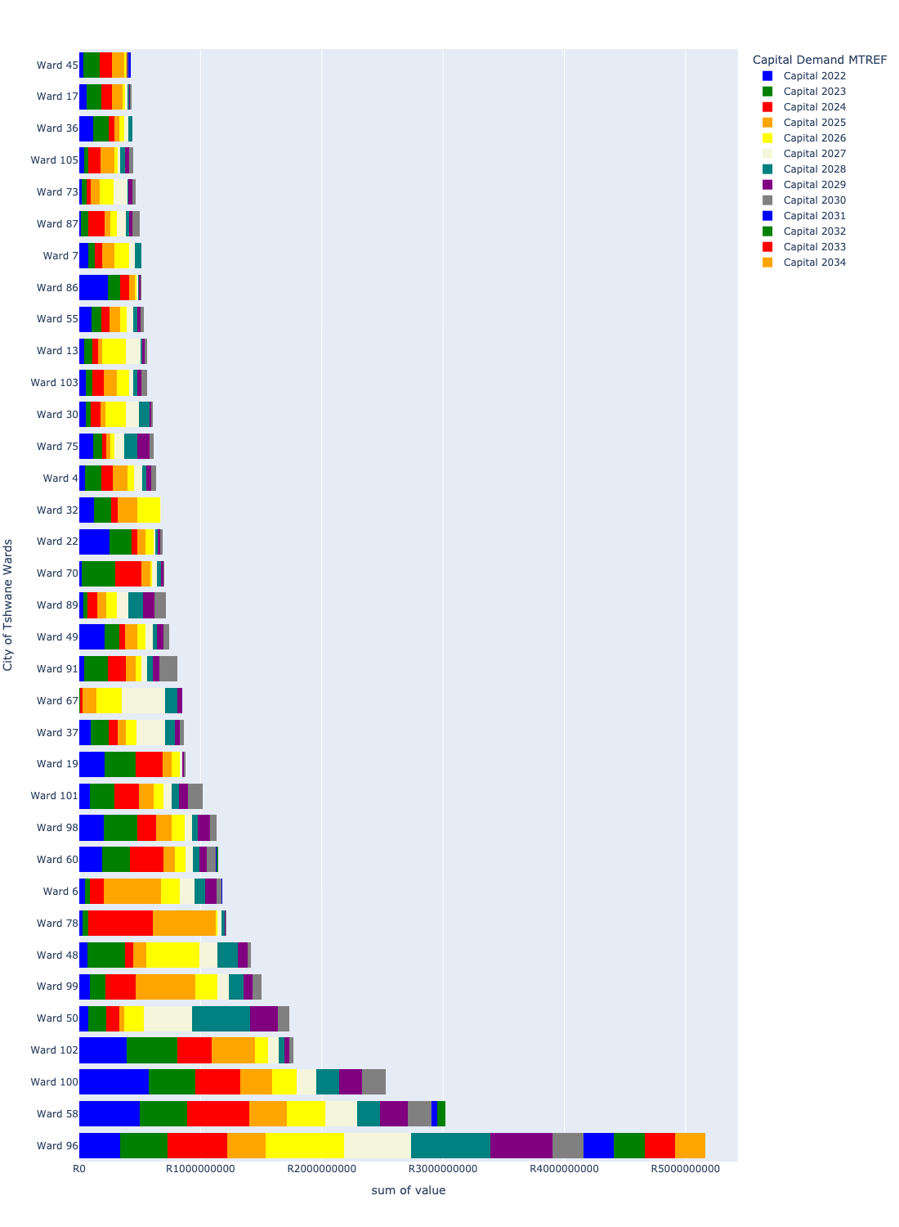

# Total Capital Demand per City of Tshwane Ward - MTREF only

Table 4.1 below provides a concise summary of key statistical insights regarding the total MTREF capital demand per City of Tshwane Ward.

Table 4.1: City of Tshwane Wards Analysis - MTREF Capital Demand (R)

|  |  |  |  |
| --- | --- | --- | --- |
| Description | Info (1) | Info (2) | Info (3) |
| MTREF Capital demand in all City of Tshwane Wards - Overview | MTREF capital demand in all City of Tshwane Wards: R21,480,882,838 | The average MTREF capital demand per City of Tshwane Ward: R200,755,914 | The 75th percentile of MTREF capital demand for City of Tshwane Wards: R256,830,440 |
| The highest MTREF capital demand | In City of Tshwane Ward: Ward 58 | MTREF capital Demand in Ward 58: R1,404,770,061 | Percentage of total MRTEF capital demand in Ward 58: 6.54% |
| The lowest MTREF capital demand | In City of Tshwane Ward: Ward 72 | MTREF capital Demand in Ward 72: R0 | Percentage of total MTREF capital demand in Ward 72: 0.00% |

The following figures provide a histogram representation of the capital demand per City of Tshwane Ward. A colour breakdown is provided of each year's sub-total that contribute towards the overall MTREF total capital demand of each City of Tshwane Ward.

Figure 4.1.1: Capital Demand per City of Tshwane Ward - MTREF Period (1/3)

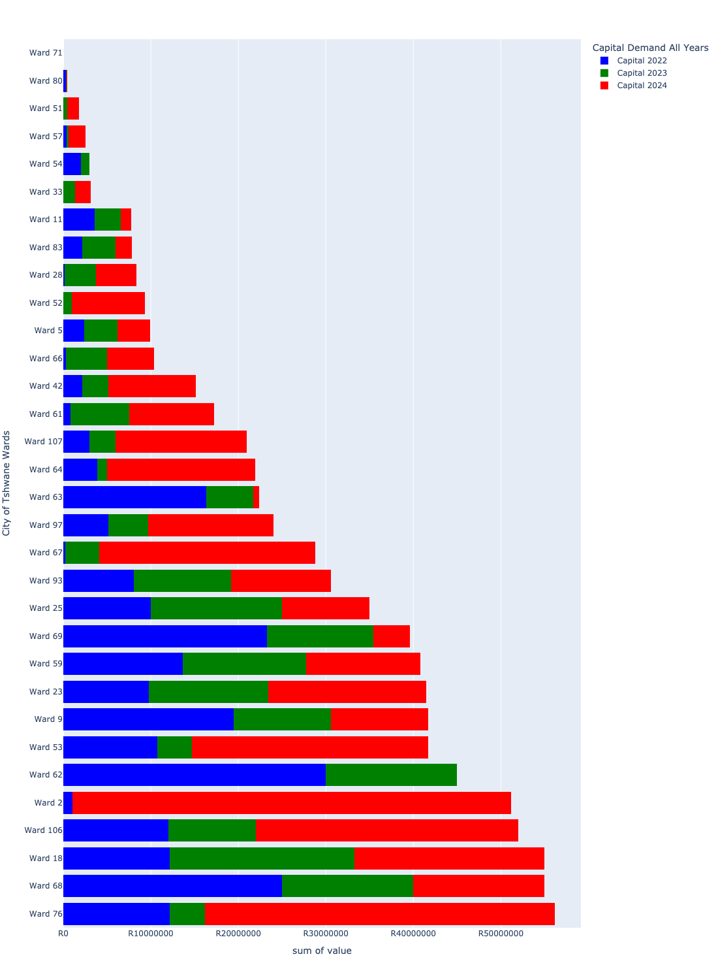

Figure 4.1.2: Capital Demand per City of Tshwane Ward - MTREF Period (2/3)

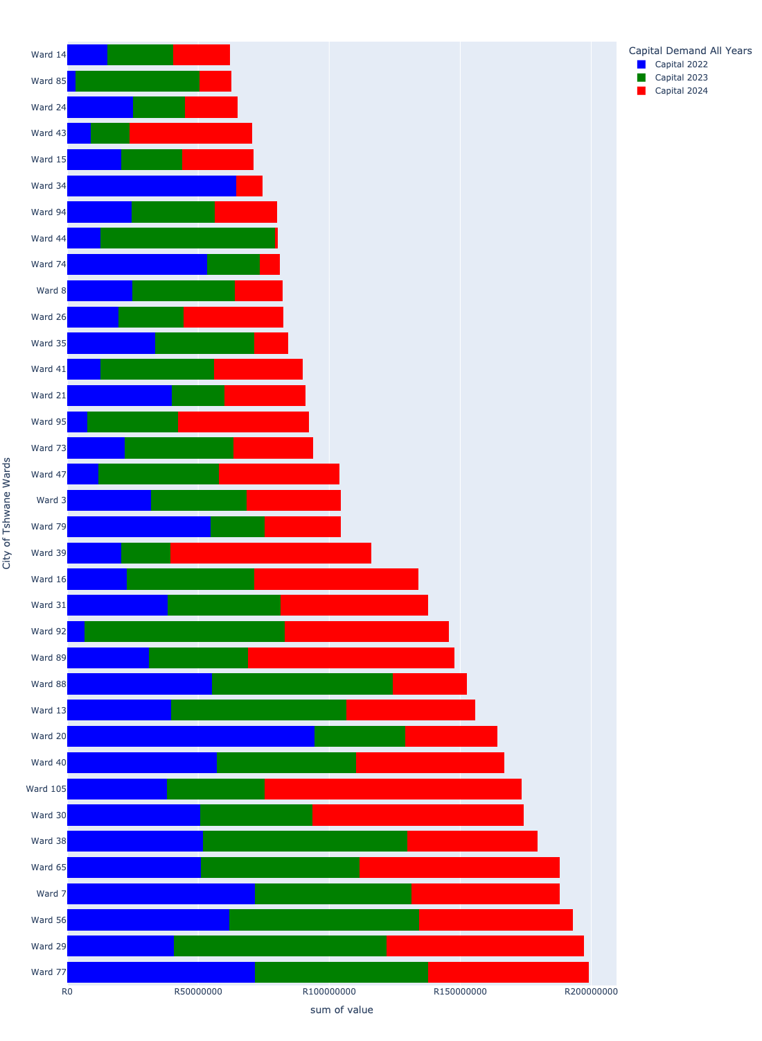

Figure 4.1.3: Capital Demand per City of Tshwane Ward - MTREF Period (3/3)

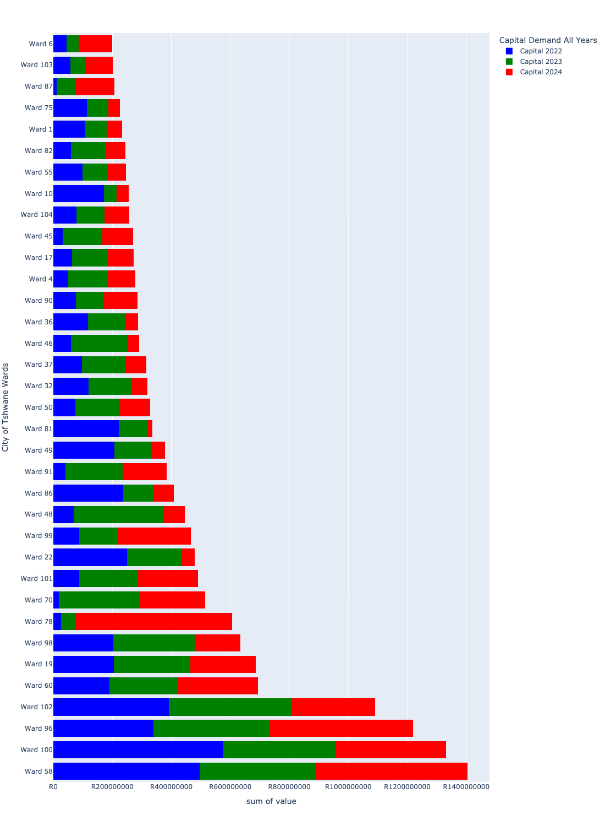

# Summary per City of Tshwane Ward

## Ward 1

Figure 5.1: Ward 1 Funding Requests

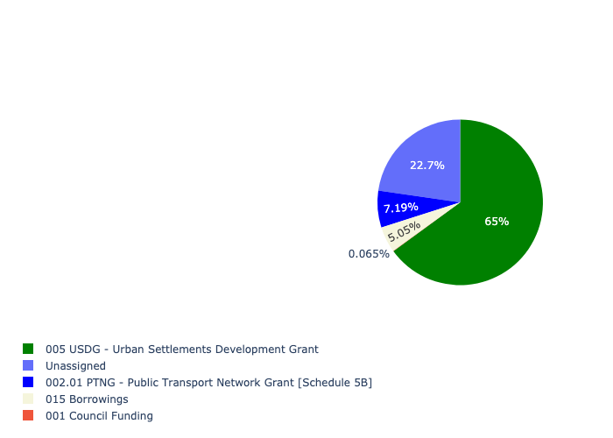

Figure 5.2: Ward 1 Departmental Requests

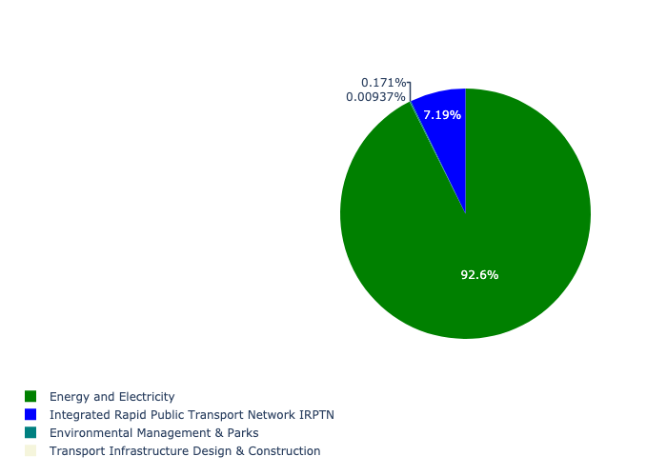

Table 5.1: Summary - Ward 1

|  |  |
| --- | --- |
| Item | Description |
| Total Capital Demand for Ward 1 - All Years | R287,895,268 Rank: 48 (1 = Highest) |
| Total Capital Demand for Ward 1 - MTREF | R287,895,268 Rank: 31 (1 = Highest) |
| Financial Years in which capital requirements are listed for Ward 1 | 2022, 2023, 2024, 2025, 2026, 2027, 2028, 2029, 2030 and 2031 |
| Financial Year with highest capital demand for Ward 1 | Capital 2022 |
| Ward 1 intersecting feature used | Works Location |
| Total number of projects intersecting with Ward 1 | 13 Rank: 39 (1 = Highest) |

## Ward 2

Figure 5.3: Ward 2 Funding Requests

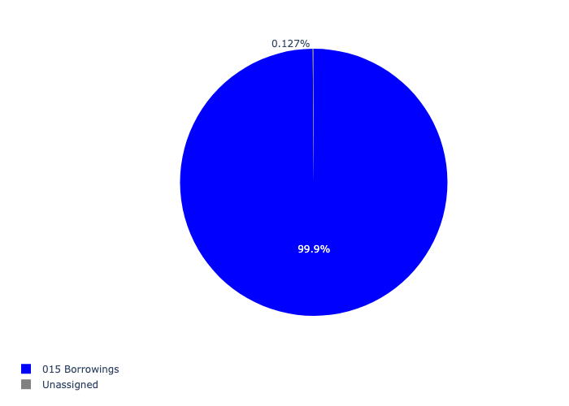

Figure 5.4: Ward 2 Departmental Requests

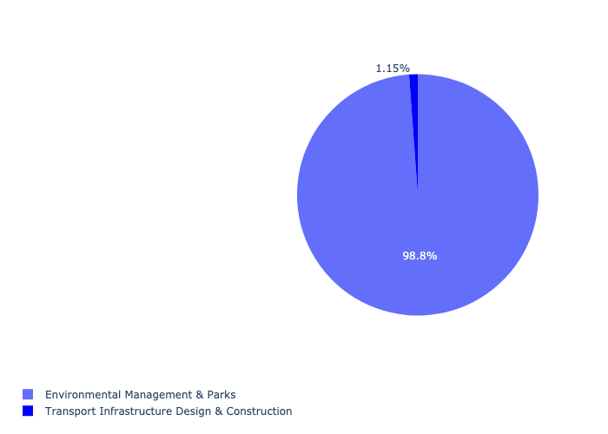

Table 5.2: Summary - Ward 2

|  |  |
| --- | --- |
| Item | Description |
| Total Capital Demand for Ward 2 - All Years | R61,591,038 Rank: 90 (1 = Highest) |
| Total Capital Demand for Ward 2 - MTREF | R61,591,038 Rank: 76 (1 = Highest) |
| Financial Years in which capital requirements are listed for Ward 2 | 2022, 2023, 2024, 2025, 2026, 2027, 2028, 2029, 2030 and 2031 |
| Financial Year with highest capital demand for Ward 2 | Capital 2024 |
| Ward 2 intersecting feature used | Works Location |
| Total number of projects intersecting with Ward 2 | 5 Rank: 94 (1 = Highest) |

## Ward 3

Figure 5.5: Ward 3 Funding Requests

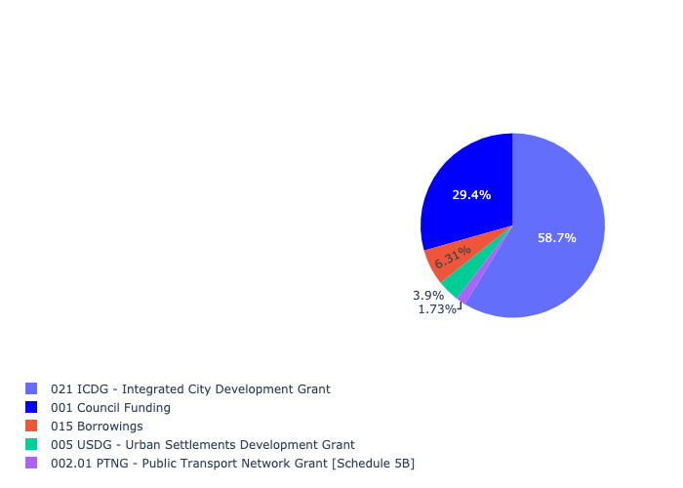

Figure 5.6: Ward 3 Departmental Requests

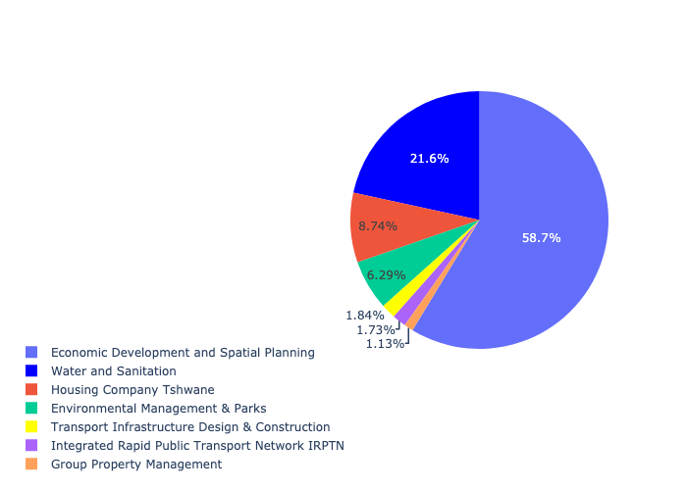

Table 5.3: Summary - Ward 3

|  |  |
| --- | --- |
| Item | Description |
| Total Capital Demand for Ward 3 - All Years | R223,494,341 Rank: 56 (1 = Highest) |
| Total Capital Demand for Ward 3 - MTREF | R223,494,341 Rank: 54 (1 = Highest) |
| Financial Years in which capital requirements are listed for Ward 3 | 2022, 2023, 2024, 2025, 2026, 2027, 2028, 2029 and 2030 |
| Financial Year with highest capital demand for Ward 3 | Capital 2025 |
| Ward 3 intersecting feature used | Works Location |
| Total number of projects intersecting with Ward 3 | 11 Rank: 50 (1 = Highest) |

## Ward 4

Figure 5.7: Ward 4 Funding Requests

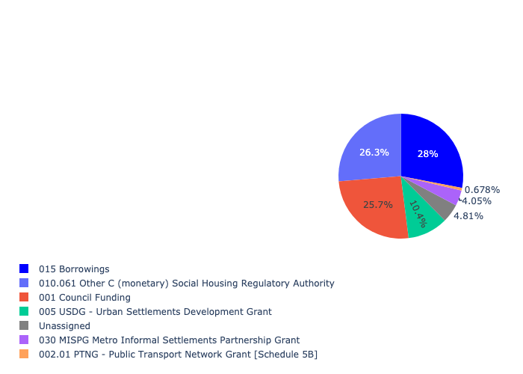

Figure 5.8: Ward 4 Departmental Requests

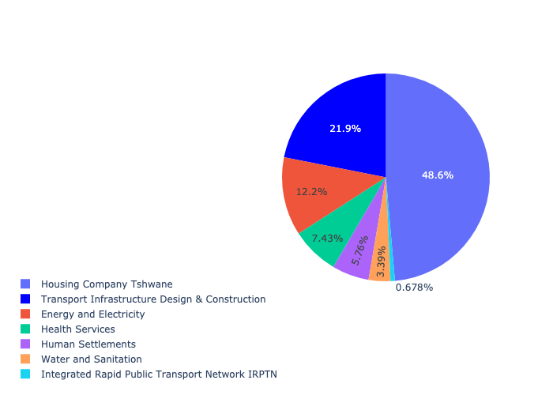

Table 5.4: Summary - Ward 4

|  |  |
| --- | --- |
| Item | Description |
| Total Capital Demand for Ward 4 - All Years | R634,230,238 Rank: 22 (1 = Highest) |
| Total Capital Demand for Ward 4 - MTREF | R634,230,238 Rank: 24 (1 = Highest) |
| Financial Years in which capital requirements are listed for Ward 4 | 2022, 2023, 2024, 2025, 2026, 2027, 2028, 2029 and 2030 |
| Financial Year with highest capital demand for Ward 4 | Capital 2023 |
| Ward 4 intersecting feature used | Works Location |
| Total number of projects intersecting with Ward 4 | 20 Rank: 14 (1 = Highest) |

## Ward 5

Figure 5.9: Ward 5 Funding Requests

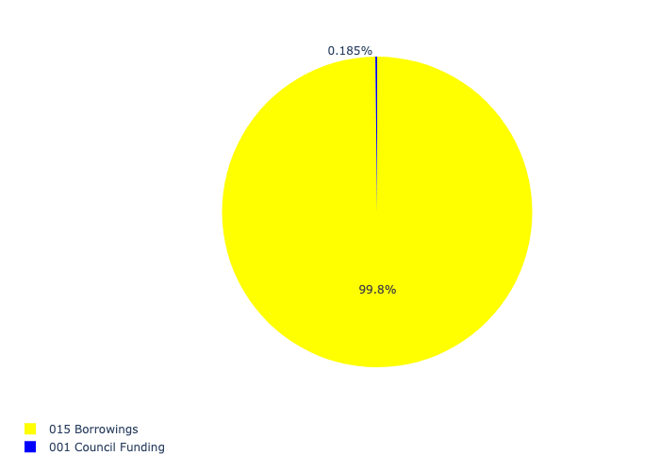

Figure 5.10: Ward 5 Departmental Requests

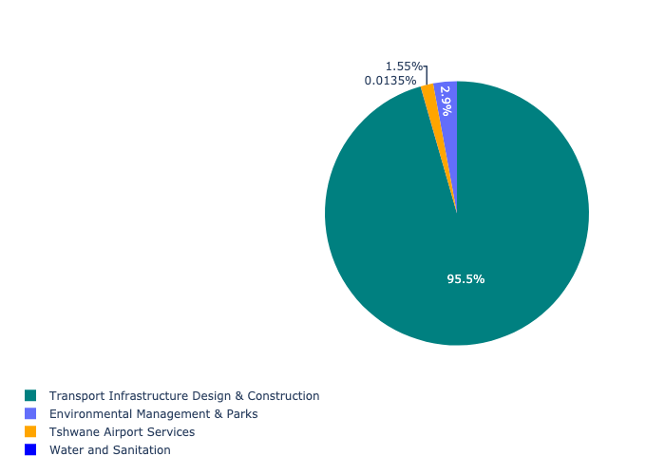

Table 5.5: Summary - Ward 5

|  |  |
| --- | --- |
| Item | Description |
| Total Capital Demand for Ward 5 - All Years | R57,082,224 Rank: 92 (1 = Highest) |
| Total Capital Demand for Ward 5 - MTREF | R57,082,224 Rank: 93 (1 = Highest) |
| Financial Years in which capital requirements are listed for Ward 5 | 2022, 2023, 2024, 2025, 2026, 2027, 2028, 2029, 2030 and 2031 |
| Financial Year with highest capital demand for Ward 5 | Capital 2027 |
| Ward 5 intersecting feature used | Works Location |
| Total number of projects intersecting with Ward 5 | 9 Rank: 61 (1 = Highest) |

## Ward 6

Figure 5.11: Ward 6 Funding Requests

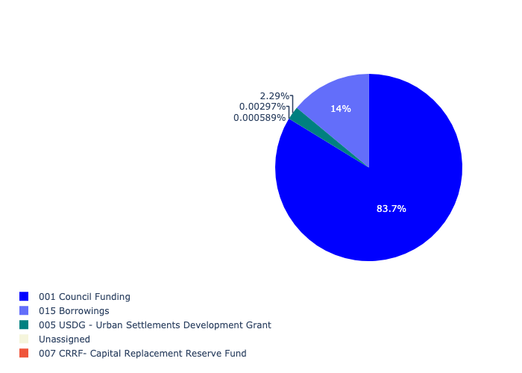

Figure 5.12: Ward 6 Departmental Requests

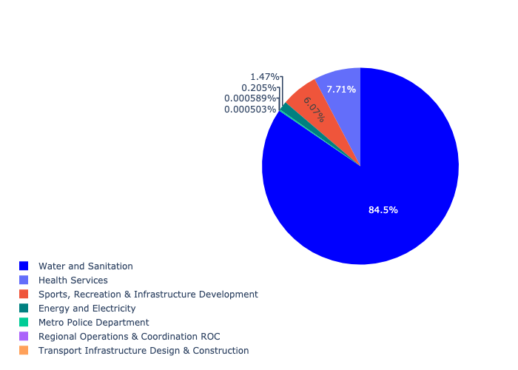

Table 5.6: Summary - Ward 6

|  |  |
| --- | --- |
| Item | Description |
| Total Capital Demand for Ward 6 - All Years | R1,182,463,074 Rank: 9 (1 = Highest) |
| Total Capital Demand for Ward 6 - MTREF | R1,182,463,074 Rank: 35 (1 = Highest) |
| Financial Years in which capital requirements are listed for Ward 6 | 2022, 2023, 2024, 2025, 2026, 2027, 2028, 2029, 2030 and 2031 |
| Financial Year with highest capital demand for Ward 6 | Capital 2025 |
| Ward 6 intersecting feature used | Works Location |
| Total number of projects intersecting with Ward 6 | 10 Rank: 55 (1 = Highest) |

## Ward 7

Figure 5.13: Ward 7 Funding Requests

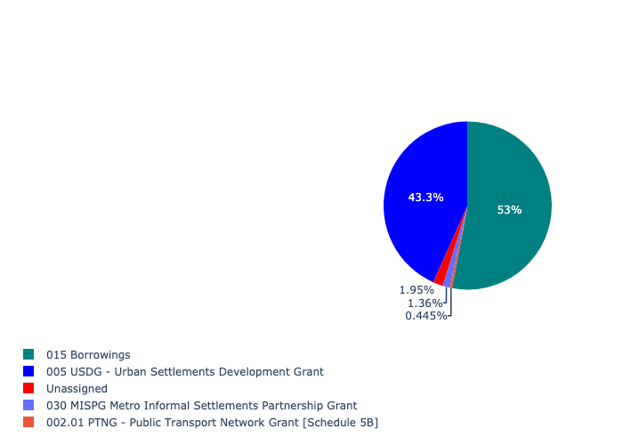

Figure 5.14: Ward 7 Departmental Requests

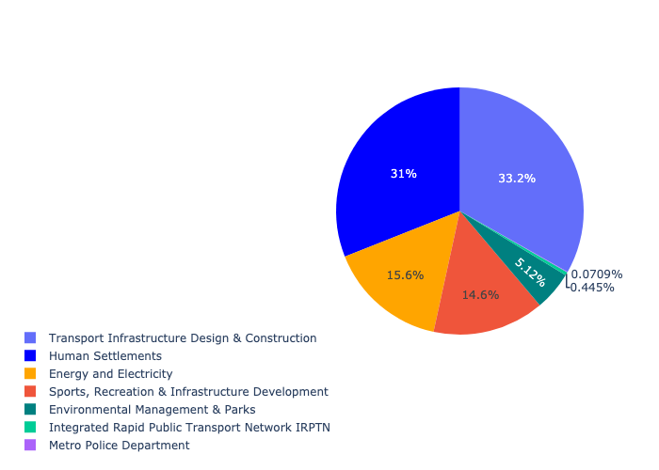

Table 5.7: Summary - Ward 7

|  |  |
| --- | --- |
| Item | Description |
| Total Capital Demand for Ward 7 - All Years | R513,520,850 Rank: 29 (1 = Highest) |
| Total Capital Demand for Ward 7 - MTREF | R513,520,850 Rank: 39 (1 = Highest) |
| Financial Years in which capital requirements are listed for Ward 7 | 2022, 2023, 2024, 2025, 2026, 2027 and 2028 |
| Financial Year with highest capital demand for Ward 7 | Capital 2026 |
| Ward 7 intersecting feature used | Works Location |
| Total number of projects intersecting with Ward 7 | 20 Rank: 14 (1 = Highest) |

## Ward 8

Figure 5.15: Ward 8 Funding Requests

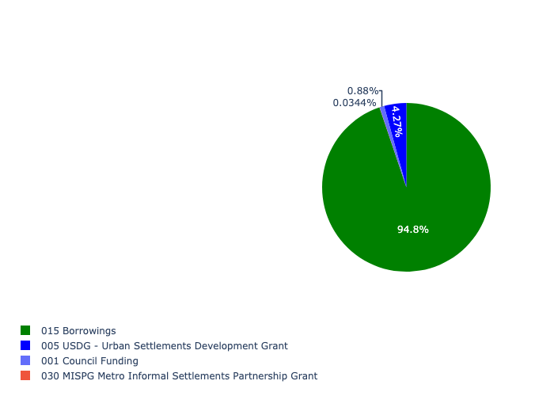

Figure 5.16: Ward 8 Departmental Requests

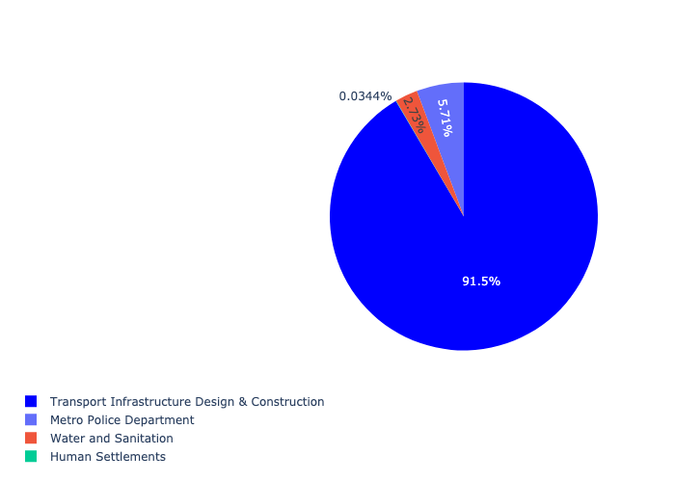

Table 5.8: Summary - Ward 8

|  |  |
| --- | --- |
| Item | Description |
| Total Capital Demand for Ward 8 - All Years | R227,777,962 Rank: 55 (1 = Highest) |
| Total Capital Demand for Ward 8 - MTREF | R227,777,962 Rank: 62 (1 = Highest) |
| Financial Years in which capital requirements are listed for Ward 8 | 2022, 2023, 2024, 2025, 2026, 2027, 2028, 2029 and 2030 |
| Financial Year with highest capital demand for Ward 8 | Capital 2023 |
| Ward 8 intersecting feature used | Works Location |
| Total number of projects intersecting with Ward 8 | 10 Rank: 55 (1 = Highest) |

## Ward 9

Figure 5.17: Ward 9 Funding Requests

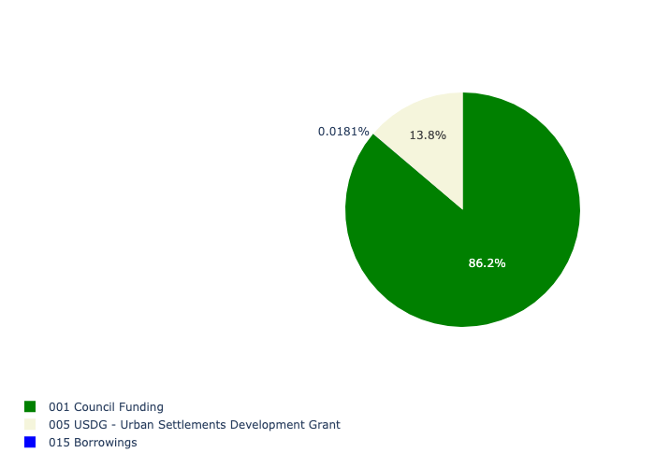

Figure 5.18: Ward 9 Departmental Requests

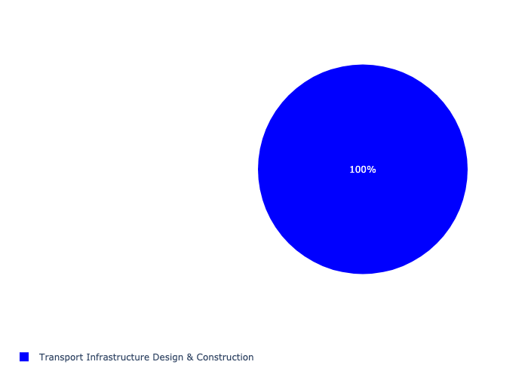

Table 5.9: Summary - Ward 9

|  |  |
| --- | --- |
| Item | Description |
| Total Capital Demand for Ward 9 - All Years | R80,612,295 Rank: 83 (1 = Highest) |
| Total Capital Demand for Ward 9 - MTREF | R80,612,295 Rank: 79 (1 = Highest) |
| Financial Years in which capital requirements are listed for Ward 9 | 2022, 2023, 2024, 2025, 2026 and 2027 |
| Financial Year with highest capital demand for Ward 9 | Capital 2026 |
| Ward 9 intersecting feature used | Works Location |
| Total number of projects intersecting with Ward 9 | 2 Rank: 105 (1 = Highest) |

## Ward 10

Figure 5.19: Ward 10 Funding Requests

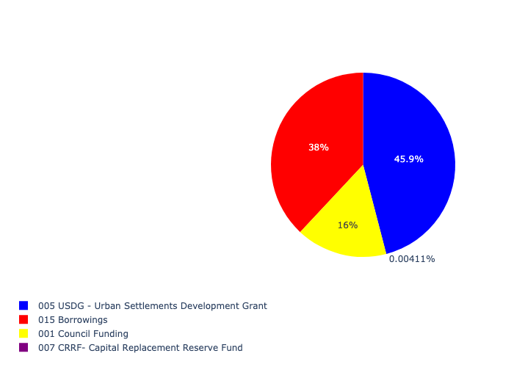

Figure 5.20: Ward 10 Departmental Requests

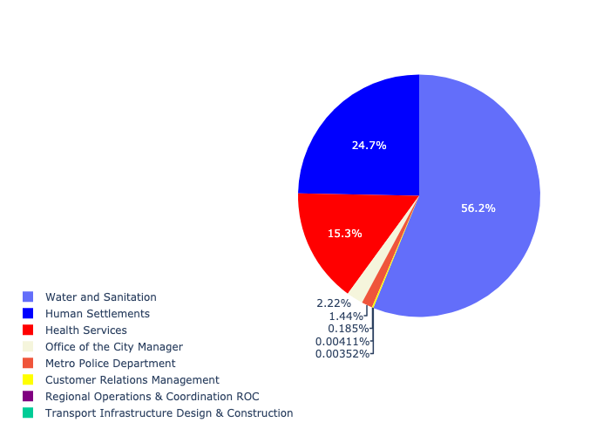

Table 5.10: Summary - Ward 10

|  |  |
| --- | --- |
| Item | Description |
| Total Capital Demand for Ward 10 - All Years | R301,108,214 Rank: 47 (1 = Highest) |
| Total Capital Demand for Ward 10 - MTREF | R301,108,214 Rank: 28 (1 = Highest) |
| Financial Years in which capital requirements are listed for Ward 10 | 2022, 2023, 2024, 2025, 2026 and 2027 |
| Financial Year with highest capital demand for Ward 10 | Capital 2022 |
| Ward 10 intersecting feature used | Works Location |
| Total number of projects intersecting with Ward 10 | 16 Rank: 29 (1 = Highest) |

## Ward 11

Figure 5.21: Ward 11 Funding Requests

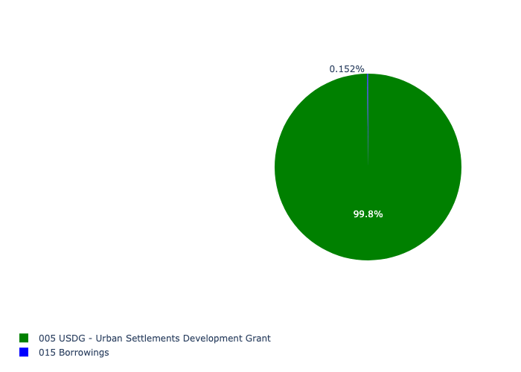

Figure 5.22: Ward 11 Departmental Requests

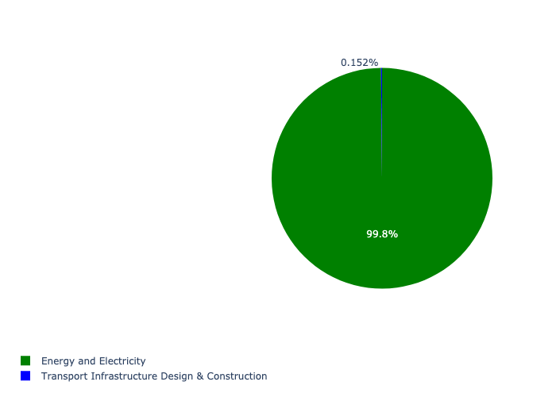

Table 5.11: Summary - Ward 11

|  |  |
| --- | --- |
| Item | Description |
| Total Capital Demand for Ward 11 - All Years | R7,781,408 Rank: 102 (1 = Highest) |
| Total Capital Demand for Ward 11 - MTREF | R7,781,408 Rank: 97 (1 = Highest) |
| Financial Years in which capital requirements are listed for Ward 11 | 2022, 2023, 2024 and 2027 |
| Financial Year with highest capital demand for Ward 11 | Capital 2022 |
| Ward 11 intersecting feature used | Works Location |
| Total number of projects intersecting with Ward 11 | 2 Rank: 105 (1 = Highest) |

## Ward 12

Figure 5.23: Ward 12 Funding Requests

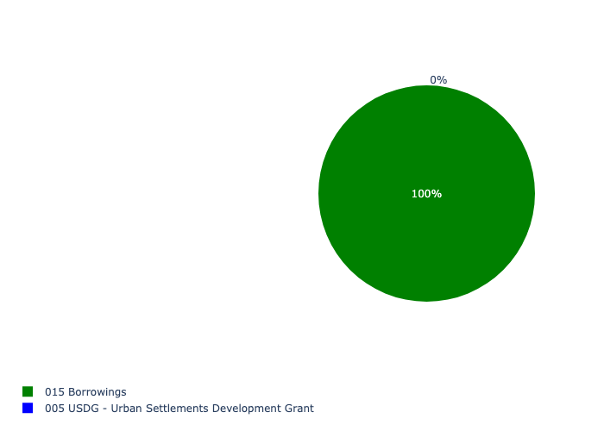

Figure 5.24: Ward 12 Departmental Requests

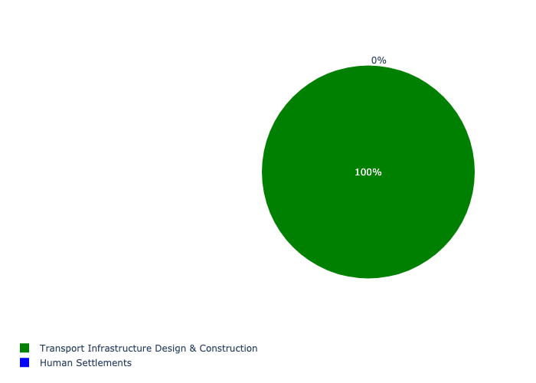

Table 5.12: Summary - Ward 12

|  |  |
| --- | --- |
| Item | Description |
| Total Capital Demand for Ward 12 - All Years | R10,057 Rank: 106 (1 = Highest) |
| Total Capital Demand for Ward 12 - MTREF | R10,057 Rank: 105 (1 = Highest) |
| Financial Years in which capital requirements are listed for Ward 12 | 2027 |
| Financial Year with highest capital demand for Ward 12 | Capital 2027 |
| Ward 12 intersecting feature used | Works Location |
| Total number of projects intersecting with Ward 12 | 2 Rank: 105 (1 = Highest) |

## Ward 13

Figure 5.25: Ward 13 Funding Requests

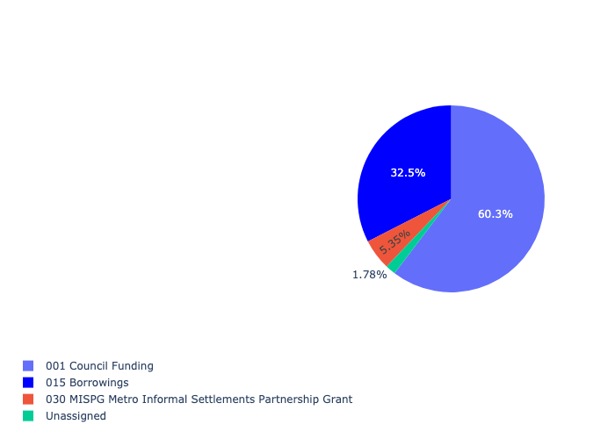

Figure 5.26: Ward 13 Departmental Requests

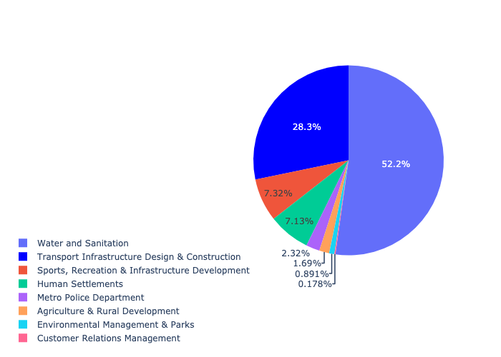

Table 5.13: Summary - Ward 13

|  |  |
| --- | --- |
| Item | Description |
| Total Capital Demand for Ward 13 - All Years | R561,058,349 Rank: 26 (1 = Highest) |
| Total Capital Demand for Ward 13 - MTREF | R561,058,349 Rank: 46 (1 = Highest) |
| Financial Years in which capital requirements are listed for Ward 13 | 2022, 2023, 2024, 2025, 2026, 2027, 2028, 2029 and 2030 |
| Financial Year with highest capital demand for Ward 13 | Capital 2026 |
| Ward 13 intersecting feature used | Works Location |
| Total number of projects intersecting with Ward 13 | 17 Rank: 22 (1 = Highest) |

## Ward 14

Figure 5.27: Ward 14 Funding Requests

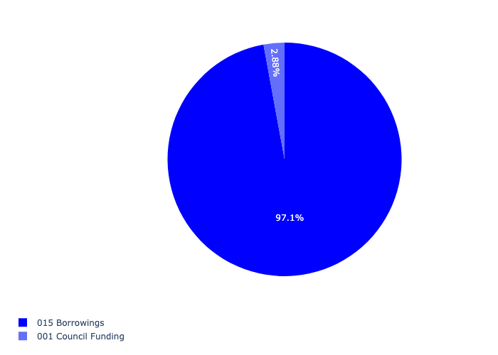

Figure 5.28: Ward 14 Departmental Requests

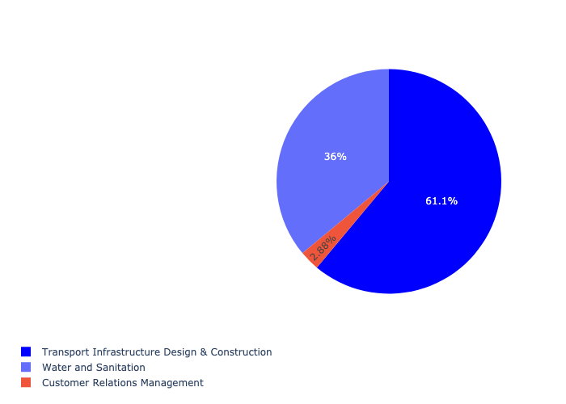

Table 5.14: Summary - Ward 14

|  |  |
| --- | --- |
| Item | Description |
| Total Capital Demand for Ward 14 - All Years | R277,518,687 Rank: 50 (1 = Highest) |
| Total Capital Demand for Ward 14 - MTREF | R277,518,687 Rank: 71 (1 = Highest) |
| Financial Years in which capital requirements are listed for Ward 14 | 2022, 2023, 2024, 2025, 2026, 2027, 2028, 2029 and 2030 |
| Financial Year with highest capital demand for Ward 14 | Capital 2027 |
| Ward 14 intersecting feature used | Works Location |
| Total number of projects intersecting with Ward 14 | 6 Rank: 88 (1 = Highest) |

## Ward 15

Figure 5.29: Ward 15 Funding Requests

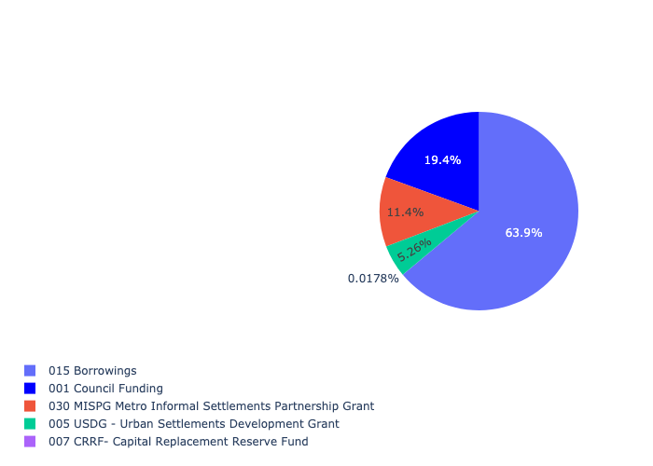

Figure 5.30: Ward 15 Departmental Requests

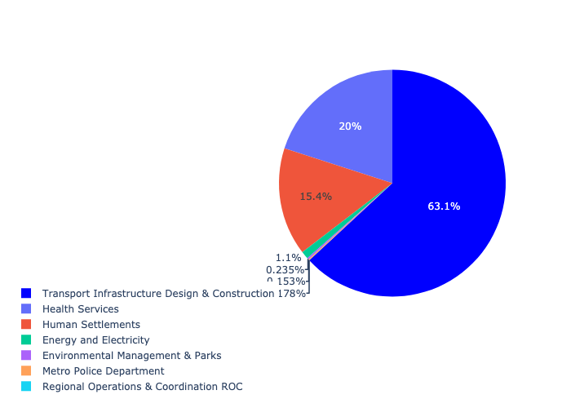

Table 5.15: Summary - Ward 15

|  |  |
| --- | --- |
| Item | Description |
| Total Capital Demand for Ward 15 - All Years | R149,686,708 Rank: 71 (1 = Highest) |
| Total Capital Demand for Ward 15 - MTREF | R149,686,708 Rank: 67 (1 = Highest) |
| Financial Years in which capital requirements are listed for Ward 15 | 2022, 2023, 2024, 2025, 2026, 2027, 2028, 2029 and 2030 |
| Financial Year with highest capital demand for Ward 15 | Capital 2024 |
| Ward 15 intersecting feature used | Works Location |
| Total number of projects intersecting with Ward 15 | 13 Rank: 39 (1 = Highest) |

## Ward 16

Figure 5.31: Ward 16 Funding Requests

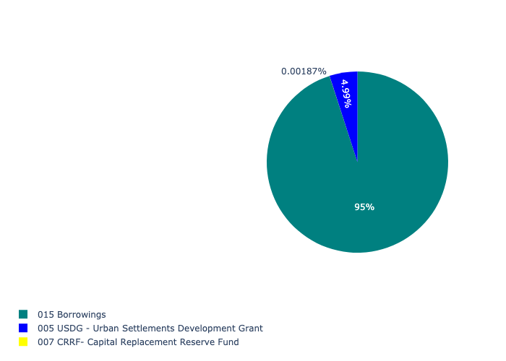

Figure 5.32: Ward 16 Departmental Requests

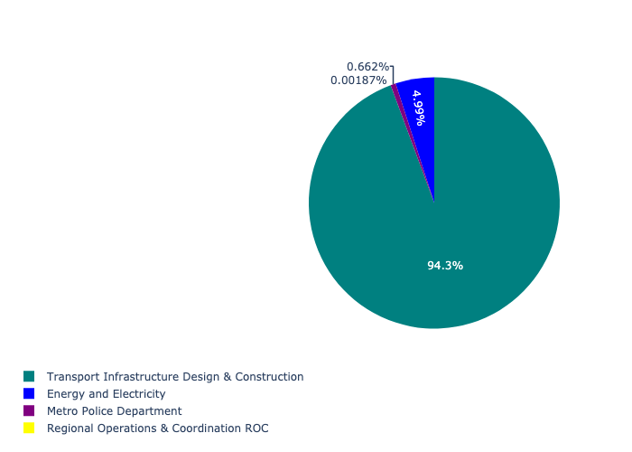

Table 5.16: Summary - Ward 16

|  |  |
| --- | --- |
| Item | Description |
| Total Capital Demand for Ward 16 - All Years | R416,960,550 Rank: 36 (1 = Highest) |
| Total Capital Demand for Ward 16 - MTREF | R416,960,550 Rank: 51 (1 = Highest) |
| Financial Years in which capital requirements are listed for Ward 16 | 2022, 2023, 2024, 2025, 2026, 2027, 2028, 2029 and 2030 |
| Financial Year with highest capital demand for Ward 16 | Capital 2024 |
| Ward 16 intersecting feature used | Works Location |
| Total number of projects intersecting with Ward 16 | 10 Rank: 55 (1 = Highest) |

## Ward 17

Figure 5.33: Ward 17 Funding Requests

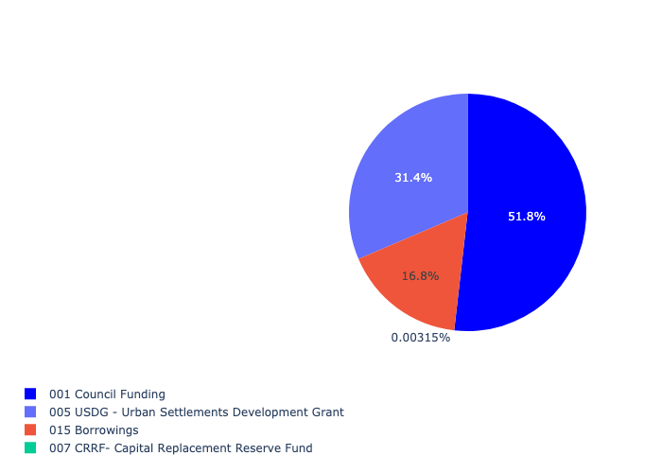

Figure 5.34: Ward 17 Departmental Requests

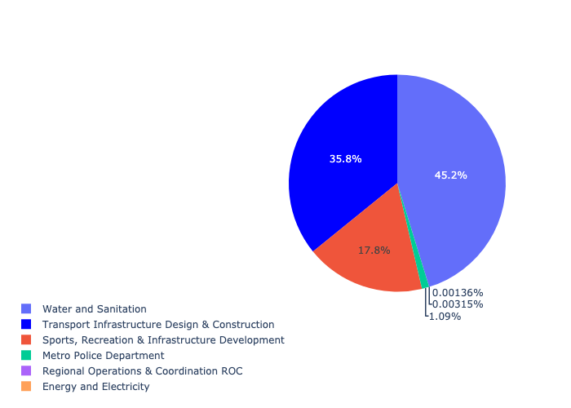

Table 5.17: Summary - Ward 17

|  |  |
| --- | --- |
| Item | Description |
| Total Capital Demand for Ward 17 - All Years | R434,323,299 Rank: 34 (1 = Highest) |
| Total Capital Demand for Ward 17 - MTREF | R434,323,299 Rank: 25 (1 = Highest) |
| Financial Years in which capital requirements are listed for Ward 17 | 2022, 2023, 2024, 2025, 2026, 2027, 2028, 2029 and 2030 |
| Financial Year with highest capital demand for Ward 17 | Capital 2023 |
| Ward 17 intersecting feature used | Works Location |
| Total number of projects intersecting with Ward 17 | 13 Rank: 39 (1 = Highest) |

## Ward 18

Figure 5.35: Ward 18 Funding Requests

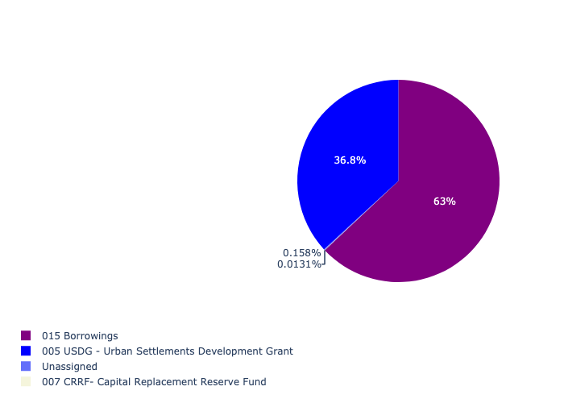

Figure 5.36: Ward 18 Departmental Requests

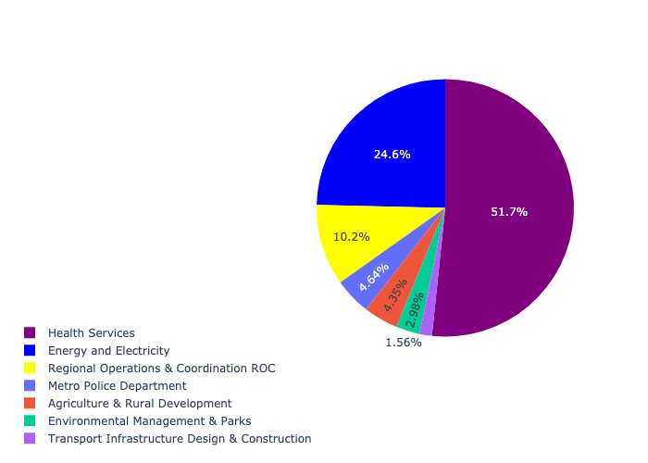

Table 5.18: Summary - Ward 18

|  |  |
| --- | --- |
| Item | Description |
| Total Capital Demand for Ward 18 - All Years | R61,024,355 Rank: 91 (1 = Highest) |
| Total Capital Demand for Ward 18 - MTREF | R61,024,355 Rank: 74 (1 = Highest) |
| Financial Years in which capital requirements are listed for Ward 18 | 2022, 2023, 2024, 2025, 2026, 2027, 2028, 2029 and 2030 |
| Financial Year with highest capital demand for Ward 18 | Capital 2024 |
| Ward 18 intersecting feature used | Works Location |
| Total number of projects intersecting with Ward 18 | 17 Rank: 22 (1 = Highest) |

## Ward 19

Figure 5.37: Ward 19 Funding Requests

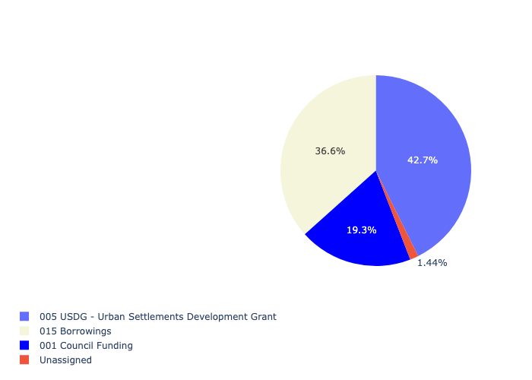

Figure 5.38: Ward 19 Departmental Requests

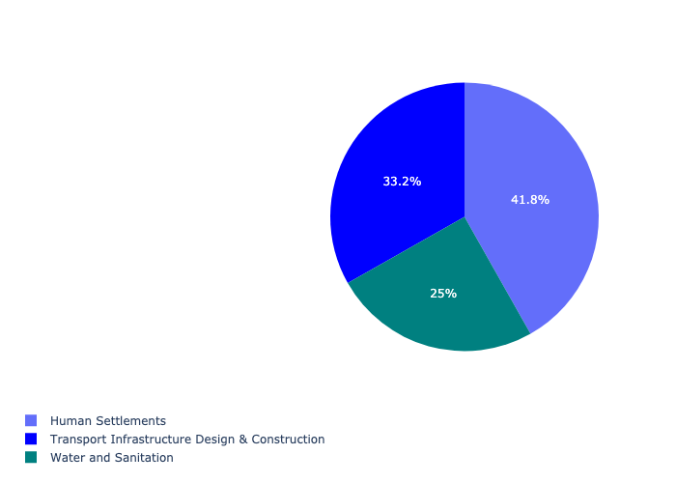

Table 5.19: Summary - Ward 19

|  |  |
| --- | --- |
| Item | Description |
| Total Capital Demand for Ward 19 - All Years | R876,427,565 Rank: 13 (1 = Highest) |
| Total Capital Demand for Ward 19 - MTREF | R876,427,565 Rank: 6 (1 = Highest) |
| Financial Years in which capital requirements are listed for Ward 19 | 2022, 2023, 2024, 2025, 2026, 2027, 2029 and 2030 |
| Financial Year with highest capital demand for Ward 19 | Capital 2023 |
| Ward 19 intersecting feature used | Works Location |
| Total number of projects intersecting with Ward 19 | 12 Rank: 45 (1 = Highest) |

## Ward 20

Figure 5.39: Ward 20 Funding Requests

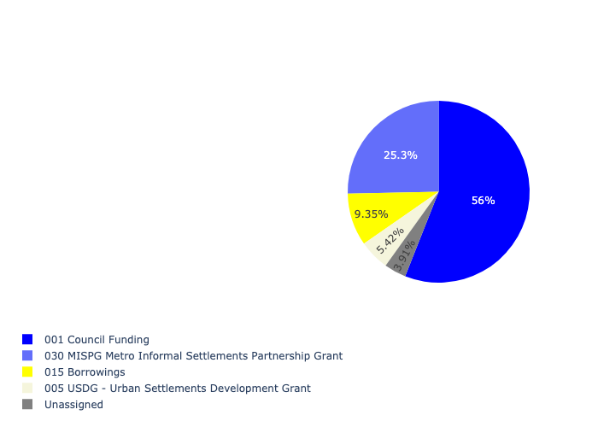

Figure 5.40: Ward 20 Departmental Requests

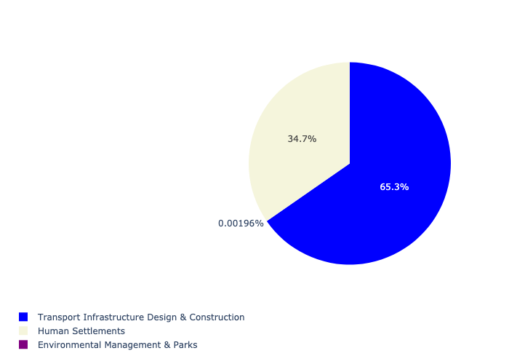

Table 5.20: Summary - Ward 20

|  |  |
| --- | --- |
| Item | Description |
| Total Capital Demand for Ward 20 - All Years | R214,281,375 Rank: 58 (1 = Highest) |
| Total Capital Demand for Ward 20 - MTREF | R214,281,375 Rank: 45 (1 = Highest) |
| Financial Years in which capital requirements are listed for Ward 20 | 2022, 2023, 2024, 2025, 2026 and 2027 |
| Financial Year with highest capital demand for Ward 20 | Capital 2022 |
| Ward 20 intersecting feature used | Works Location |
| Total number of projects intersecting with Ward 20 | 7 Rank: 77 (1 = Highest) |

## Ward 21

Figure 5.41: Ward 21 Funding Requests

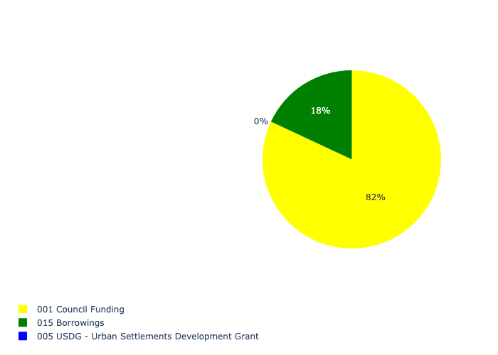

Figure 5.42: Ward 21 Departmental Requests

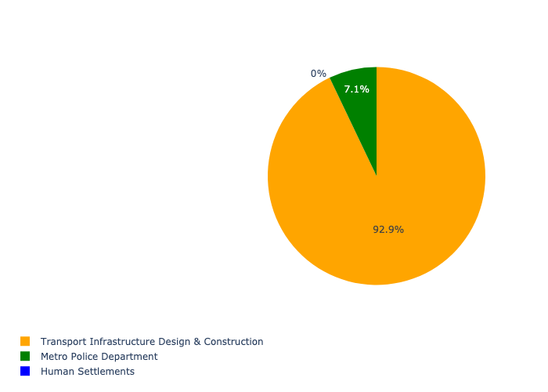

Table 5.21: Summary - Ward 21

|  |  |
| --- | --- |
| Item | Description |
| Total Capital Demand for Ward 21 - All Years | R183,012,305 Rank: 65 (1 = Highest) |
| Total Capital Demand for Ward 21 - MTREF | R183,012,305 Rank: 58 (1 = Highest) |
| Financial Years in which capital requirements are listed for Ward 21 | 2022, 2023, 2024, 2025, 2026 and 2027 |
| Financial Year with highest capital demand for Ward 21 | Capital 2025 |
| Ward 21 intersecting feature used | Works Location |
| Total number of projects intersecting with Ward 21 | 6 Rank: 88 (1 = Highest) |

## Ward 22

Figure 5.43: Ward 22 Funding Requests

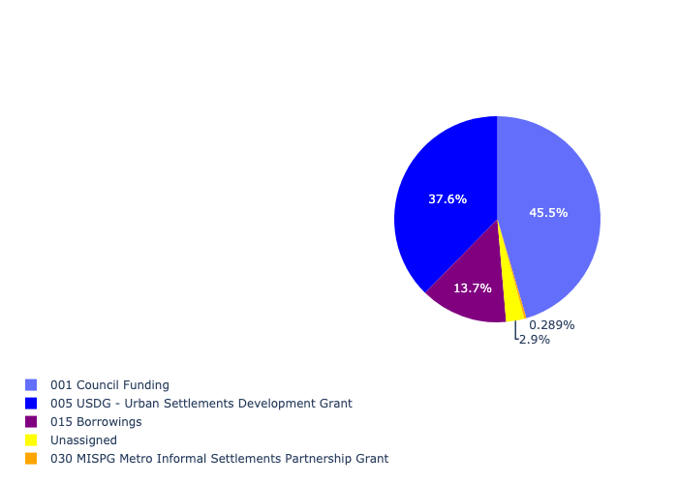

Figure 5.44: Ward 22 Departmental Requests

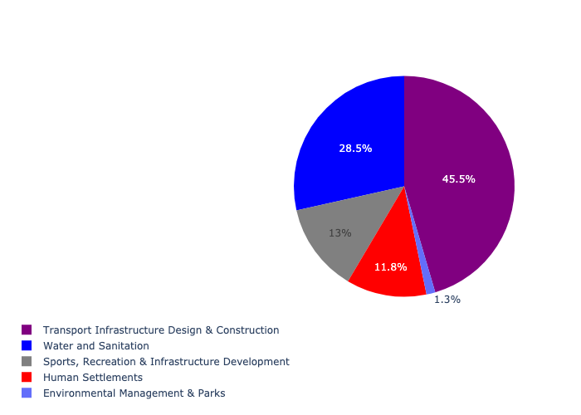

Table 5.22: Summary - Ward 22

|  |  |
| --- | --- |
| Item | Description |
| Total Capital Demand for Ward 22 - All Years | R690,006,018 Rank: 20 (1 = Highest) |
| Total Capital Demand for Ward 22 - MTREF | R690,006,018 Rank: 11 (1 = Highest) |
| Financial Years in which capital requirements are listed for Ward 22 | 2022, 2023, 2024, 2025, 2026, 2027, 2028, 2029 and 2030 |
| Financial Year with highest capital demand for Ward 22 | Capital 2022 |
| Ward 22 intersecting feature used | Works Location |
| Total number of projects intersecting with Ward 22 | 15 Rank: 34 (1 = Highest) |

## Ward 23

Figure 5.45: Ward 23 Funding Requests

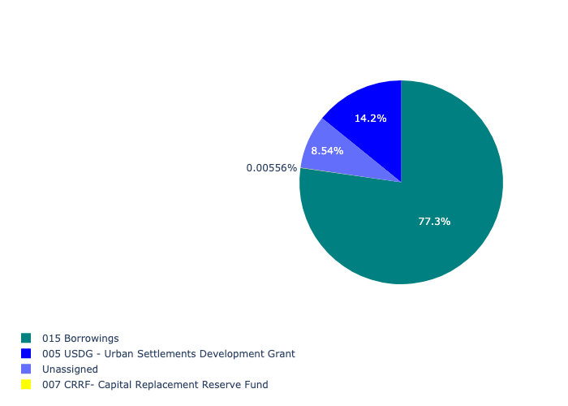

Figure 5.46: Ward 23 Departmental Requests

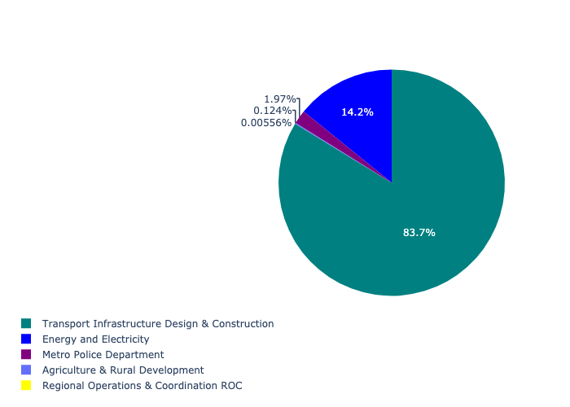

Table 5.23: Summary - Ward 23

|  |  |
| --- | --- |
| Item | Description |
| Total Capital Demand for Ward 23 - All Years | R106,358,791 Rank: 78 (1 = Highest) |
| Total Capital Demand for Ward 23 - MTREF | R106,358,791 Rank: 80 (1 = Highest) |
| Financial Years in which capital requirements are listed for Ward 23 | 2022, 2023, 2024, 2025, 2026, 2027, 2028, 2029 and 2030 |
| Financial Year with highest capital demand for Ward 23 | Capital 2024 |
| Ward 23 intersecting feature used | Works Location |
| Total number of projects intersecting with Ward 23 | 7 Rank: 77 (1 = Highest) |

## Ward 24

Figure 5.47: Ward 24 Funding Requests

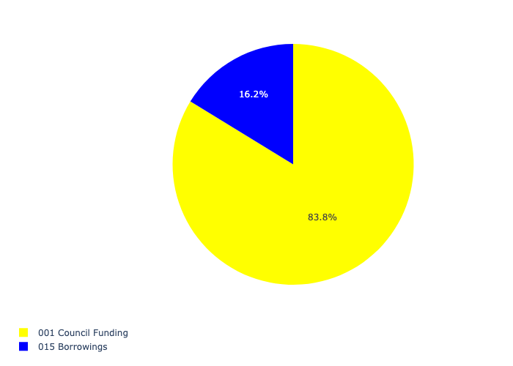

Figure 5.48: Ward 24 Departmental Requests



Table 5.24: Summary - Ward 24

|  |  |
| --- | --- |
| Item | Description |
| Total Capital Demand for Ward 24 - All Years | R155,070,511 Rank: 70 (1 = Highest) |
| Total Capital Demand for Ward 24 - MTREF | R155,070,511 Rank: 69 (1 = Highest) |
| Financial Years in which capital requirements are listed for Ward 24 | 2022, 2023, 2024, 2025, 2026, 2027, 2028, 2029 and 2030 |
| Financial Year with highest capital demand for Ward 24 | Capital 2022 |
| Ward 24 intersecting feature used | Works Location |
| Total number of projects intersecting with Ward 24 | 3 Rank: 102 (1 = Highest) |

## Ward 25

Figure 5.49: Ward 25 Funding Requests

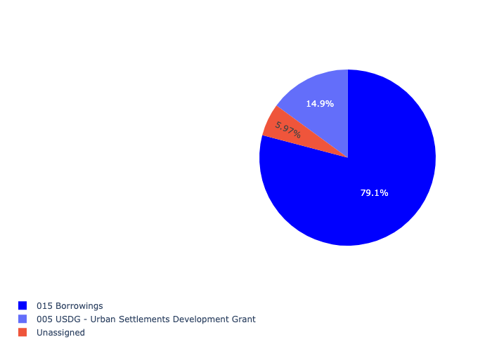

Figure 5.50: Ward 25 Departmental Requests

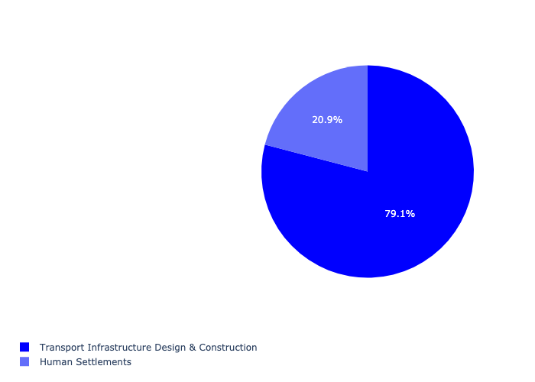

Table 5.25: Summary - Ward 25

|  |  |
| --- | --- |
| Item | Description |
| Total Capital Demand for Ward 25 - All Years | R167,398,884 Rank: 68 (1 = Highest) |
| Total Capital Demand for Ward 25 - MTREF | R167,398,884 Rank: 83 (1 = Highest) |
| Financial Years in which capital requirements are listed for Ward 25 | 2022, 2023, 2024, 2025, 2026 and 2027 |
| Financial Year with highest capital demand for Ward 25 | Capital 2026 |
| Ward 25 intersecting feature used | Works Location |
| Total number of projects intersecting with Ward 25 | 7 Rank: 77 (1 = Highest) |

## Ward 26

Figure 5.51: Ward 26 Funding Requests

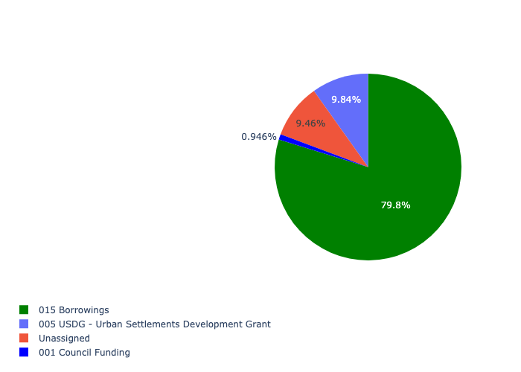

Figure 5.52: Ward 26 Departmental Requests

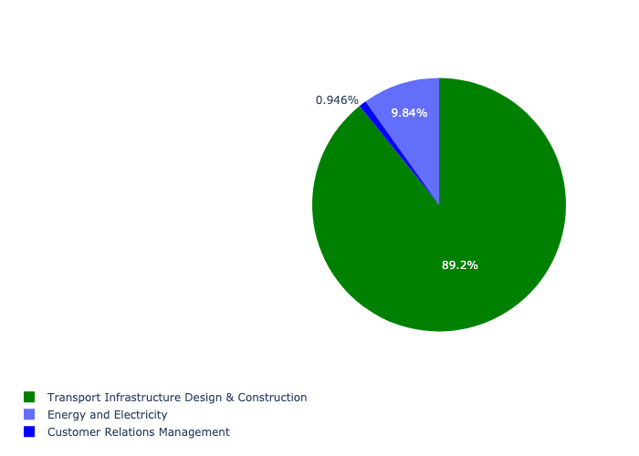

Table 5.26: Summary - Ward 26

|  |  |
| --- | --- |
| Item | Description |
| Total Capital Demand for Ward 26 - All Years | R211,338,385 Rank: 59 (1 = Highest) |
| Total Capital Demand for Ward 26 - MTREF | R211,338,385 Rank: 61 (1 = Highest) |
| Financial Years in which capital requirements are listed for Ward 26 | 2022, 2023, 2024, 2025, 2026, 2027, 2028, 2029 and 2030 |
| Financial Year with highest capital demand for Ward 26 | Capital 2024 |
| Ward 26 intersecting feature used | Works Location |
| Total number of projects intersecting with Ward 26 | 8 Rank: 67 (1 = Highest) |

## Ward 27

Figure 5.53: Ward 27 Funding Requests

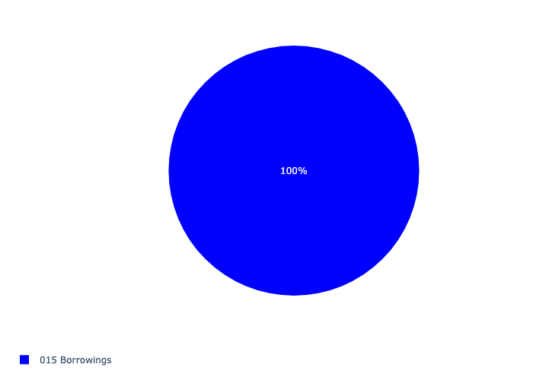

Figure 5.54: Ward 27 Departmental Requests



Table 5.27: Summary - Ward 27

|  |  |
| --- | --- |
| Item | Description |
| Total Capital Demand for Ward 27 - All Years | R95,592,376 Rank: 80 (1 = Highest) |
| Total Capital Demand for Ward 27 - MTREF | R95,592,376 Rank: 105 (1 = Highest) |
| Financial Years in which capital requirements are listed for Ward 27 | 2025, 2026 and 2027 |
| Financial Year with highest capital demand for Ward 27 | Capital 2026 |
| Ward 27 intersecting feature used | Works Location |
| Total number of projects intersecting with Ward 27 | 4 Rank: 98 (1 = Highest) |

## Ward 28

Figure 5.55: Ward 28 Funding Requests

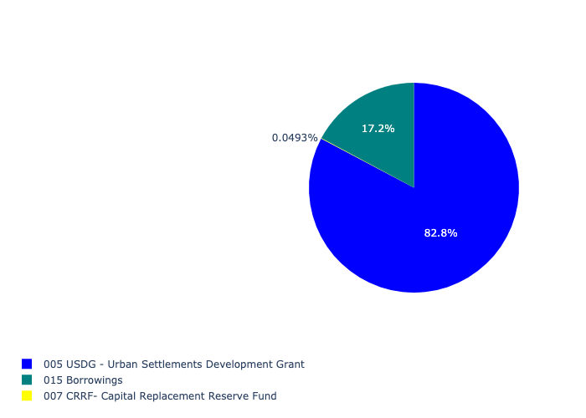

Figure 5.56: Ward 28 Departmental Requests

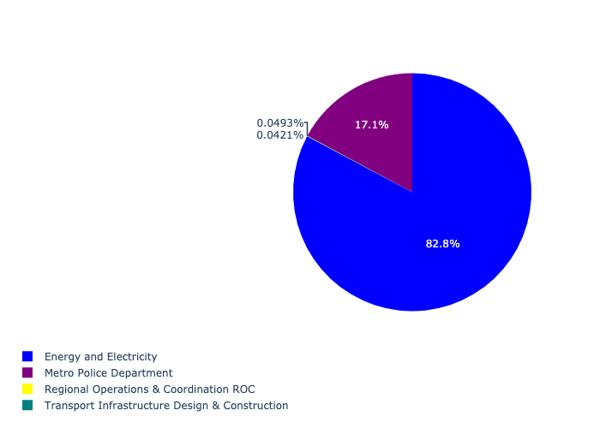

Table 5.28: Summary - Ward 28

|  |  |
| --- | --- |
| Item | Description |
| Total Capital Demand for Ward 28 - All Years | R8,402,489 Rank: 101 (1 = Highest) |
| Total Capital Demand for Ward 28 - MTREF | R8,402,489 Rank: 95 (1 = Highest) |
| Financial Years in which capital requirements are listed for Ward 28 | 2022, 2023, 2024, 2026 and 2027 |
| Financial Year with highest capital demand for Ward 28 | Capital 2024 |
| Ward 28 intersecting feature used | Works Location |
| Total number of projects intersecting with Ward 28 | 5 Rank: 94 (1 = Highest) |

## Ward 29

Figure 5.57: Ward 29 Funding Requests

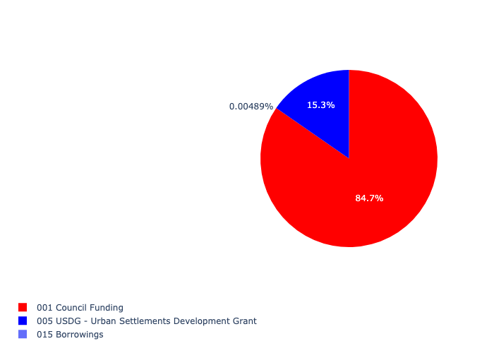

Figure 5.58: Ward 29 Departmental Requests

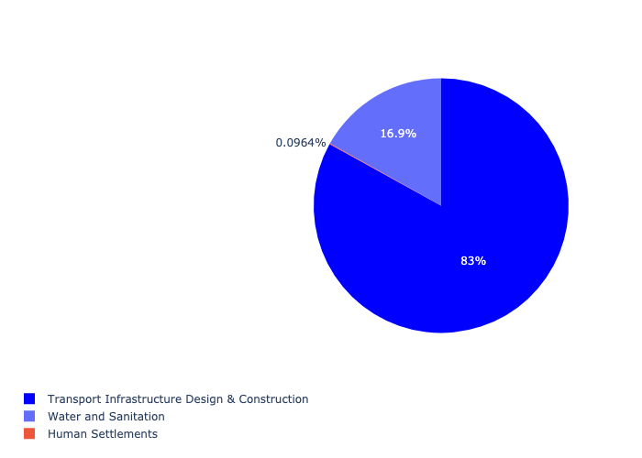

Table 5.29: Summary - Ward 29

|  |  |
| --- | --- |
| Item | Description |
| Total Capital Demand for Ward 29 - All Years | R414,745,521 Rank: 37 (1 = Highest) |
| Total Capital Demand for Ward 29 - MTREF | R414,745,521 Rank: 37 (1 = Highest) |
| Financial Years in which capital requirements are listed for Ward 29 | 2022, 2023, 2024, 2025, 2026, 2027, 2028, 2029, 2030 and 2031 |
| Financial Year with highest capital demand for Ward 29 | Capital 2025 |
| Ward 29 intersecting feature used | Works Location |
| Total number of projects intersecting with Ward 29 | 11 Rank: 50 (1 = Highest) |

## Ward 30

Figure 5.59: Ward 30 Funding Requests

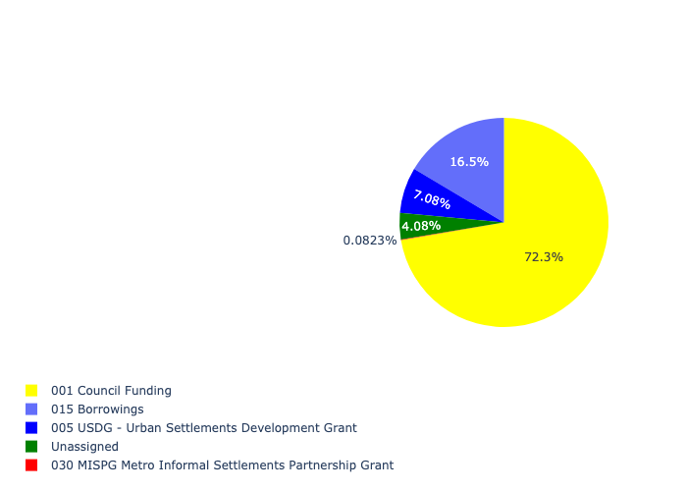

Figure 5.60: Ward 30 Departmental Requests

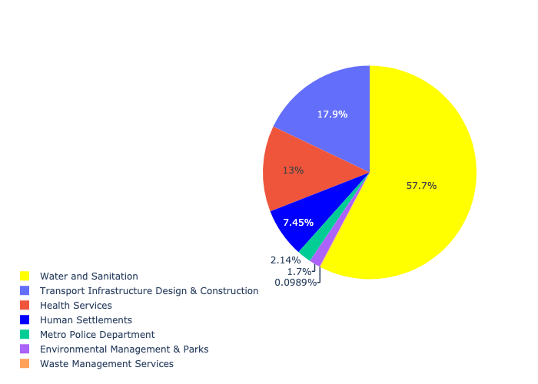

Table 5.30: Summary - Ward 30

|  |  |
| --- | --- |
| Item | Description |
| Total Capital Demand for Ward 30 - All Years | R603,848,214 Rank: 24 (1 = Highest) |
| Total Capital Demand for Ward 30 - MTREF | R603,848,214 Rank: 42 (1 = Highest) |
| Financial Years in which capital requirements are listed for Ward 30 | 2022, 2023, 2024, 2025, 2026, 2027, 2028, 2029 and 2030 |
| Financial Year with highest capital demand for Ward 30 | Capital 2026 |
| Ward 30 intersecting feature used | Works Location |
| Total number of projects intersecting with Ward 30 | 16 Rank: 29 (1 = Highest) |

## Ward 31

Figure 5.61: Ward 31 Funding Requests

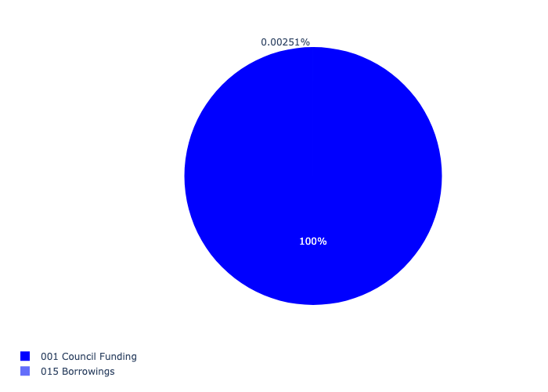

Figure 5.62: Ward 31 Departmental Requests



Table 5.31: Summary - Ward 31

|  |  |
| --- | --- |
| Item | Description |
| Total Capital Demand for Ward 31 - All Years | R384,213,477 Rank: 40 (1 = Highest) |
| Total Capital Demand for Ward 31 - MTREF | R384,213,477 Rank: 50 (1 = Highest) |
| Financial Years in which capital requirements are listed for Ward 31 | 2022, 2023, 2024, 2025, 2026, 2027, 2028, 2029 and 2030 |
| Financial Year with highest capital demand for Ward 31 | Capital 2026 |
| Ward 31 intersecting feature used | Works Location |
| Total number of projects intersecting with Ward 31 | 6 Rank: 88 (1 = Highest) |

## Ward 32

Figure 5.63: Ward 32 Funding Requests

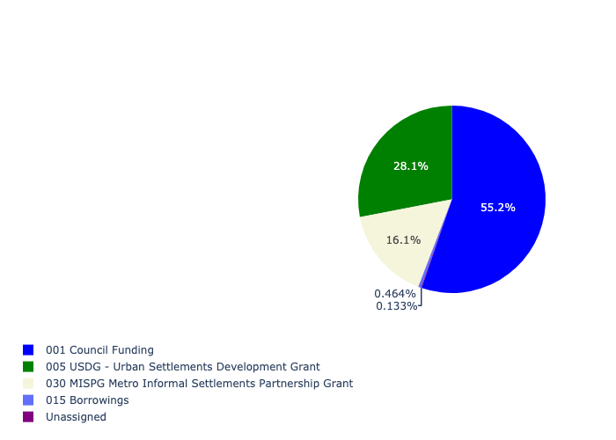

Figure 5.64: Ward 32 Departmental Requests

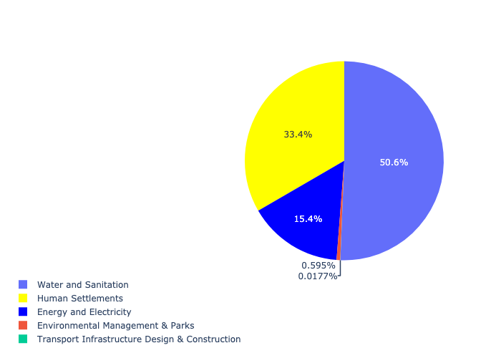

Table 5.32: Summary - Ward 32

|  |  |
| --- | --- |
| Item | Description |
| Total Capital Demand for Ward 32 - All Years | R671,593,879 Rank: 21 (1 = Highest) |
| Total Capital Demand for Ward 32 - MTREF | R671,593,879 Rank: 19 (1 = Highest) |
| Financial Years in which capital requirements are listed for Ward 32 | 2022, 2023, 2024, 2025, 2026, 2027 and 2028 |
| Financial Year with highest capital demand for Ward 32 | Capital 2026 |
| Ward 32 intersecting feature used | Works Location |
| Total number of projects intersecting with Ward 32 | 12 Rank: 45 (1 = Highest) |

## Ward 33

Figure 5.65: Ward 33 Funding Requests

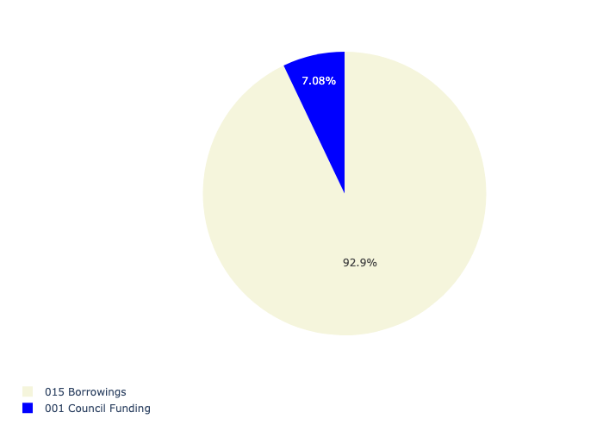

Figure 5.66: Ward 33 Departmental Requests

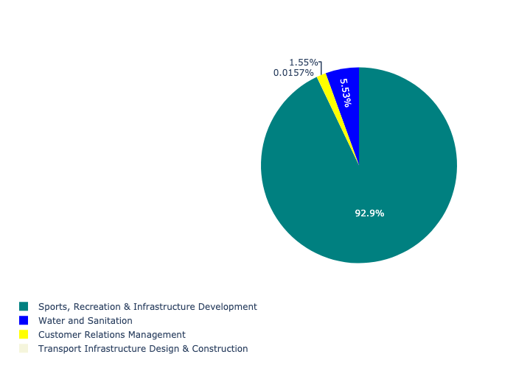

Table 5.33: Summary - Ward 33

|  |  |
| --- | --- |
| Item | Description |
| Total Capital Demand for Ward 33 - All Years | R64,580,215 Rank: 89 (1 = Highest) |
| Total Capital Demand for Ward 33 - MTREF | R64,580,215 Rank: 98 (1 = Highest) |
| Financial Years in which capital requirements are listed for Ward 33 | 2023, 2024, 2025, 2026, 2027 and 2028 |
| Financial Year with highest capital demand for Ward 33 | Capital 2027 |
| Ward 33 intersecting feature used | Works Location |
| Total number of projects intersecting with Ward 33 | 4 Rank: 98 (1 = Highest) |

## Ward 34

Figure 5.67: Ward 34 Funding Requests

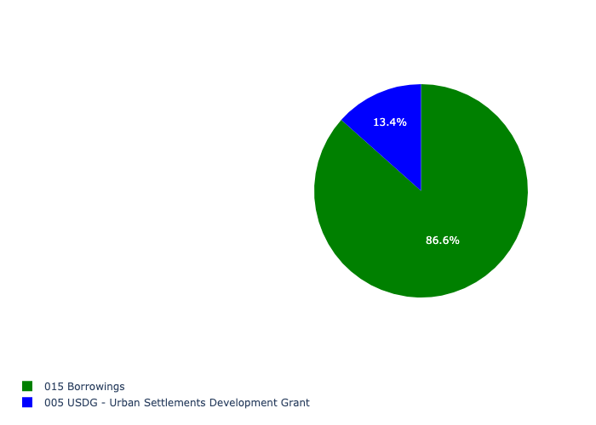

Figure 5.68: Ward 34 Departmental Requests

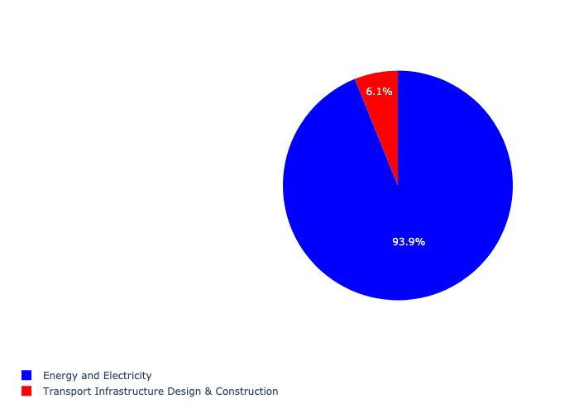

Table 5.34: Summary - Ward 34

|  |  |
| --- | --- |
| Item | Description |
| Total Capital Demand for Ward 34 - All Years | R74,549,717 Rank: 86 (1 = Highest) |
| Total Capital Demand for Ward 34 - MTREF | R74,549,717 Rank: 66 (1 = Highest) |
| Financial Years in which capital requirements are listed for Ward 34 | 2022, 2024 and 2027 |
| Financial Year with highest capital demand for Ward 34 | Capital 2022 |
| Ward 34 intersecting feature used | Works Location |
| Total number of projects intersecting with Ward 34 | 5 Rank: 94 (1 = Highest) |

## Ward 35

Figure 5.69: Ward 35 Funding Requests

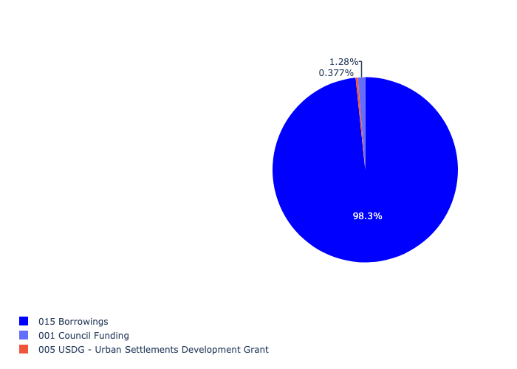

Figure 5.70: Ward 35 Departmental Requests

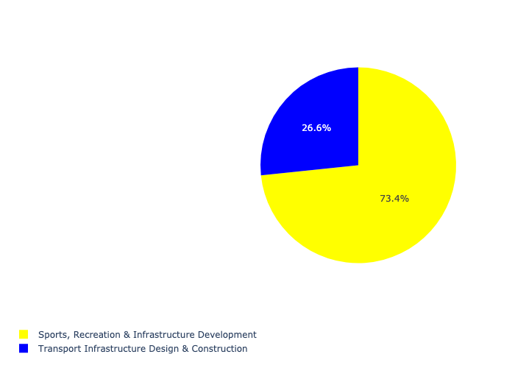

Table 5.35: Summary - Ward 35

|  |  |
| --- | --- |
| Item | Description |
| Total Capital Demand for Ward 35 - All Years | R201,743,107 Rank: 61 (1 = Highest) |
| Total Capital Demand for Ward 35 - MTREF | R201,743,107 Rank: 60 (1 = Highest) |
| Financial Years in which capital requirements are listed for Ward 35 | 2022, 2023, 2024, 2025, 2026, 2027, 2028, 2029, 2030 and 2031 |
| Financial Year with highest capital demand for Ward 35 | Capital 2023 |
| Ward 35 intersecting feature used | Works Location |
| Total number of projects intersecting with Ward 35 | 6 Rank: 88 (1 = Highest) |

## Ward 36

Figure 5.71: Ward 36 Funding Requests

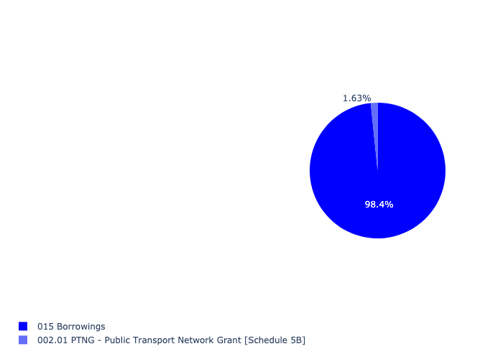

Figure 5.72: Ward 36 Departmental Requests

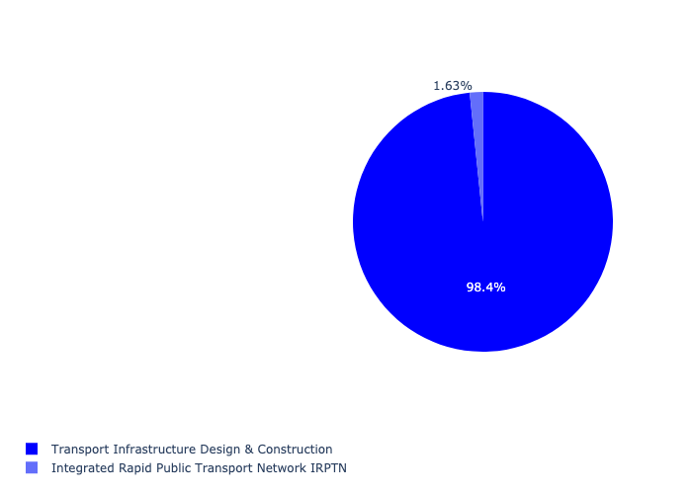

Table 5.36: Summary - Ward 36

|  |  |
| --- | --- |
| Item | Description |
| Total Capital Demand for Ward 36 - All Years | R439,235,741 Rank: 33 (1 = Highest) |
| Total Capital Demand for Ward 36 - MTREF | R439,235,741 Rank: 22 (1 = Highest) |
| Financial Years in which capital requirements are listed for Ward 36 | 2022, 2023, 2024, 2025, 2026, 2027 and 2028 |
| Financial Year with highest capital demand for Ward 36 | Capital 2023 |
| Ward 36 intersecting feature used | Works Location |
| Total number of projects intersecting with Ward 36 | 12 Rank: 45 (1 = Highest) |

## Ward 37

Figure 5.73: Ward 37 Funding Requests

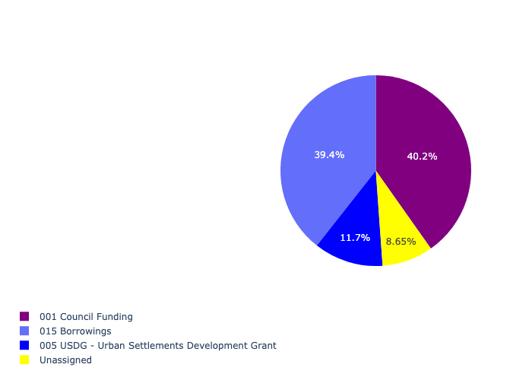

Figure 5.74: Ward 37 Departmental Requests

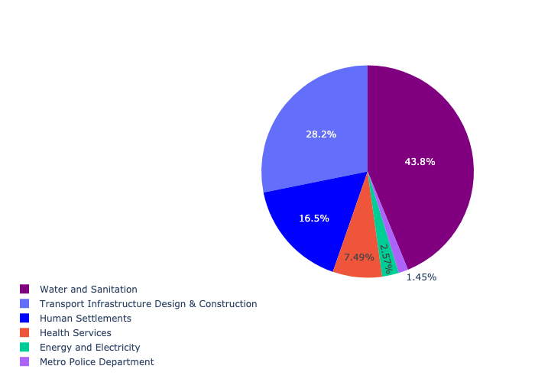

Table 5.37: Summary - Ward 37

|  |  |
| --- | --- |
| Item | Description |
| Total Capital Demand for Ward 37 - All Years | R863,998,630 Rank: 14 (1 = Highest) |
| Total Capital Demand for Ward 37 - MTREF | R863,998,630 Rank: 20 (1 = Highest) |
| Financial Years in which capital requirements are listed for Ward 37 | 2022, 2023, 2024, 2025, 2026, 2027, 2028, 2029 and 2030 |
| Financial Year with highest capital demand for Ward 37 | Capital 2027 |
| Ward 37 intersecting feature used | Works Location |
| Total number of projects intersecting with Ward 37 | 16 Rank: 29 (1 = Highest) |

## Ward 38

Figure 5.75: Ward 38 Funding Requests

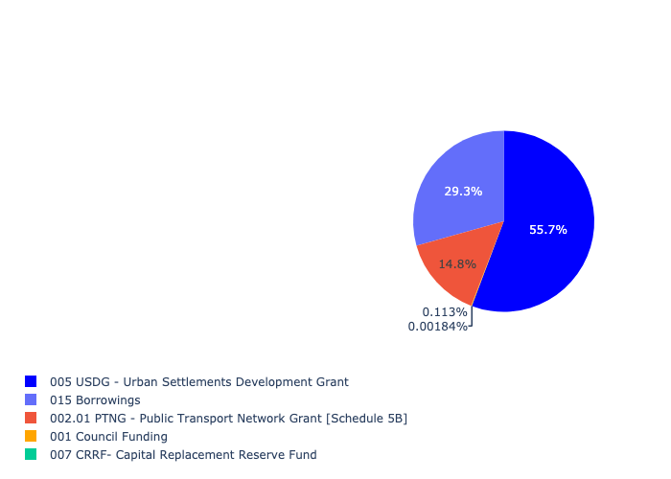

Figure 5.76: Ward 38 Departmental Requests

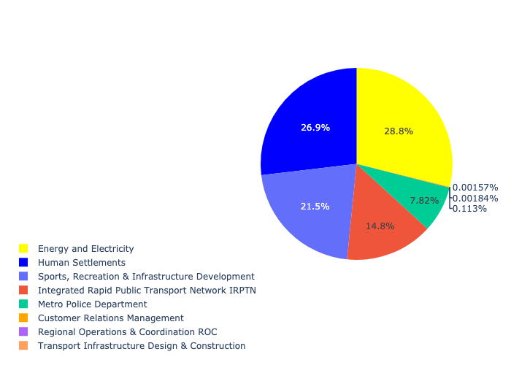

Table 5.38: Summary - Ward 38

|  |  |
| --- | --- |
| Item | Description |
| Total Capital Demand for Ward 38 - All Years | R254,716,852 Rank: 52 (1 = Highest) |
| Total Capital Demand for Ward 38 - MTREF | R254,716,852 Rank: 41 (1 = Highest) |
| Financial Years in which capital requirements are listed for Ward 38 | 2022, 2023, 2024, 2025, 2026 and 2027 |
| Financial Year with highest capital demand for Ward 38 | Capital 2023 |
| Ward 38 intersecting feature used | Works Location |
| Total number of projects intersecting with Ward 38 | 12 Rank: 45 (1 = Highest) |

## Ward 39

Figure 5.77: Ward 39 Funding Requests

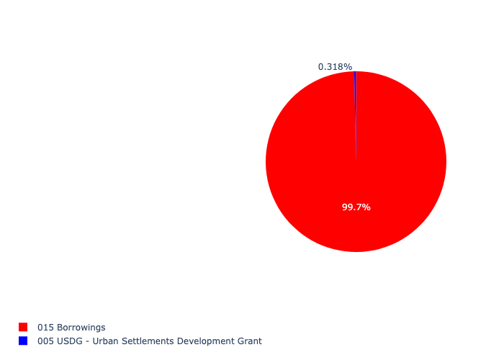

Figure 5.78: Ward 39 Departmental Requests

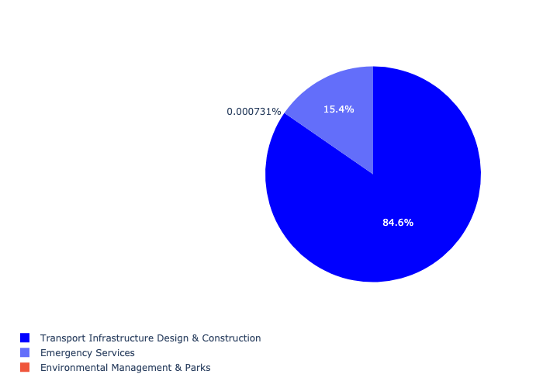

Table 5.39: Summary - Ward 39

|  |  |
| --- | --- |
| Item | Description |
| Total Capital Demand for Ward 39 - All Years | R392,892,667 Rank: 39 (1 = Highest) |
| Total Capital Demand for Ward 39 - MTREF | R392,892,667 Rank: 52 (1 = Highest) |
| Financial Years in which capital requirements are listed for Ward 39 | 2022, 2023, 2024, 2025, 2026, 2027, 2028, 2029 and 2030 |
| Financial Year with highest capital demand for Ward 39 | Capital 2024 |
| Ward 39 intersecting feature used | Works Location |
| Total number of projects intersecting with Ward 39 | 7 Rank: 77 (1 = Highest) |

## Ward 40

Figure 5.79: Ward 40 Funding Requests

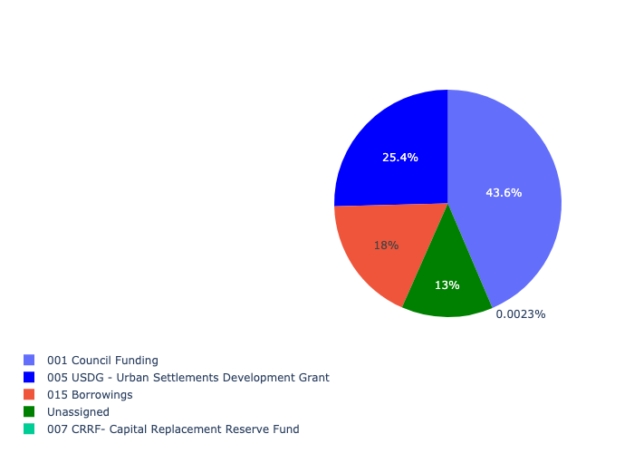

Figure 5.80: Ward 40 Departmental Requests

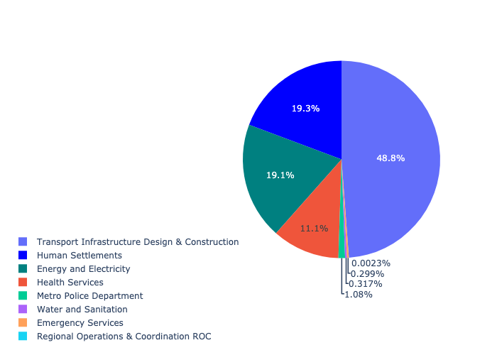

Table 5.40: Summary - Ward 40

|  |  |
| --- | --- |
| Item | Description |
| Total Capital Demand for Ward 40 - All Years | R334,827,978 Rank: 45 (1 = Highest) |
| Total Capital Demand for Ward 40 - MTREF | R334,827,978 Rank: 44 (1 = Highest) |
| Financial Years in which capital requirements are listed for Ward 40 | 2022, 2023, 2024, 2025, 2026, 2027, 2028, 2029 and 2030 |
| Financial Year with highest capital demand for Ward 40 | Capital 2025 |
| Ward 40 intersecting feature used | Works Location |
| Total number of projects intersecting with Ward 40 | 17 Rank: 22 (1 = Highest) |

## Ward 41

Figure 5.81: Ward 41 Funding Requests

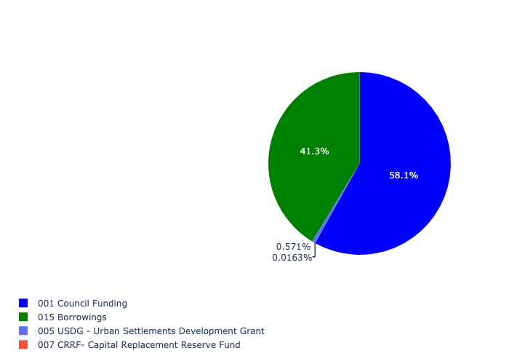

Figure 5.82: Ward 41 Departmental Requests

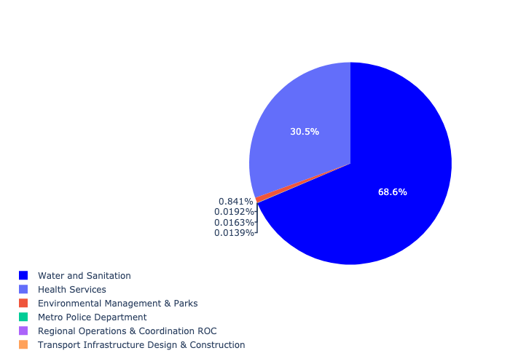

Table 5.41: Summary - Ward 41

|  |  |
| --- | --- |
| Item | Description |
| Total Capital Demand for Ward 41 - All Years | R137,646,632 Rank: 74 (1 = Highest) |
| Total Capital Demand for Ward 41 - MTREF | R137,646,632 Rank: 59 (1 = Highest) |
| Financial Years in which capital requirements are listed for Ward 41 | 2022, 2023, 2024, 2025, 2026 and 2027 |
| Financial Year with highest capital demand for Ward 41 | Capital 2023 |
| Ward 41 intersecting feature used | Works Location |
| Total number of projects intersecting with Ward 41 | 7 Rank: 77 (1 = Highest) |

## Ward 42

Figure 5.83: Ward 42 Funding Requests

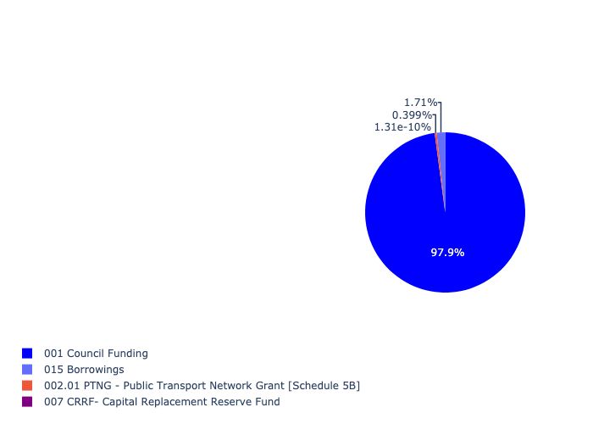

Figure 5.84: Ward 42 Departmental Requests

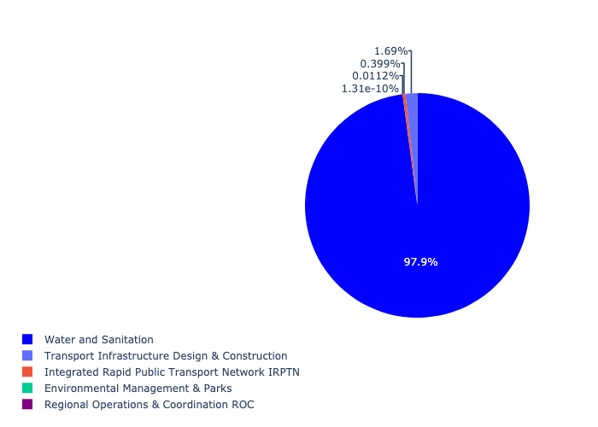

Table 5.42: Summary - Ward 42

|  |  |
| --- | --- |
| Item | Description |
| Total Capital Demand for Ward 42 - All Years | R103,171,662 Rank: 79 (1 = Highest) |
| Total Capital Demand for Ward 42 - MTREF | R103,171,662 Rank: 91 (1 = Highest) |
| Financial Years in which capital requirements are listed for Ward 42 | 2022, 2023, 2024, 2025, 2026, 2027, 2028 and 2029 |
| Financial Year with highest capital demand for Ward 42 | Capital 2026 |
| Ward 42 intersecting feature used | Works Location |
| Total number of projects intersecting with Ward 42 | 7 Rank: 77 (1 = Highest) |

## Ward 43

Figure 5.85: Ward 43 Funding Requests

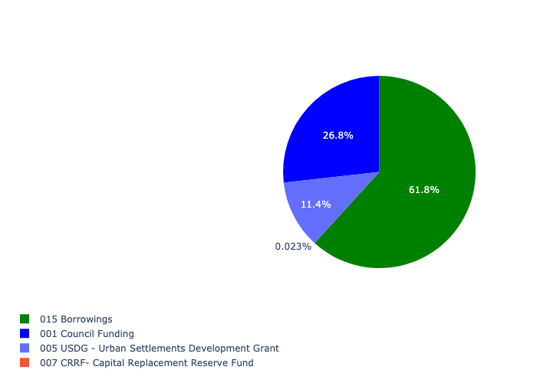

Figure 5.86: Ward 43 Departmental Requests

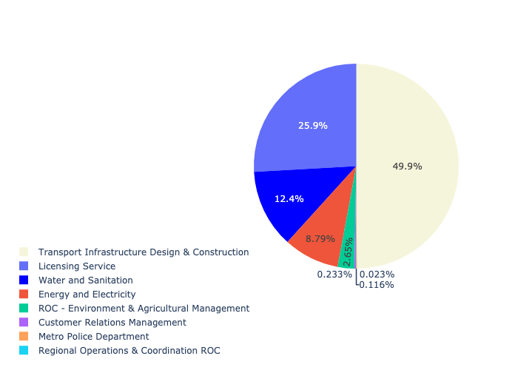

Table 5.43: Summary - Ward 43

|  |  |
| --- | --- |
| Item | Description |
| Total Capital Demand for Ward 43 - All Years | R118,998,103 Rank: 76 (1 = Highest) |
| Total Capital Demand for Ward 43 - MTREF | R118,998,103 Rank: 68 (1 = Highest) |
| Financial Years in which capital requirements are listed for Ward 43 | 2022, 2023, 2024, 2025, 2026, 2027, 2028, 2029, 2030 and 2031 |
| Financial Year with highest capital demand for Ward 43 | Capital 2024 |
| Ward 43 intersecting feature used | Works Location |
| Total number of projects intersecting with Ward 43 | 17 Rank: 22 (1 = Highest) |

## Ward 44

Figure 5.87: Ward 44 Funding Requests

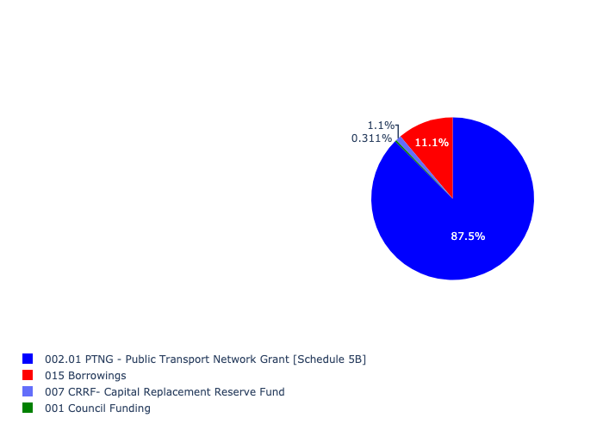

Figure 5.88: Ward 44 Departmental Requests

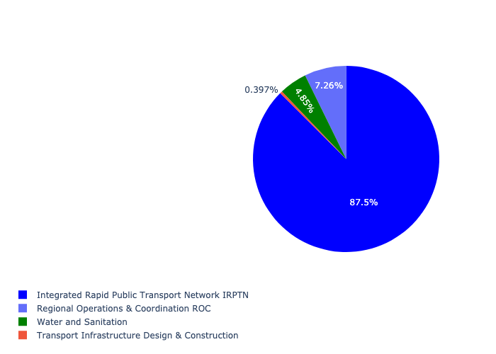

Table 5.44: Summary - Ward 44

|  |  |
| --- | --- |
| Item | Description |
| Total Capital Demand for Ward 44 - All Years | R81,103,417 Rank: 82 (1 = Highest) |
| Total Capital Demand for Ward 44 - MTREF | R81,103,417 Rank: 64 (1 = Highest) |
| Financial Years in which capital requirements are listed for Ward 44 | 2022, 2023, 2024, 2025, 2026 and 2027 |
| Financial Year with highest capital demand for Ward 44 | Capital 2023 |
| Ward 44 intersecting feature used | Works Location |
| Total number of projects intersecting with Ward 44 | 16 Rank: 29 (1 = Highest) |

## Ward 45

Figure 5.89: Ward 45 Funding Requests

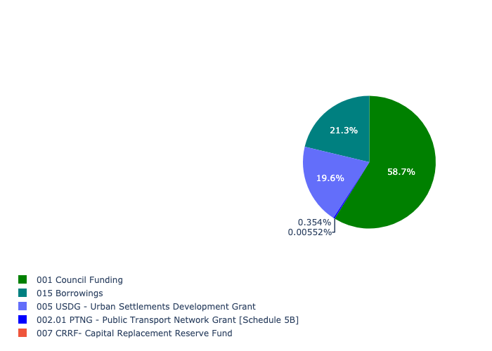

Figure 5.90: Ward 45 Departmental Requests

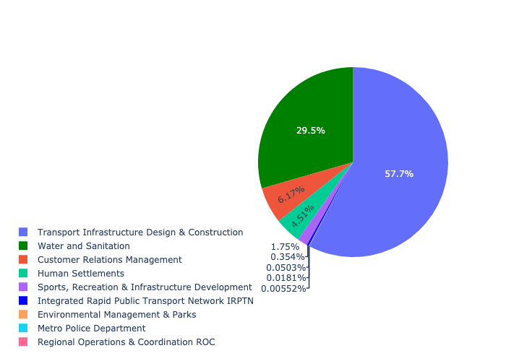

Table 5.45: Summary - Ward 45

|  |  |
| --- | --- |
| Item | Description |
| Total Capital Demand for Ward 45 - All Years | R426,086,253 Rank: 35 (1 = Highest) |
| Total Capital Demand for Ward 45 - MTREF | R426,086,253 Rank: 26 (1 = Highest) |
| Financial Years in which capital requirements are listed for Ward 45 | 2022, 2023, 2024, 2025, 2026, 2027, 2029, 2030 and 2031 |
| Financial Year with highest capital demand for Ward 45 | Capital 2023 |
| Ward 45 intersecting feature used | Works Location |
| Total number of projects intersecting with Ward 45 | 20 Rank: 14 (1 = Highest) |

## Ward 46

Figure 5.91: Ward 46 Funding Requests

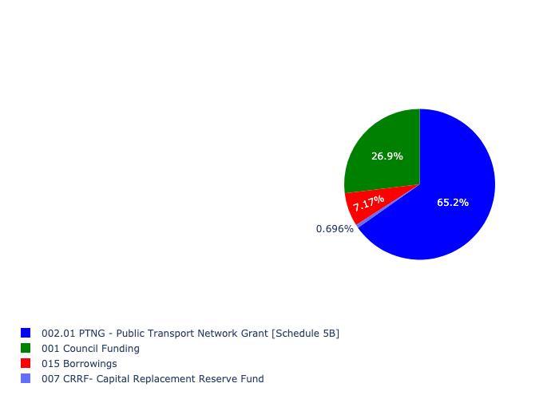

Figure 5.92: Ward 46 Departmental Requests

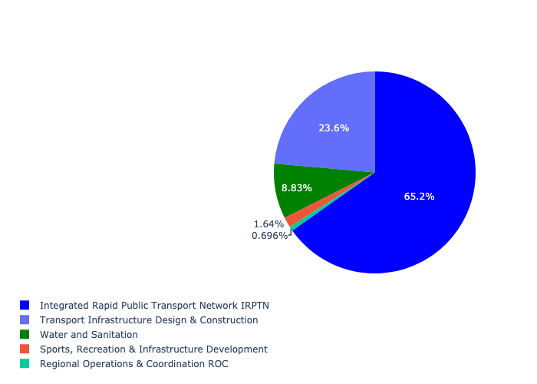

Table 5.46: Summary - Ward 46

|  |  |
| --- | --- |
| Item | Description |
| Total Capital Demand for Ward 46 - All Years | R412,848,107 Rank: 38 (1 = Highest) |
| Total Capital Demand for Ward 46 - MTREF | R412,848,107 Rank: 21 (1 = Highest) |
| Financial Years in which capital requirements are listed for Ward 46 | 2022, 2023, 2024, 2025, 2026, 2027, 2028, 2029, 2030 and 2031 |
| Financial Year with highest capital demand for Ward 46 | Capital 2023 |
| Ward 46 intersecting feature used | Works Location |
| Total number of projects intersecting with Ward 46 | 25 Rank: 10 (1 = Highest) |

## Ward 47

Figure 5.93: Ward 47 Funding Requests

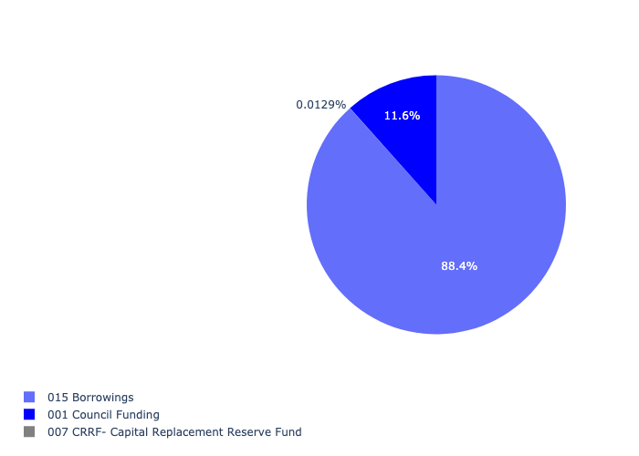

Figure 5.94: Ward 47 Departmental Requests

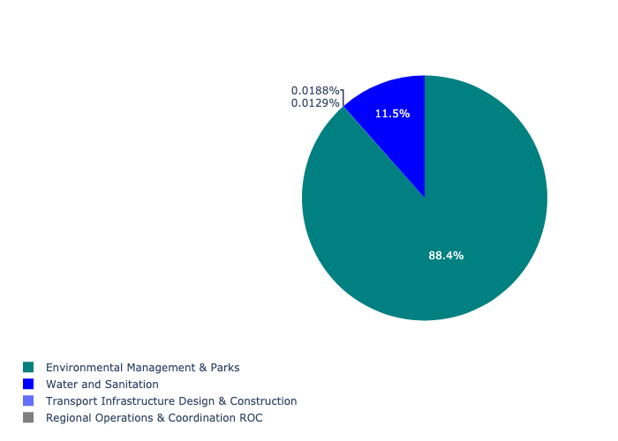

Table 5.47: Summary - Ward 47

|  |  |
| --- | --- |
| Item | Description |
| Total Capital Demand for Ward 47 - All Years | R169,131,919 Rank: 67 (1 = Highest) |
| Total Capital Demand for Ward 47 - MTREF | R169,131,919 Rank: 55 (1 = Highest) |
| Financial Years in which capital requirements are listed for Ward 47 | 2022, 2023, 2024, 2025, 2026, 2027 and 2028 |
| Financial Year with highest capital demand for Ward 47 | Capital 2025 |
| Ward 47 intersecting feature used | Works Location |
| Total number of projects intersecting with Ward 47 | 6 Rank: 88 (1 = Highest) |

## Ward 48

Figure 5.95: Ward 48 Funding Requests

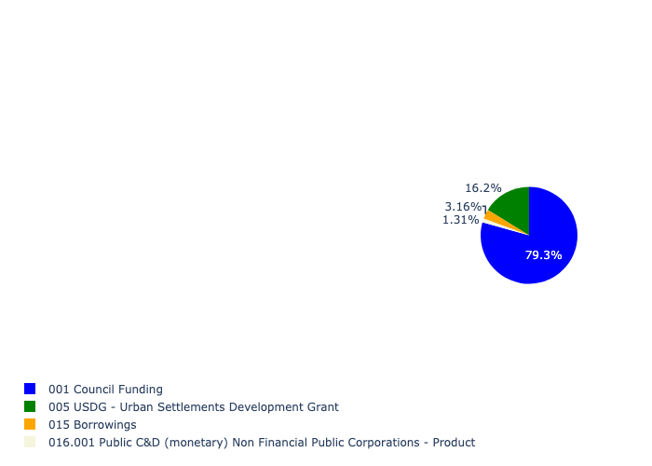

Figure 5.96: Ward 48 Departmental Requests

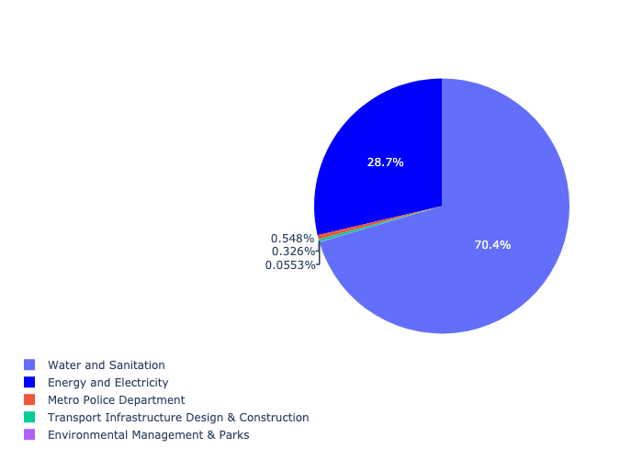

Table 5.48: Summary - Ward 48

|  |  |
| --- | --- |
| Item | Description |
| Total Capital Demand for Ward 48 - All Years | R1,416,145,669 Rank: 7 (1 = Highest) |
| Total Capital Demand for Ward 48 - MTREF | R1,416,145,669 Rank: 13 (1 = Highest) |
| Financial Years in which capital requirements are listed for Ward 48 | 2022, 2023, 2024, 2025, 2026, 2027, 2028, 2029 and 2030 |
| Financial Year with highest capital demand for Ward 48 | Capital 2026 |
| Ward 48 intersecting feature used | Works Location |
| Total number of projects intersecting with Ward 48 | 18 Rank: 19 (1 = Highest) |

## Ward 49

Figure 5.97: Ward 49 Funding Requests

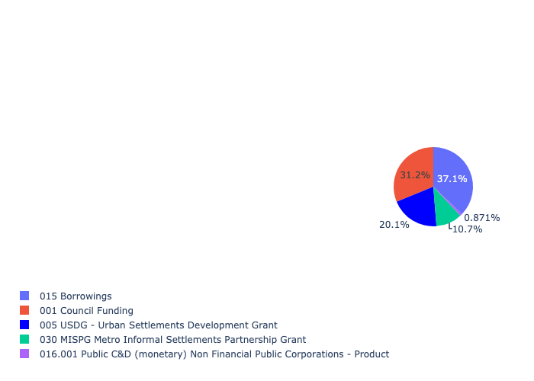

Figure 5.98: Ward 49 Departmental Requests

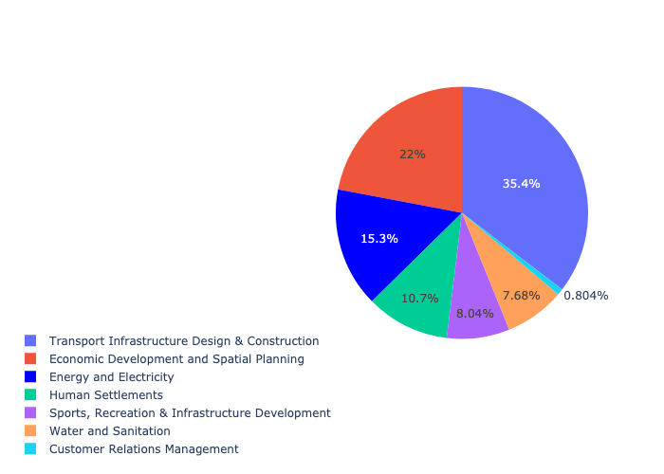

Table 5.49: Summary - Ward 49

|  |  |
| --- | --- |
| Item | Description |
| Total Capital Demand for Ward 49 - All Years | R739,630,179 Rank: 17 (1 = Highest) |
| Total Capital Demand for Ward 49 - MTREF | R739,630,179 Rank: 16 (1 = Highest) |
| Financial Years in which capital requirements are listed for Ward 49 | 2022, 2023, 2024, 2025, 2026, 2027, 2028, 2029 and 2030 |
| Financial Year with highest capital demand for Ward 49 | Capital 2022 |
| Ward 49 intersecting feature used | Works Location |
| Total number of projects intersecting with Ward 49 | 22 Rank: 11 (1 = Highest) |

## Ward 50

Figure 5.99: Ward 50 Funding Requests

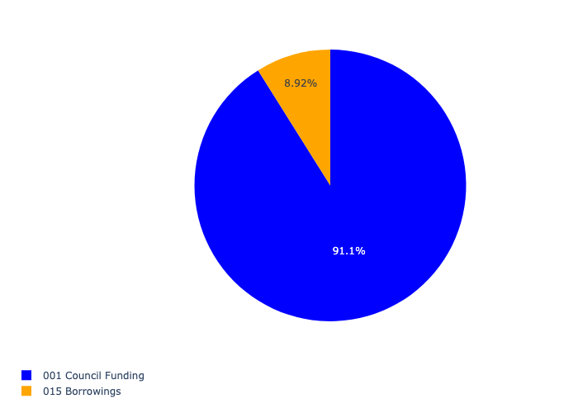

Figure 5.100: Ward 50 Departmental Requests

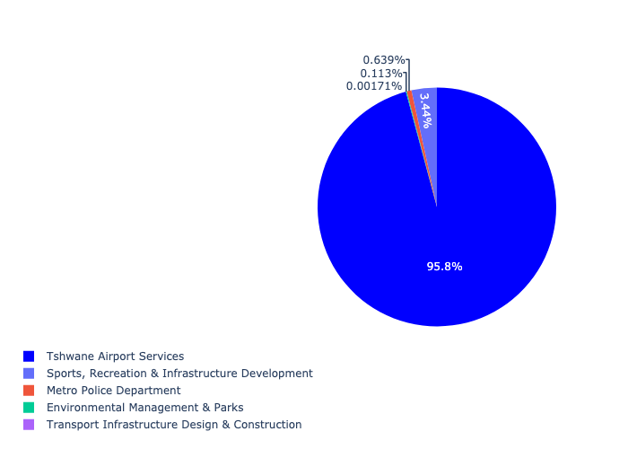

Table 5.50: Summary - Ward 50

|  |  |
| --- | --- |
| Item | Description |
| Total Capital Demand for Ward 50 - All Years | R1,735,247,626 Rank: 5 (1 = Highest) |
| Total Capital Demand for Ward 50 - MTREF | R1,735,247,626 Rank: 18 (1 = Highest) |
| Financial Years in which capital requirements are listed for Ward 50 | 2022, 2023, 2024, 2025, 2026, 2027, 2028, 2029, 2030 and 2031 |
| Financial Year with highest capital demand for Ward 50 | Capital 2028 |
| Ward 50 intersecting feature used | Works Location |
| Total number of projects intersecting with Ward 50 | 63 Rank: 2 (1 = Highest) |

## Ward 51

Figure 5.101: Ward 51 Funding Requests

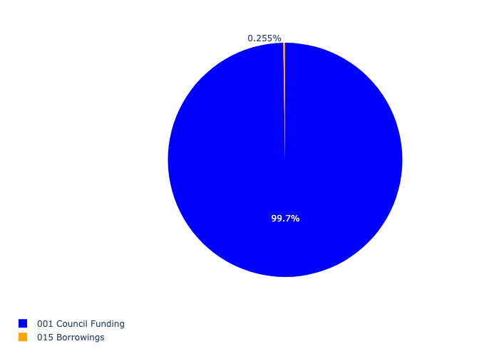

Figure 5.102: Ward 51 Departmental Requests

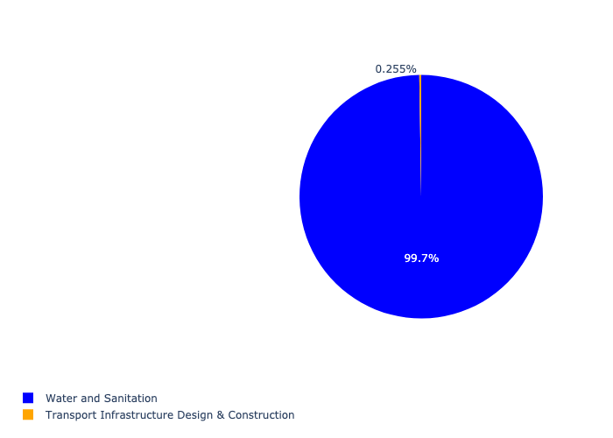

Table 5.51: Summary - Ward 51

|  |  |
| --- | --- |
| Item | Description |
| Total Capital Demand for Ward 51 - All Years | R2,454,682 Rank: 104 (1 = Highest) |
| Total Capital Demand for Ward 51 - MTREF | R2,454,682 Rank: 101 (1 = Highest) |
| Financial Years in which capital requirements are listed for Ward 51 | 2023, 2024, 2025 and 2027 |
| Financial Year with highest capital demand for Ward 51 | Capital 2024 |
| Ward 51 intersecting feature used | Works Location |
| Total number of projects intersecting with Ward 51 | 3 Rank: 102 (1 = Highest) |

## Ward 52

Figure 5.103: Ward 52 Funding Requests

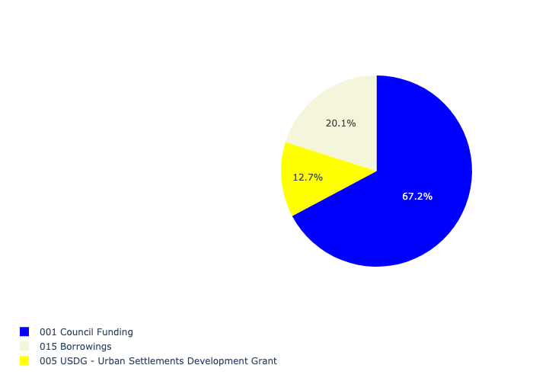

Figure 5.104: Ward 52 Departmental Requests

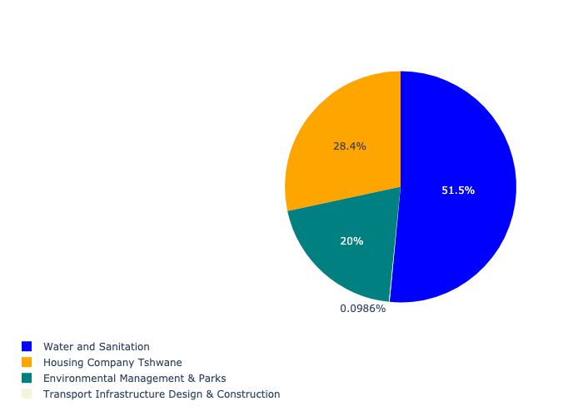

Table 5.52: Summary - Ward 52

|  |  |
| --- | --- |
| Item | Description |
| Total Capital Demand for Ward 52 - All Years | R18,649,906 Rank: 100 (1 = Highest) |
| Total Capital Demand for Ward 52 - MTREF | R18,649,906 Rank: 94 (1 = Highest) |
| Financial Years in which capital requirements are listed for Ward 52 | 2023, 2024, 2025, 2026, 2027, 2028, 2029, 2030 and 2031 |
| Financial Year with highest capital demand for Ward 52 | Capital 2024 |
| Ward 52 intersecting feature used | Works Location |
| Total number of projects intersecting with Ward 52 | 9 Rank: 61 (1 = Highest) |

## Ward 53

Figure 5.105: Ward 53 Funding Requests

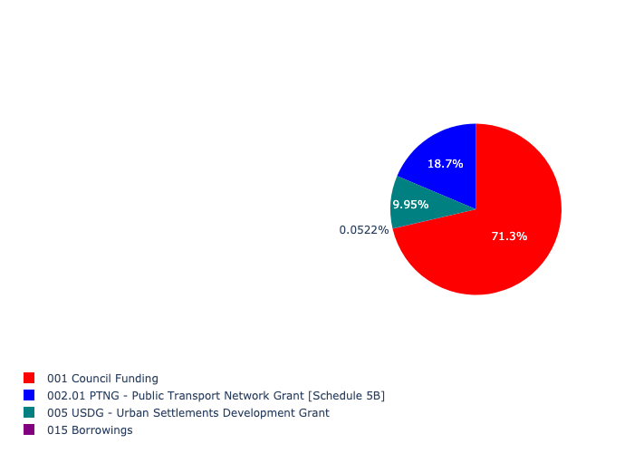

Figure 5.106: Ward 53 Departmental Requests

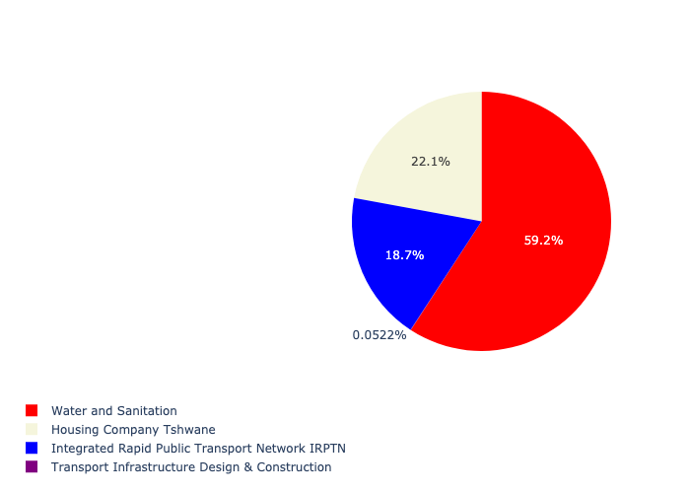

Table 5.53: Summary - Ward 53

|  |  |
| --- | --- |
| Item | Description |
| Total Capital Demand for Ward 53 - All Years | R51,737,035 Rank: 95 (1 = Highest) |
| Total Capital Demand for Ward 53 - MTREF | R51,737,035 Rank: 78 (1 = Highest) |
| Financial Years in which capital requirements are listed for Ward 53 | 2022, 2023, 2024, 2026 and 2027 |
| Financial Year with highest capital demand for Ward 53 | Capital 2024 |
| Ward 53 intersecting feature used | Works Location |
| Total number of projects intersecting with Ward 53 | 10 Rank: 55 (1 = Highest) |

## Ward 54

Figure 5.107: Ward 54 Funding Requests

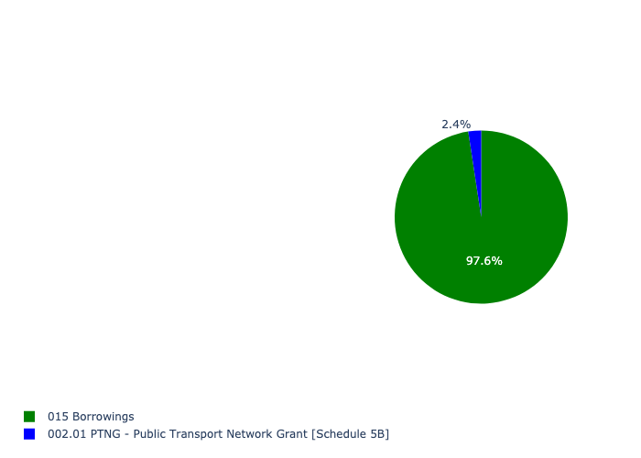

Figure 5.108: Ward 54 Departmental Requests

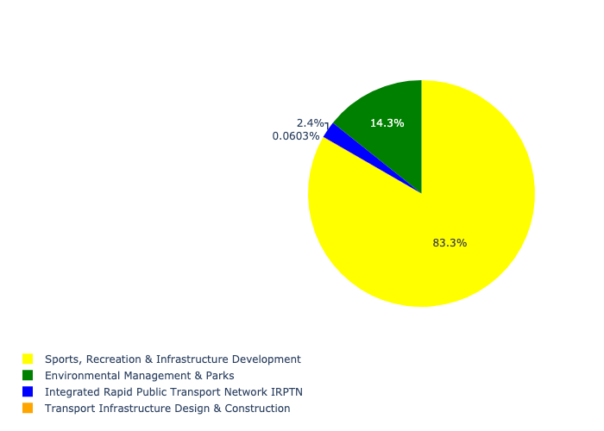

Table 5.54: Summary - Ward 54

|  |  |
| --- | --- |
| Item | Description |
| Total Capital Demand for Ward 54 - All Years | R42,035,567 Rank: 97 (1 = Highest) |
| Total Capital Demand for Ward 54 - MTREF | R42,035,567 Rank: 99 (1 = Highest) |
| Financial Years in which capital requirements are listed for Ward 54 | 2022, 2023, 2025, 2026, 2027, 2028, 2029, 2030 and 2031 |
| Financial Year with highest capital demand for Ward 54 | Capital 2026 |
| Ward 54 intersecting feature used | Works Location |
| Total number of projects intersecting with Ward 54 | 7 Rank: 77 (1 = Highest) |

## Ward 55

Figure 5.109: Ward 55 Funding Requests

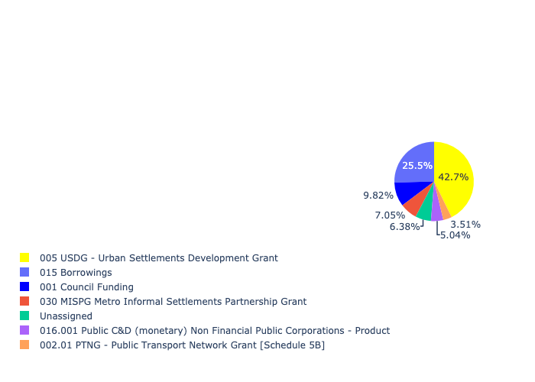

Figure 5.110: Ward 55 Departmental Requests

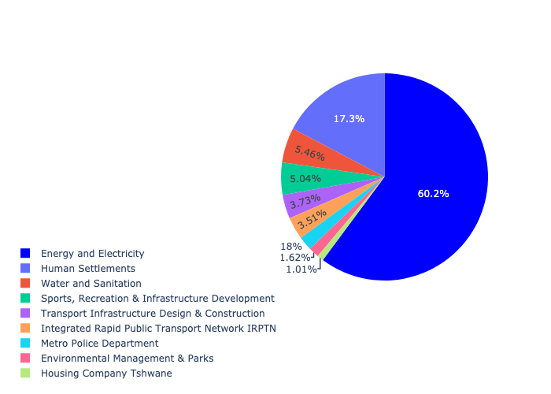

Table 5.55: Summary - Ward 55

|  |  |
| --- | --- |
| Item | Description |
| Total Capital Demand for Ward 55 - All Years | R531,480,285 Rank: 27 (1 = Highest) |
| Total Capital Demand for Ward 55 - MTREF | R531,480,285 Rank: 29 (1 = Highest) |
| Financial Years in which capital requirements are listed for Ward 55 | 2022, 2023, 2024, 2025, 2026, 2027, 2028, 2029, 2030 and 2031 |
| Financial Year with highest capital demand for Ward 55 | Capital 2022 |
| Ward 55 intersecting feature used | Works Location |
| Total number of projects intersecting with Ward 55 | 28 Rank: 7 (1 = Highest) |

## Ward 56

Figure 5.111: Ward 56 Funding Requests

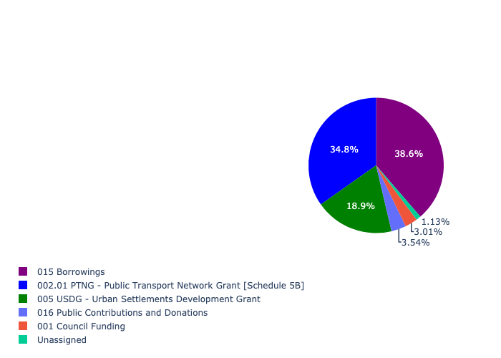

Figure 5.112: Ward 56 Departmental Requests

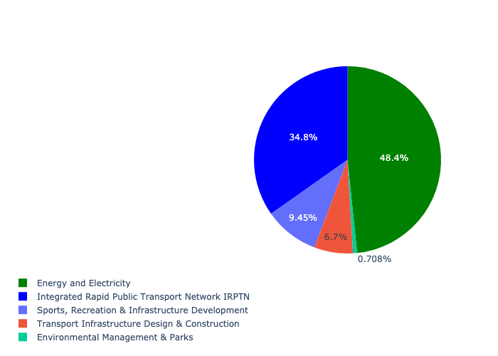

Table 5.56: Summary - Ward 56

|  |  |
| --- | --- |
| Item | Description |
| Total Capital Demand for Ward 56 - All Years | R363,494,736 Rank: 43 (1 = Highest) |
| Total Capital Demand for Ward 56 - MTREF | R363,494,736 Rank: 38 (1 = Highest) |
| Financial Years in which capital requirements are listed for Ward 56 | 2022, 2023, 2024, 2025, 2026, 2027, 2028, 2029, 2030 and 2031 |
| Financial Year with highest capital demand for Ward 56 | Capital 2023 |
| Ward 56 intersecting feature used | Works Location |
| Total number of projects intersecting with Ward 56 | 14 Rank: 36 (1 = Highest) |

## Ward 57

Figure 5.113: Ward 57 Funding Requests

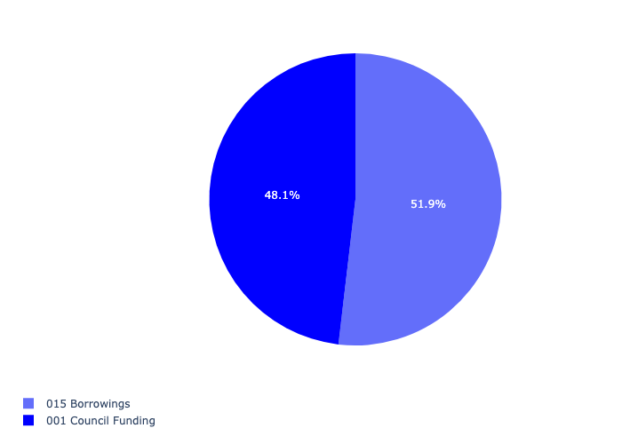

Figure 5.114: Ward 57 Departmental Requests

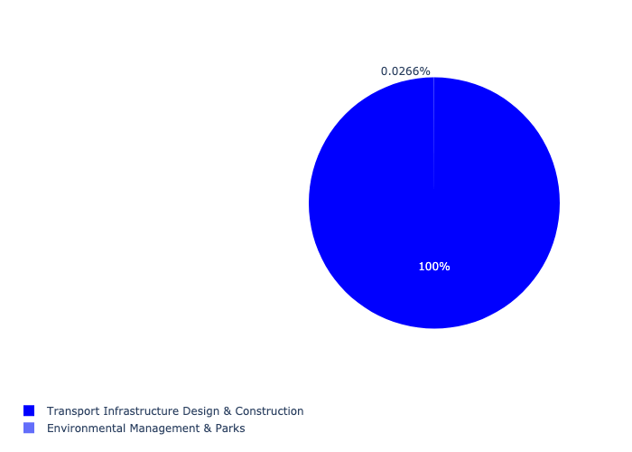

Table 5.57: Summary - Ward 57

|  |  |
| --- | --- |
| Item | Description |
| Total Capital Demand for Ward 57 - All Years | R37,101,852 Rank: 98 (1 = Highest) |
| Total Capital Demand for Ward 57 - MTREF | R37,101,852 Rank: 100 (1 = Highest) |
| Financial Years in which capital requirements are listed for Ward 57 | 2022, 2023, 2024, 2025, 2026, 2027, 2028, 2029 and 2030 |
| Financial Year with highest capital demand for Ward 57 | Capital 2027 |
| Ward 57 intersecting feature used | Works Location |
| Total number of projects intersecting with Ward 57 | 8 Rank: 67 (1 = Highest) |

## Ward 58

Figure 5.115: Ward 58 Funding Requests

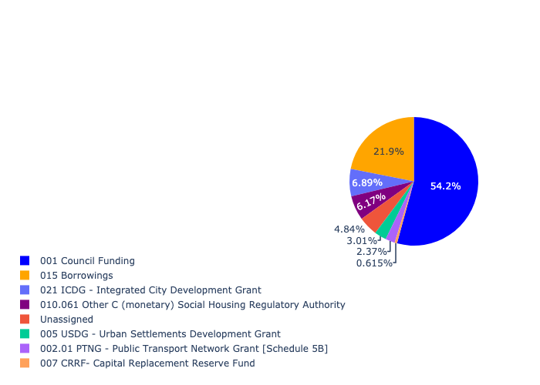

Figure 5.116: Ward 58 Departmental Requests

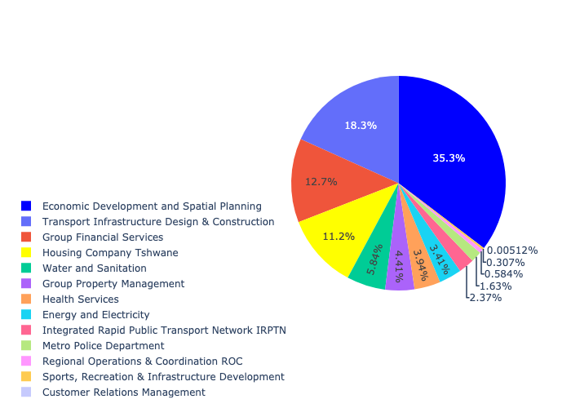

Table 5.58: Summary - Ward 58

|  |  |
| --- | --- |
| Item | Description |
| Total Capital Demand for Ward 58 - All Years | R3,018,470,988 Rank: 2 (1 = Highest) |
| Total Capital Demand for Ward 58 - MTREF | R3,018,470,988 Rank: 1 (1 = Highest) |
| Financial Years in which capital requirements are listed for Ward 58 | 2022, 2023, 2024, 2025, 2026, 2027, 2028, 2029, 2030, 2031 and 2032 |
| Financial Year with highest capital demand for Ward 58 | Capital 2024 |
| Ward 58 intersecting feature used | Works Location |
| Total number of projects intersecting with Ward 58 | 85 Rank: 1 (1 = Highest) |

## Ward 59

Figure 5.117: Ward 59 Funding Requests

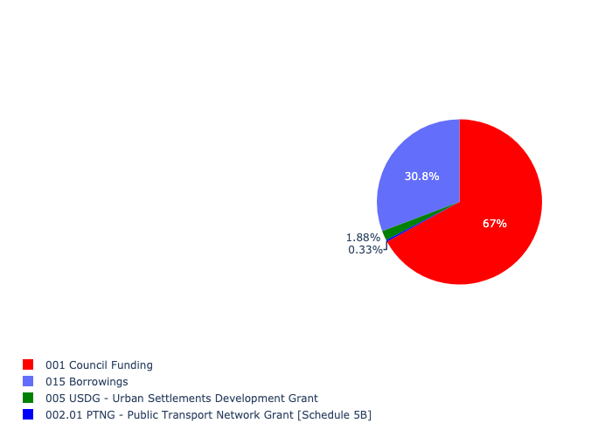

Figure 5.118: Ward 59 Departmental Requests

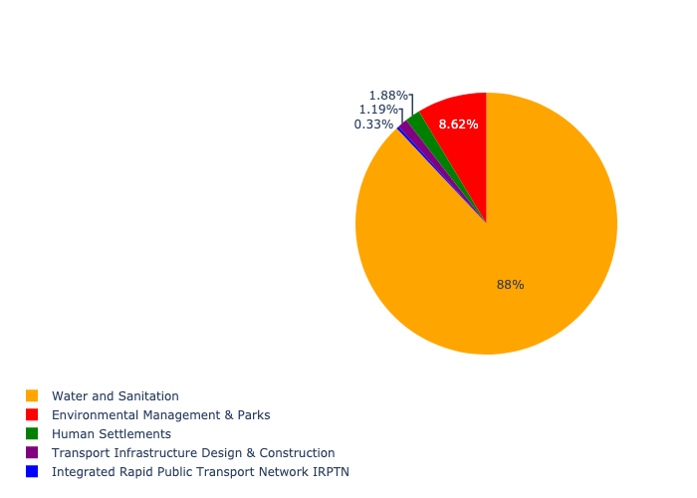

Table 5.59: Summary - Ward 59

|  |  |
| --- | --- |
| Item | Description |
| Total Capital Demand for Ward 59 - All Years | R188,008,835 Rank: 64 (1 = Highest) |
| Total Capital Demand for Ward 59 - MTREF | R188,008,835 Rank: 81 (1 = Highest) |
| Financial Years in which capital requirements are listed for Ward 59 | 2022, 2023, 2024, 2025, 2026, 2027, 2028, 2029 and 2030 |
| Financial Year with highest capital demand for Ward 59 | Capital 2026 |
| Ward 59 intersecting feature used | Works Location |
| Total number of projects intersecting with Ward 59 | 16 Rank: 29 (1 = Highest) |

## Ward 60

Figure 5.119: Ward 60 Funding Requests

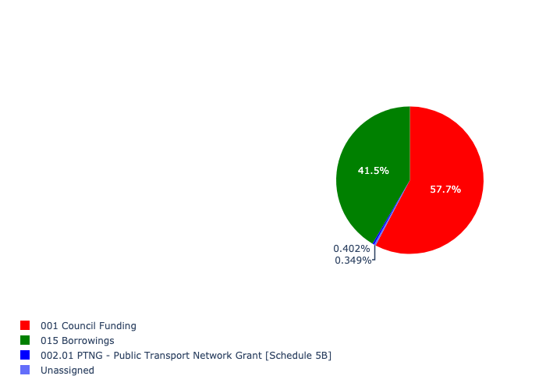

Figure 5.120: Ward 60 Departmental Requests

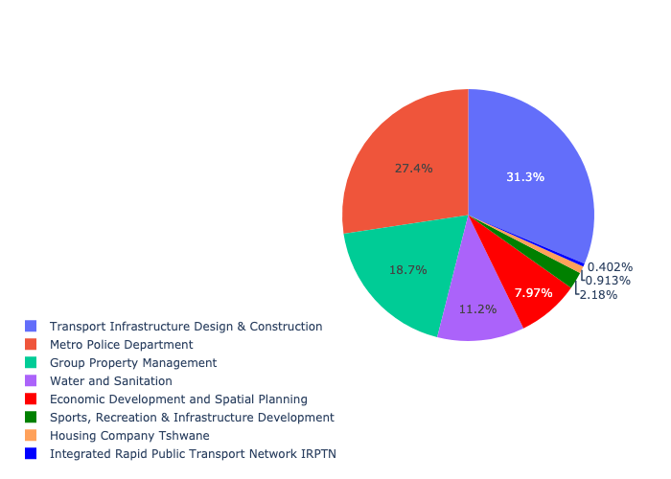

Table 5.60: Summary - Ward 60

|  |  |
| --- | --- |
| Item | Description |
| Total Capital Demand for Ward 60 - All Years | R1,144,542,665 Rank: 10 (1 = Highest) |
| Total Capital Demand for Ward 60 - MTREF | R1,144,542,665 Rank: 5 (1 = Highest) |
| Financial Years in which capital requirements are listed for Ward 60 | 2022, 2023, 2024, 2025, 2026, 2027, 2028, 2029, 2030, 2031 and 2032 |
| Financial Year with highest capital demand for Ward 60 | Capital 2024 |
| Ward 60 intersecting feature used | Works Location |
| Total number of projects intersecting with Ward 60 | 27 Rank: 8 (1 = Highest) |

## Ward 61

Figure 5.121: Ward 61 Funding Requests

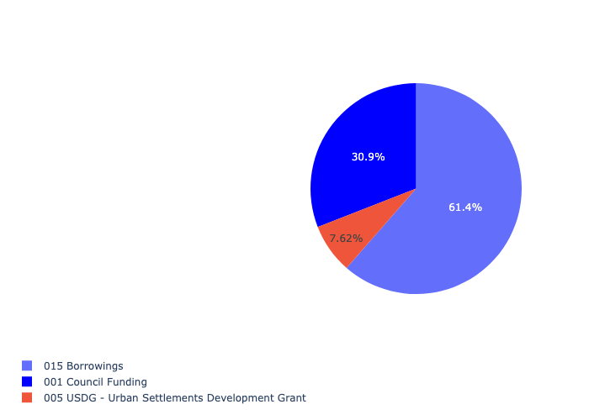

Figure 5.122: Ward 61 Departmental Requests

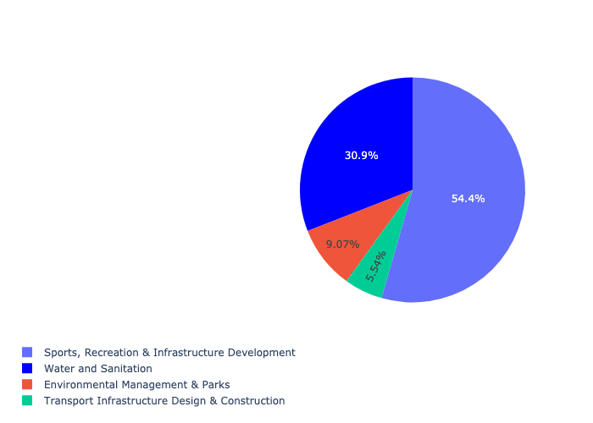

Table 5.61: Summary - Ward 61

|  |  |
| --- | --- |
| Item | Description |
| Total Capital Demand for Ward 61 - All Years | R55,103,340 Rank: 93 (1 = Highest) |
| Total Capital Demand for Ward 61 - MTREF | R55,103,340 Rank: 90 (1 = Highest) |
| Financial Years in which capital requirements are listed for Ward 61 | 2022, 2023, 2024, 2025, 2026, 2027 and 2028 |
| Financial Year with highest capital demand for Ward 61 | Capital 2028 |
| Ward 61 intersecting feature used | Works Location |
| Total number of projects intersecting with Ward 61 | 11 Rank: 50 (1 = Highest) |

## Ward 62

Figure 5.123: Ward 62 Funding Requests

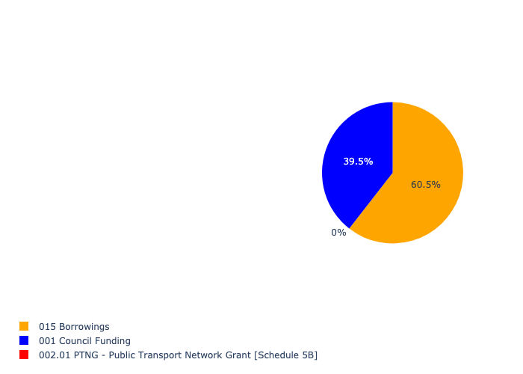

Figure 5.124: Ward 62 Departmental Requests

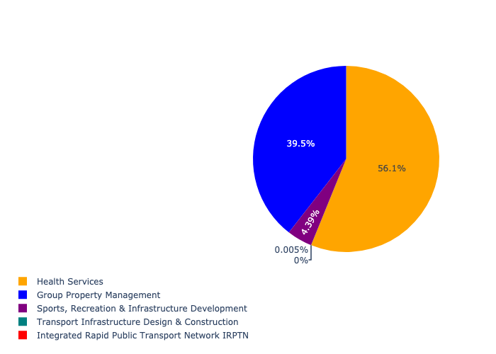

Table 5.62: Summary - Ward 62

|  |  |
| --- | --- |
| Item | Description |
| Total Capital Demand for Ward 62 - All Years | R114,005,698 Rank: 77 (1 = Highest) |
| Total Capital Demand for Ward 62 - MTREF | R114,005,698 Rank: 77 (1 = Highest) |
| Financial Years in which capital requirements are listed for Ward 62 | 2022, 2023, 2027, 2028, 2029 and 2030 |
| Financial Year with highest capital demand for Ward 62 | Capital 2029 |
| Ward 62 intersecting feature used | Works Location |
| Total number of projects intersecting with Ward 62 | 8 Rank: 67 (1 = Highest) |

## Ward 63

Figure 5.125: Ward 63 Funding Requests

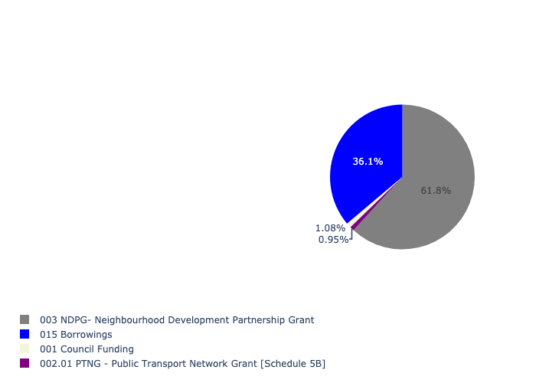

Figure 5.126: Ward 63 Departmental Requests

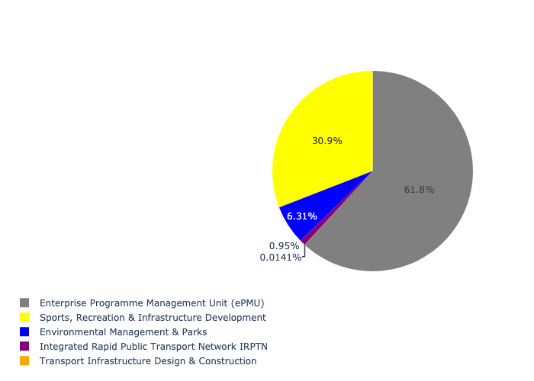

Table 5.63: Summary - Ward 63

|  |  |
| --- | --- |
| Item | Description |
| Total Capital Demand for Ward 63 - All Years | R32,352,853 Rank: 99 (1 = Highest) |
| Total Capital Demand for Ward 63 - MTREF | R32,352,853 Rank: 87 (1 = Highest) |
| Financial Years in which capital requirements are listed for Ward 63 | 2022, 2023, 2024, 2027 and 2028 |
| Financial Year with highest capital demand for Ward 63 | Capital 2022 |
| Ward 63 intersecting feature used | Works Location |
| Total number of projects intersecting with Ward 63 | 13 Rank: 39 (1 = Highest) |

## Ward 64

Figure 5.127: Ward 64 Funding Requests



Figure 5.128: Ward 64 Departmental Requests

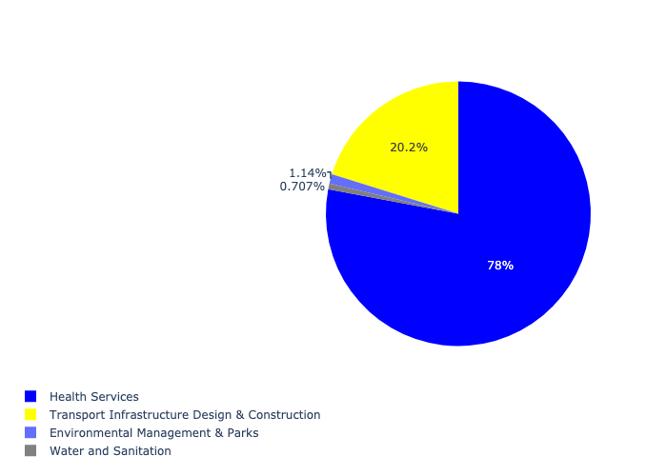

Table 5.64: Summary - Ward 64

|  |  |
| --- | --- |
| Item | Description |
| Total Capital Demand for Ward 64 - All Years | R52,929,371 Rank: 94 (1 = Highest) |
| Total Capital Demand for Ward 64 - MTREF | R52,929,371 Rank: 88 (1 = Highest) |
| Financial Years in which capital requirements are listed for Ward 64 | 2022, 2023, 2024, 2025, 2026 and 2027 |
| Financial Year with highest capital demand for Ward 64 | Capital 2025 |
| Ward 64 intersecting feature used | Works Location |
| Total number of projects intersecting with Ward 64 | 5 Rank: 94 (1 = Highest) |

## Ward 65

Figure 5.129: Ward 65 Funding Requests

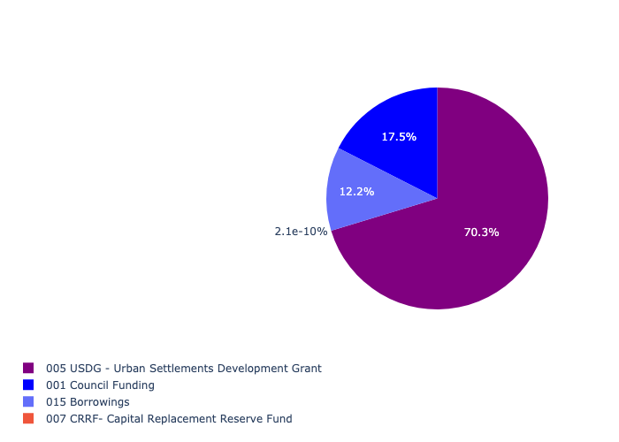

Figure 5.130: Ward 65 Departmental Requests

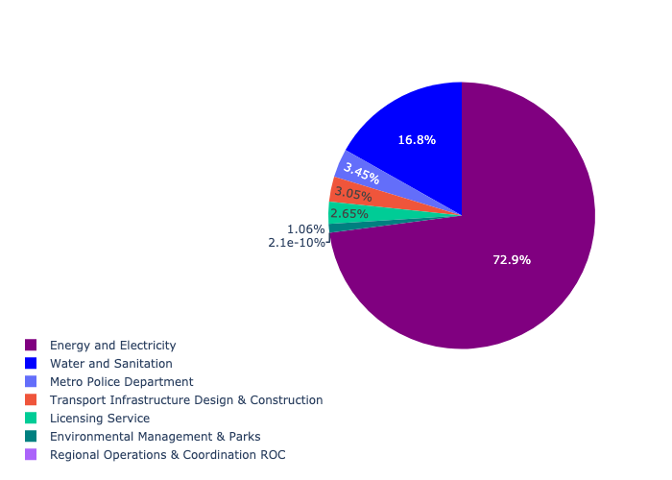

Table 5.65: Summary - Ward 65

|  |  |
| --- | --- |
| Item | Description |
| Total Capital Demand for Ward 65 - All Years | R286,986,039 Rank: 49 (1 = Highest) |
| Total Capital Demand for Ward 65 - MTREF | R286,986,039 Rank: 40 (1 = Highest) |
| Financial Years in which capital requirements are listed for Ward 65 | 2022, 2023, 2024, 2025, 2026 and 2027 |
| Financial Year with highest capital demand for Ward 65 | Capital 2024 |
| Ward 65 intersecting feature used | Works Location |
| Total number of projects intersecting with Ward 65 | 17 Rank: 22 (1 = Highest) |

## Ward 66

Figure 5.131: Ward 66 Funding Requests



Figure 5.132: Ward 66 Departmental Requests

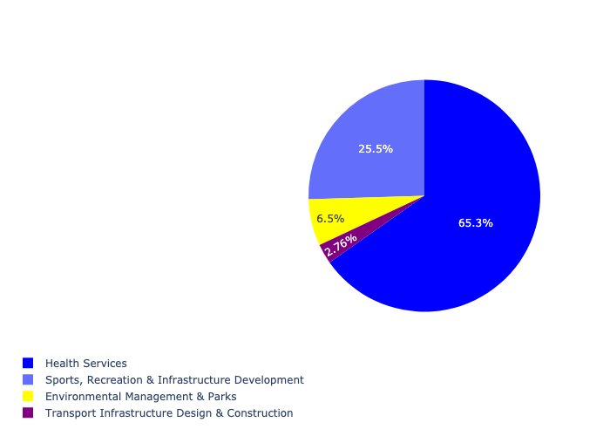

Table 5.66: Summary - Ward 66

|  |  |
| --- | --- |
| Item | Description |
| Total Capital Demand for Ward 66 - All Years | R68,081,767 Rank: 87 (1 = Highest) |
| Total Capital Demand for Ward 66 - MTREF | R68,081,767 Rank: 92 (1 = Highest) |
| Financial Years in which capital requirements are listed for Ward 66 | 2022, 2023, 2024, 2025, 2026, 2027, 2028 and 2029 |
| Financial Year with highest capital demand for Ward 66 | Capital 2025 |
| Ward 66 intersecting feature used | Works Location |
| Total number of projects intersecting with Ward 66 | 8 Rank: 67 (1 = Highest) |

## Ward 67

Figure 5.133: Ward 67 Funding Requests

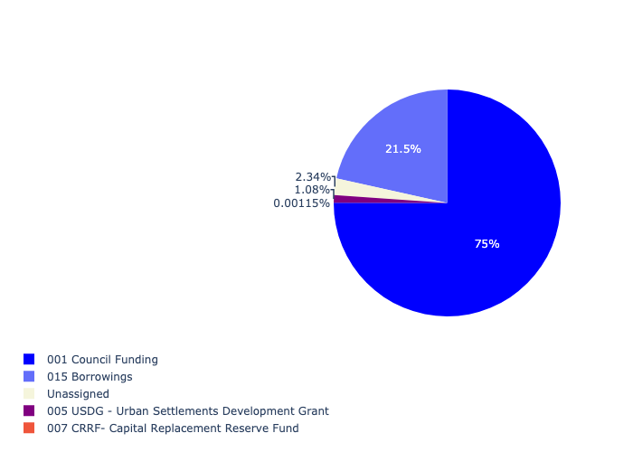

Figure 5.134: Ward 67 Departmental Requests

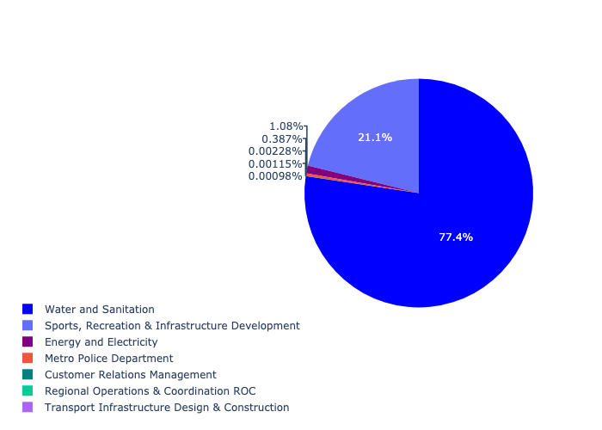

Table 5.67: Summary - Ward 67

|  |  |
| --- | --- |
| Item | Description |
| Total Capital Demand for Ward 67 - All Years | R847,663,669 Rank: 15 (1 = Highest) |
| Total Capital Demand for Ward 67 - MTREF | R847,663,669 Rank: 85 (1 = Highest) |
| Financial Years in which capital requirements are listed for Ward 67 | 2022, 2023, 2024, 2025, 2026, 2027, 2028 and 2029 |
| Financial Year with highest capital demand for Ward 67 | Capital 2027 |
| Ward 67 intersecting feature used | Works Location |
| Total number of projects intersecting with Ward 67 | 7 Rank: 77 (1 = Highest) |

## Ward 68

Figure 5.135: Ward 68 Funding Requests

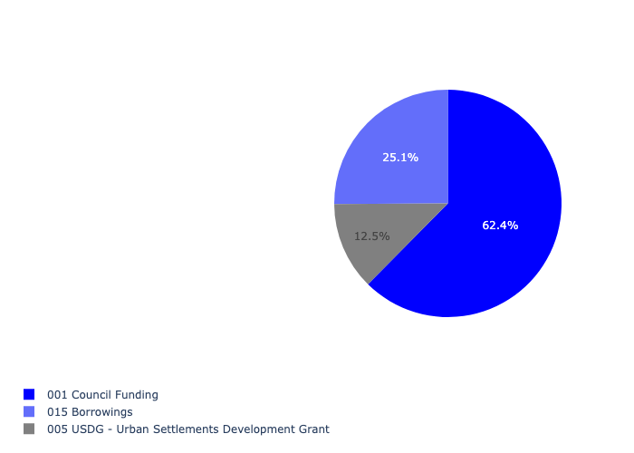

Figure 5.136: Ward 68 Departmental Requests

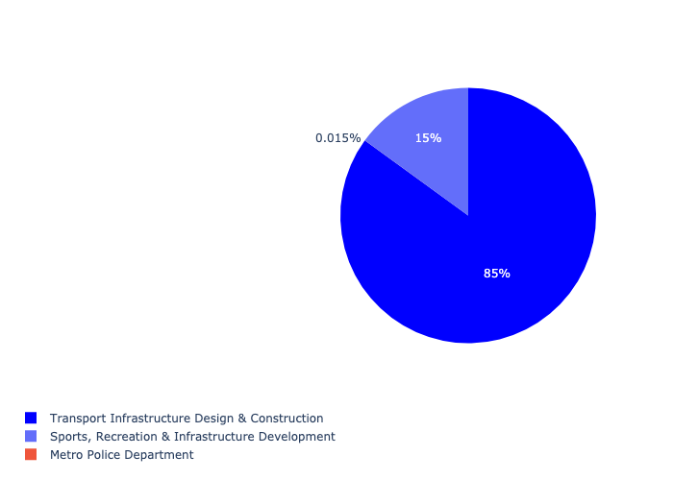

Table 5.68: Summary - Ward 68

|  |  |
| --- | --- |
| Item | Description |
| Total Capital Demand for Ward 68 - All Years | R199,944,334 Rank: 62 (1 = Highest) |
| Total Capital Demand for Ward 68 - MTREF | R199,944,334 Rank: 73 (1 = Highest) |
| Financial Years in which capital requirements are listed for Ward 68 | 2022, 2023, 2024, 2025, 2026, 2027, 2028, 2029, 2030 and 2031 |
| Financial Year with highest capital demand for Ward 68 | Capital 2027 |
| Ward 68 intersecting feature used | Works Location |
| Total number of projects intersecting with Ward 68 | 7 Rank: 77 (1 = Highest) |

## Ward 69

Figure 5.137: Ward 69 Funding Requests

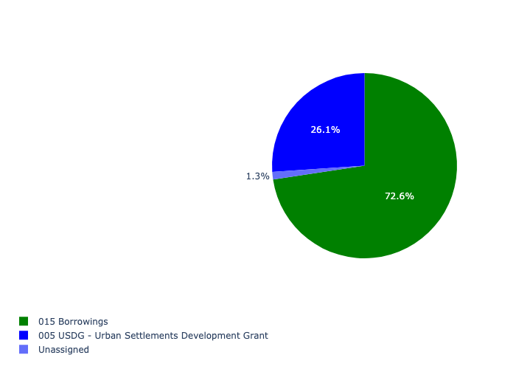

Figure 5.138: Ward 69 Departmental Requests

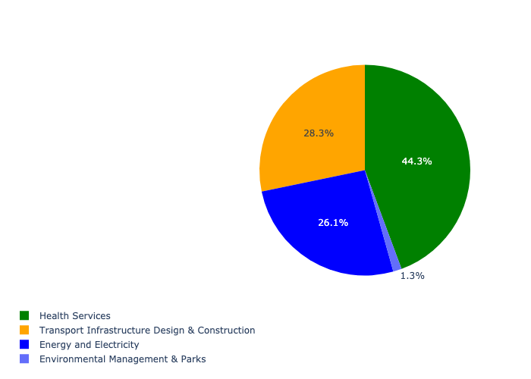

Table 5.69: Summary - Ward 69

|  |  |
| --- | --- |
| Item | Description |
| Total Capital Demand for Ward 69 - All Years | R76,672,923 Rank: 85 (1 = Highest) |
| Total Capital Demand for Ward 69 - MTREF | R76,672,923 Rank: 82 (1 = Highest) |
| Financial Years in which capital requirements are listed for Ward 69 | 2022, 2023, 2024, 2026, 2027 and 2028 |
| Financial Year with highest capital demand for Ward 69 | Capital 2022 |
| Ward 69 intersecting feature used | Works Location |
| Total number of projects intersecting with Ward 69 | 8 Rank: 67 (1 = Highest) |

## Ward 70

Figure 5.139: Ward 70 Funding Requests

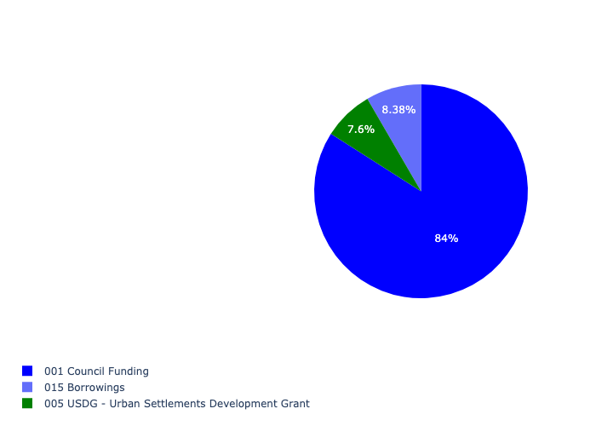

Figure 5.140: Ward 70 Departmental Requests

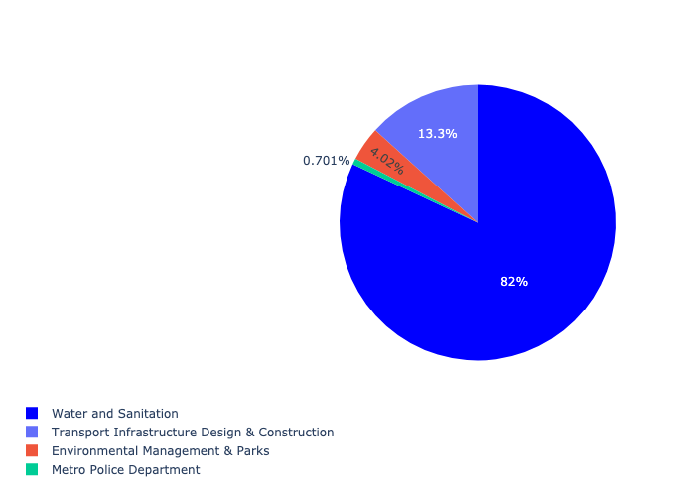

Table 5.70: Summary - Ward 70

|  |  |
| --- | --- |
| Item | Description |
| Total Capital Demand for Ward 70 - All Years | R703,961,947 Rank: 19 (1 = Highest) |
| Total Capital Demand for Ward 70 - MTREF | R703,961,947 Rank: 9 (1 = Highest) |
| Financial Years in which capital requirements are listed for Ward 70 | 2022, 2023, 2024, 2025, 2026, 2027, 2028, 2029 and 2030 |
| Financial Year with highest capital demand for Ward 70 | Capital 2023 |
| Ward 70 intersecting feature used | Works Location |
| Total number of projects intersecting with Ward 70 | 12 Rank: 45 (1 = Highest) |

## Ward 71

Figure 5.141: Ward 71 Funding Requests

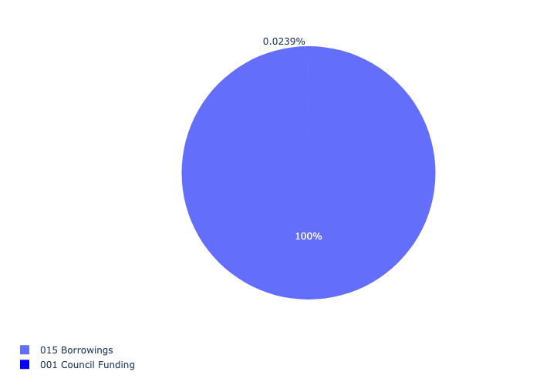

Figure 5.142: Ward 71 Departmental Requests

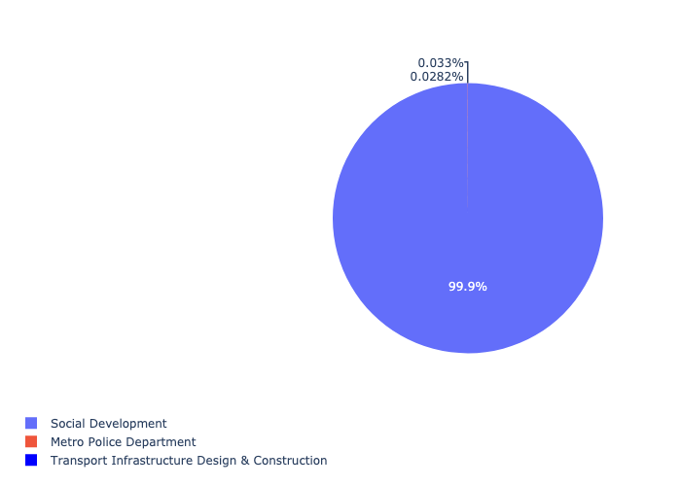

Table 5.71: Summary - Ward 71

|  |  |
| --- | --- |
| Item | Description |
| Total Capital Demand for Ward 71 - All Years | R80,024,579 Rank: 84 (1 = Highest) |
| Total Capital Demand for Ward 71 - MTREF | R80,024,579 Rank: 103 (1 = Highest) |
| Financial Years in which capital requirements are listed for Ward 71 | 2022, 2023, 2024, 2025, 2026, 2027, 2028, 2029 and 2030 |
| Financial Year with highest capital demand for Ward 71 | Capital 2027 |
| Ward 71 intersecting feature used | Works Location |
| Total number of projects intersecting with Ward 71 | 4 Rank: 98 (1 = Highest) |

## Ward 72

Figure 5.143: Ward 72 Funding Requests



Figure 5.144: Ward 72 Departmental Requests



Table 5.72: Summary - Ward 72

|  |  |
| --- | --- |
| Item | Description |
| Total Capital Demand for Ward 72 - All Years | R3,826 Rank: 107 (1 = Highest) |
| Total Capital Demand for Ward 72 - MTREF | R3,826 Rank: 105 (1 = Highest) |
| Financial Years in which capital requirements are listed for Ward 72 | 2027 |
| Financial Year with highest capital demand for Ward 72 | Capital 2027 |
| Ward 72 intersecting feature used | Works Location |
| Total number of projects intersecting with Ward 72 | 1 Rank: 107 (1 = Highest) |

## Ward 73

Figure 5.145: Ward 73 Funding Requests

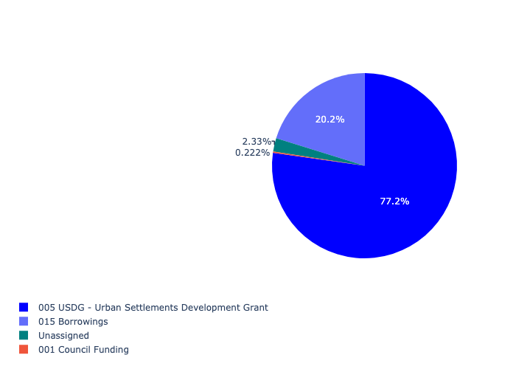

Figure 5.146: Ward 73 Departmental Requests

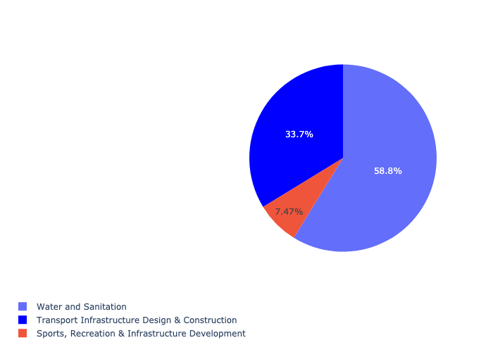

Table 5.73: Summary - Ward 73

|  |  |
| --- | --- |
| Item | Description |
| Total Capital Demand for Ward 73 - All Years | R466,924,244 Rank: 31 (1 = Highest) |
| Total Capital Demand for Ward 73 - MTREF | R466,924,244 Rank: 56 (1 = Highest) |
| Financial Years in which capital requirements are listed for Ward 73 | 2022, 2023, 2024, 2025, 2026, 2027, 2028, 2029 and 2030 |
| Financial Year with highest capital demand for Ward 73 | Capital 2026 |
| Ward 73 intersecting feature used | Works Location |
| Total number of projects intersecting with Ward 73 | 8 Rank: 67 (1 = Highest) |

## Ward 74

Figure 5.147: Ward 74 Funding Requests

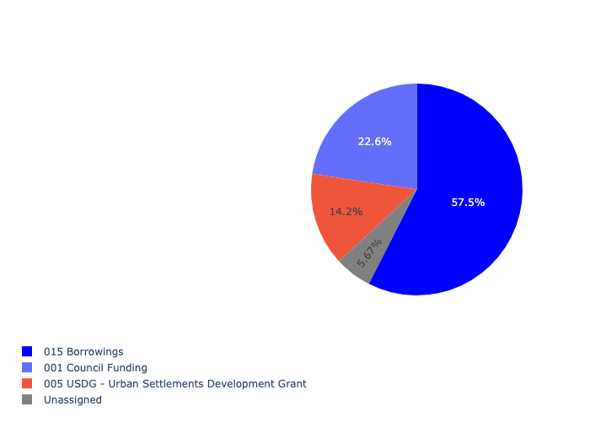

Figure 5.148: Ward 74 Departmental Requests

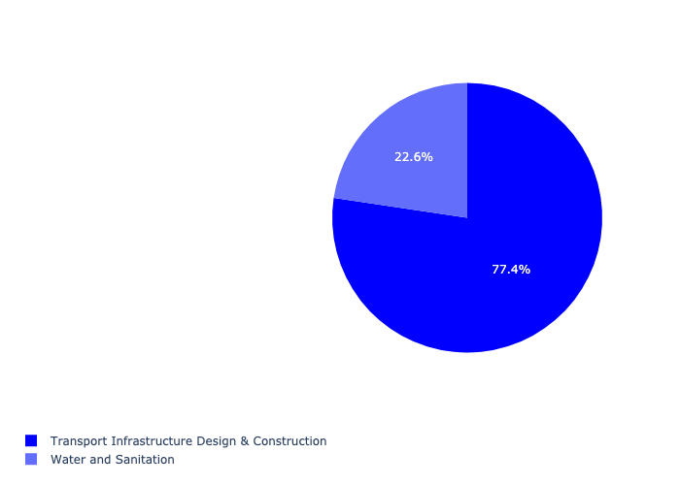

Table 5.74: Summary - Ward 74

|  |  |
| --- | --- |
| Item | Description |
| Total Capital Demand for Ward 74 - All Years | R217,948,265 Rank: 57 (1 = Highest) |
| Total Capital Demand for Ward 74 - MTREF | R217,948,265 Rank: 63 (1 = Highest) |
| Financial Years in which capital requirements are listed for Ward 74 | 2022, 2023, 2024, 2025, 2026, 2027, 2028, 2029 and 2030 |
| Financial Year with highest capital demand for Ward 74 | Capital 2022 |
| Ward 74 intersecting feature used | Works Location |
| Total number of projects intersecting with Ward 74 | 10 Rank: 55 (1 = Highest) |

## Ward 75

Figure 5.149: Ward 75 Funding Requests

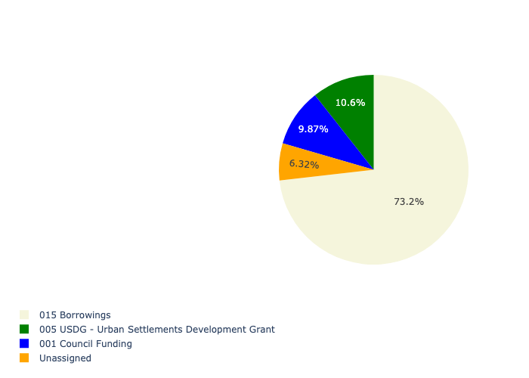

Figure 5.150: Ward 75 Departmental Requests

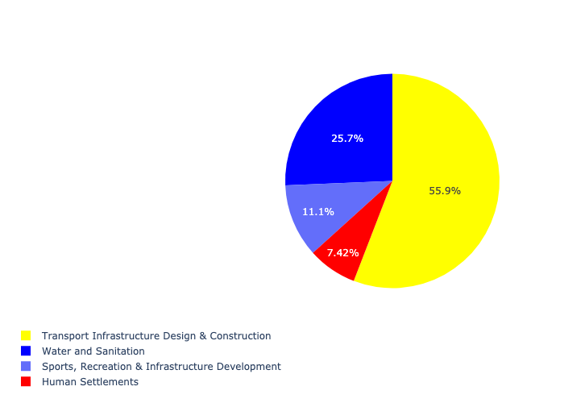

Table 5.75: Summary - Ward 75

|  |  |
| --- | --- |
| Item | Description |
| Total Capital Demand for Ward 75 - All Years | R615,376,420 Rank: 23 (1 = Highest) |
| Total Capital Demand for Ward 75 - MTREF | R615,376,420 Rank: 32 (1 = Highest) |
| Financial Years in which capital requirements are listed for Ward 75 | 2022, 2023, 2024, 2025, 2026, 2027, 2028, 2029 and 2030 |
| Financial Year with highest capital demand for Ward 75 | Capital 2022 |
| Ward 75 intersecting feature used | Works Location |
| Total number of projects intersecting with Ward 75 | 19 Rank: 17 (1 = Highest) |

## Ward 76

Figure 5.151: Ward 76 Funding Requests

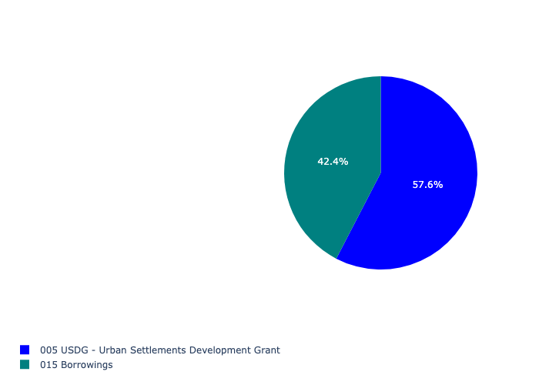

Figure 5.152: Ward 76 Departmental Requests

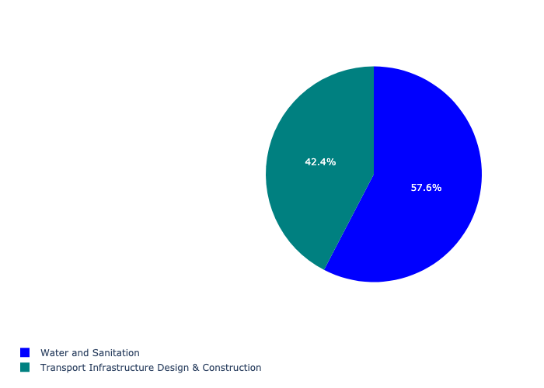

Table 5.76: Summary - Ward 76

|  |  |
| --- | --- |
| Item | Description |
| Total Capital Demand for Ward 76 - All Years | R145,777,420 Rank: 73 (1 = Highest) |
| Total Capital Demand for Ward 76 - MTREF | R145,777,420 Rank: 72 (1 = Highest) |
| Financial Years in which capital requirements are listed for Ward 76 | 2022, 2023, 2024, 2025, 2026, 2027, 2028, 2029 and 2030 |
| Financial Year with highest capital demand for Ward 76 | Capital 2025 |
| Ward 76 intersecting feature used | Works Location |
| Total number of projects intersecting with Ward 76 | 6 Rank: 88 (1 = Highest) |

## Ward 77

Figure 5.153: Ward 77 Funding Requests

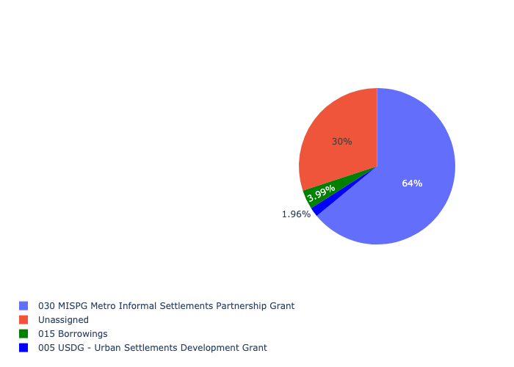

Figure 5.154: Ward 77 Departmental Requests

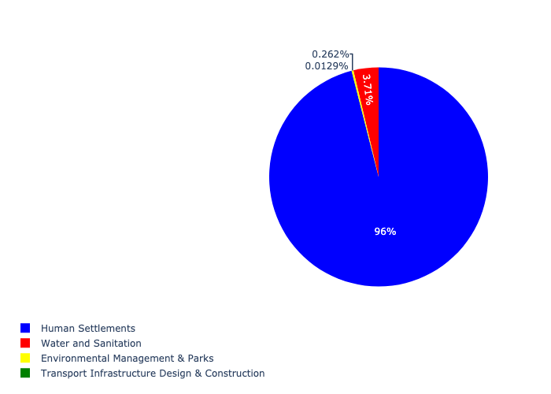

Table 5.77: Summary - Ward 77

|  |  |
| --- | --- |
| Item | Description |
| Total Capital Demand for Ward 77 - All Years | R199,704,981 Rank: 63 (1 = Highest) |
| Total Capital Demand for Ward 77 - MTREF | R199,704,981 Rank: 36 (1 = Highest) |
| Financial Years in which capital requirements are listed for Ward 77 | 2022, 2023, 2024, 2026 and 2027 |
| Financial Year with highest capital demand for Ward 77 | Capital 2022 |
| Ward 77 intersecting feature used | Works Location |
| Total number of projects intersecting with Ward 77 | 7 Rank: 77 (1 = Highest) |

## Ward 78

Figure 5.155: Ward 78 Funding Requests

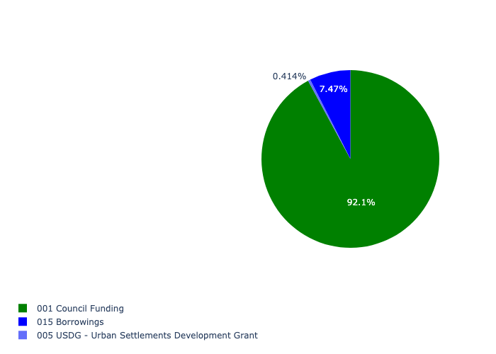

Figure 5.156: Ward 78 Departmental Requests

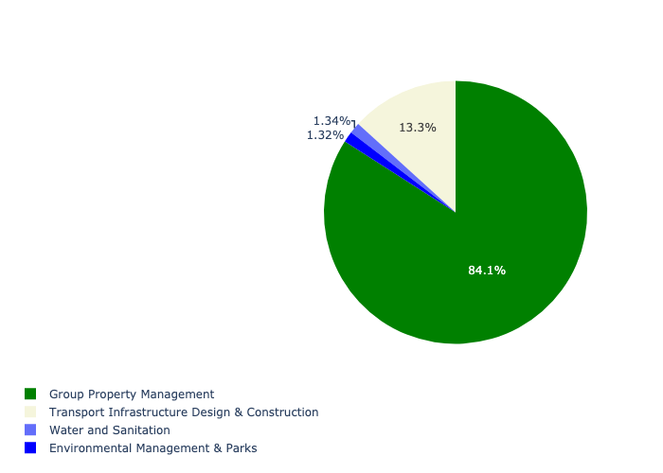

Table 5.78: Summary - Ward 78

|  |  |
| --- | --- |
| Item | Description |
| Total Capital Demand for Ward 78 - All Years | R1,214,747,352 Rank: 8 (1 = Highest) |
| Total Capital Demand for Ward 78 - MTREF | R1,214,747,352 Rank: 8 (1 = Highest) |
| Financial Years in which capital requirements are listed for Ward 78 | 2022, 2023, 2024, 2025, 2026, 2027, 2028, 2029 and 2030 |
| Financial Year with highest capital demand for Ward 78 | Capital 2024 |
| Ward 78 intersecting feature used | Works Location |
| Total number of projects intersecting with Ward 78 | 13 Rank: 39 (1 = Highest) |

## Ward 79

Figure 5.157: Ward 79 Funding Requests

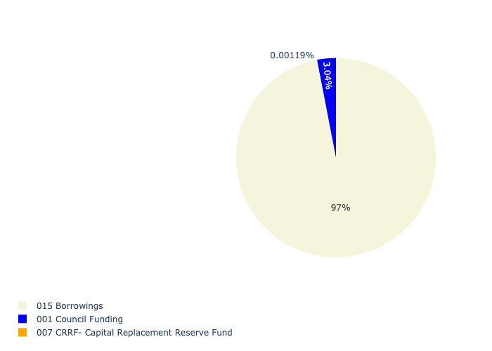

Figure 5.158: Ward 79 Departmental Requests

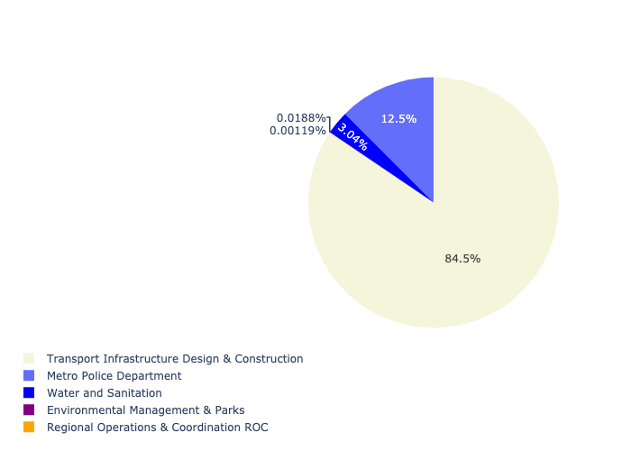

Table 5.79: Summary - Ward 79

|  |  |
| --- | --- |
| Item | Description |
| Total Capital Demand for Ward 79 - All Years | R246,623,517 Rank: 54 (1 = Highest) |
| Total Capital Demand for Ward 79 - MTREF | R246,623,517 Rank: 53 (1 = Highest) |
| Financial Years in which capital requirements are listed for Ward 79 | 2022, 2023, 2024, 2025, 2026, 2027 and 2029 |
| Financial Year with highest capital demand for Ward 79 | Capital 2025 |
| Ward 79 intersecting feature used | Works Location |
| Total number of projects intersecting with Ward 79 | 9 Rank: 61 (1 = Highest) |

## Ward 80

Figure 5.159: Ward 80 Funding Requests

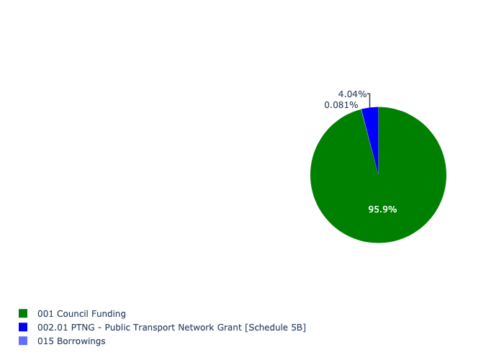

Figure 5.160: Ward 80 Departmental Requests

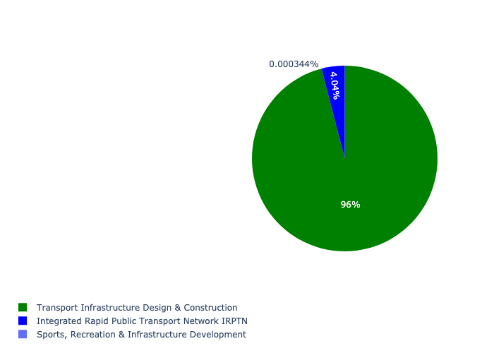

Table 5.80: Summary - Ward 80

|  |  |
| --- | --- |
| Item | Description |
| Total Capital Demand for Ward 80 - All Years | R3,929,851 Rank: 103 (1 = Highest) |
| Total Capital Demand for Ward 80 - MTREF | R3,929,851 Rank: 102 (1 = Highest) |
| Financial Years in which capital requirements are listed for Ward 80 | 2022, 2023, 2024, 2025, 2026, 2027, 2028, 2029 and 2030 |
| Financial Year with highest capital demand for Ward 80 | Capital 2027 |
| Ward 80 intersecting feature used | Works Location |
| Total number of projects intersecting with Ward 80 | 7 Rank: 77 (1 = Highest) |

## Ward 81

Figure 5.161: Ward 81 Funding Requests

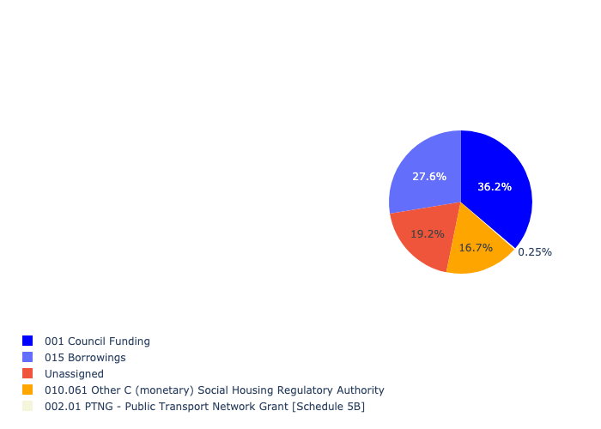

Figure 5.162: Ward 81 Departmental Requests

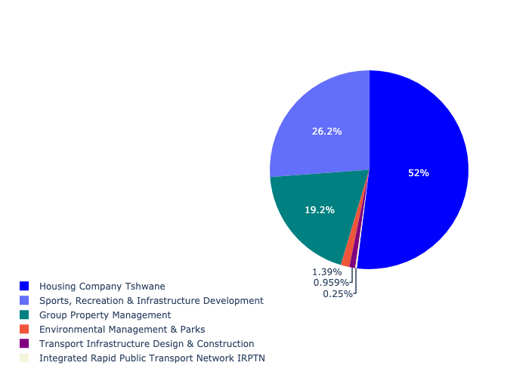

Table 5.81: Summary - Ward 81

|  |  |
| --- | --- |
| Item | Description |
| Total Capital Demand for Ward 81 - All Years | R359,060,649 Rank: 44 (1 = Highest) |
| Total Capital Demand for Ward 81 - MTREF | R359,060,649 Rank: 17 (1 = Highest) |
| Financial Years in which capital requirements are listed for Ward 81 | 2022, 2023, 2024, 2025, 2026, 2027, 2028, 2029, 2030 and 2031 |
| Financial Year with highest capital demand for Ward 81 | Capital 2022 |
| Ward 81 intersecting feature used | Works Location |
| Total number of projects intersecting with Ward 81 | 10 Rank: 55 (1 = Highest) |

## Ward 82

Figure 5.163: Ward 82 Funding Requests

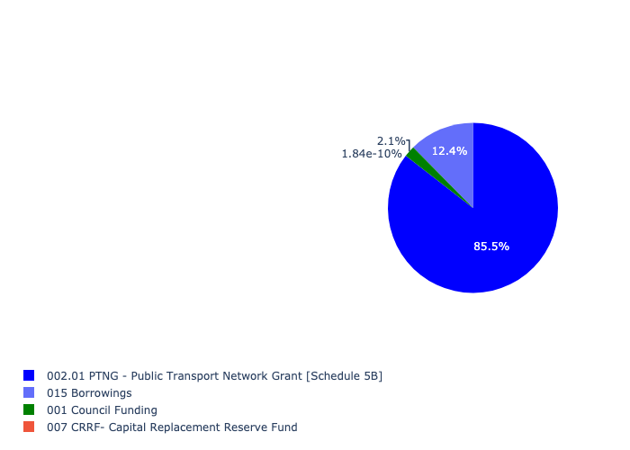

Figure 5.164: Ward 82 Departmental Requests

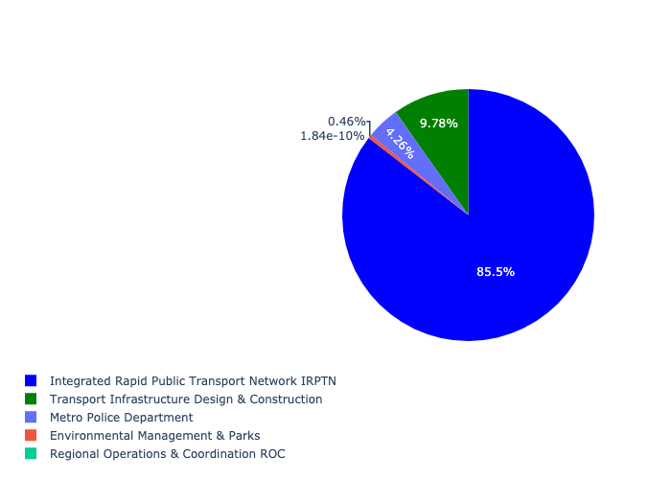

Table 5.82: Summary - Ward 82

|  |  |
| --- | --- |
| Item | Description |
| Total Capital Demand for Ward 82 - All Years | R304,918,670 Rank: 46 (1 = Highest) |
| Total Capital Demand for Ward 82 - MTREF | R304,918,670 Rank: 30 (1 = Highest) |
| Financial Years in which capital requirements are listed for Ward 82 | 2022, 2023, 2024, 2025, 2026, 2027, 2028, 2029 and 2030 |
| Financial Year with highest capital demand for Ward 82 | Capital 2023 |
| Ward 82 intersecting feature used | Works Location |
| Total number of projects intersecting with Ward 82 | 16 Rank: 29 (1 = Highest) |

## Ward 83

Figure 5.165: Ward 83 Funding Requests

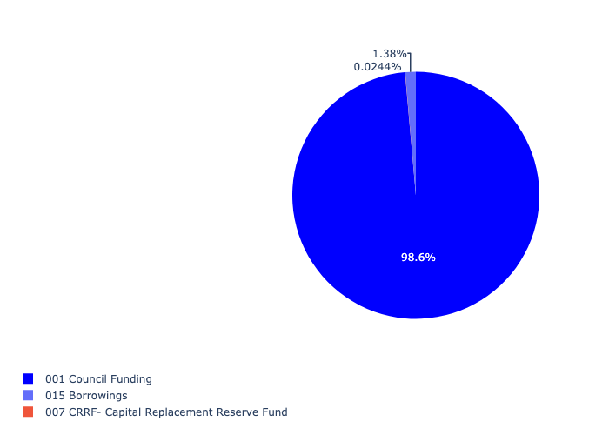

Figure 5.166: Ward 83 Departmental Requests

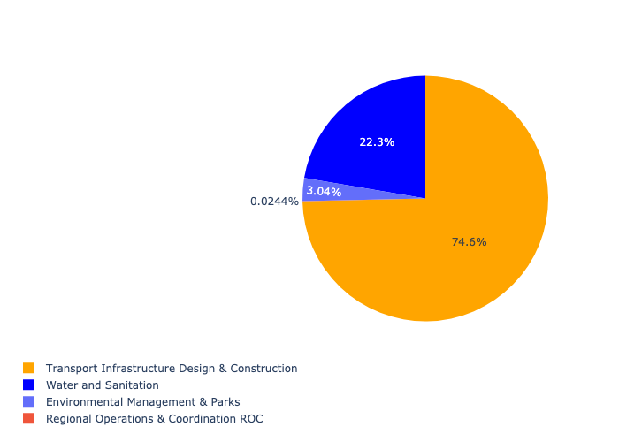

Table 5.83: Summary - Ward 83

|  |  |
| --- | --- |
| Item | Description |
| Total Capital Demand for Ward 83 - All Years | R87,381,538 Rank: 81 (1 = Highest) |
| Total Capital Demand for Ward 83 - MTREF | R87,381,538 Rank: 96 (1 = Highest) |
| Financial Years in which capital requirements are listed for Ward 83 | 2022, 2023, 2024, 2025, 2026, 2027, 2028, 2029 and 2030 |
| Financial Year with highest capital demand for Ward 83 | Capital 2029 |
| Ward 83 intersecting feature used | Works Location |
| Total number of projects intersecting with Ward 83 | 6 Rank: 88 (1 = Highest) |

## Ward 84

Figure 5.167: Ward 84 Funding Requests



Figure 5.168: Ward 84 Departmental Requests

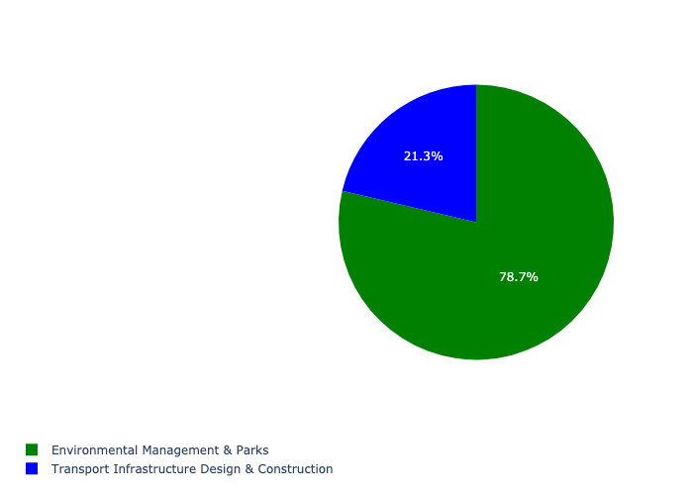

Table 5.84: Summary - Ward 84

|  |  |
| --- | --- |
| Item | Description |
| Total Capital Demand for Ward 84 - All Years | R125,423 Rank: 105 (1 = Highest) |
| Total Capital Demand for Ward 84 - MTREF | R125,423 Rank: 105 (1 = Highest) |
| Financial Years in which capital requirements are listed for Ward 84 | 2026 and 2027 |
| Financial Year with highest capital demand for Ward 84 | Capital 2026 |
| Ward 84 intersecting feature used | Works Location |
| Total number of projects intersecting with Ward 84 | 3 Rank: 102 (1 = Highest) |

## Ward 85

Figure 5.169: Ward 85 Funding Requests

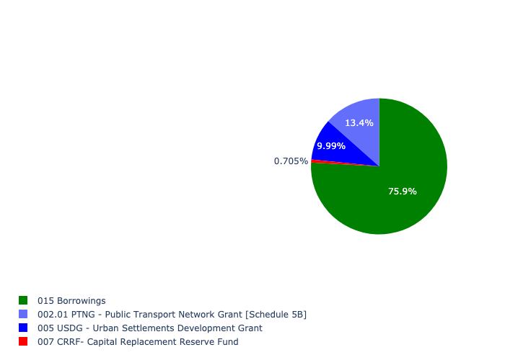

Figure 5.170: Ward 85 Departmental Requests

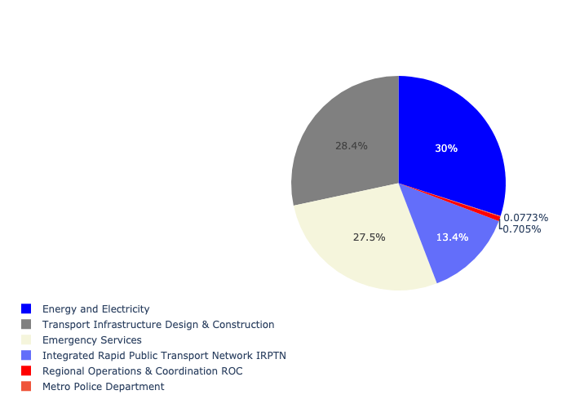

Table 5.85: Summary - Ward 85

|  |  |
| --- | --- |
| Item | Description |
| Total Capital Demand for Ward 85 - All Years | R147,192,264 Rank: 72 (1 = Highest) |
| Total Capital Demand for Ward 85 - MTREF | R147,192,264 Rank: 70 (1 = Highest) |
| Financial Years in which capital requirements are listed for Ward 85 | 2022, 2023, 2024, 2025, 2026, 2027, 2028 and 2029 |
| Financial Year with highest capital demand for Ward 85 | Capital 2023 |
| Ward 85 intersecting feature used | Works Location |
| Total number of projects intersecting with Ward 85 | 9 Rank: 61 (1 = Highest) |

## Ward 86

Figure 5.171: Ward 86 Funding Requests

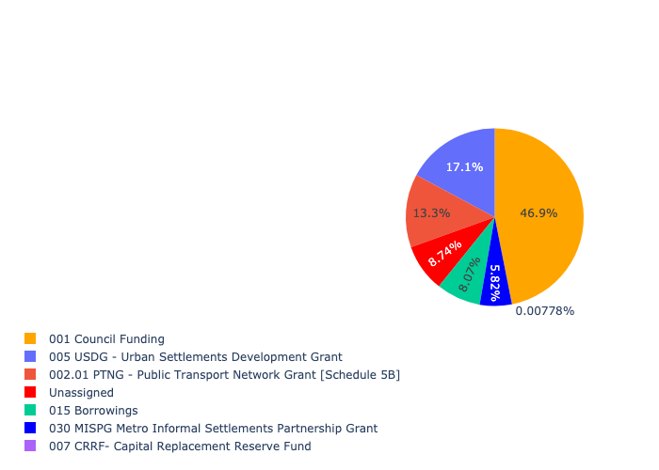

Figure 5.172: Ward 86 Departmental Requests

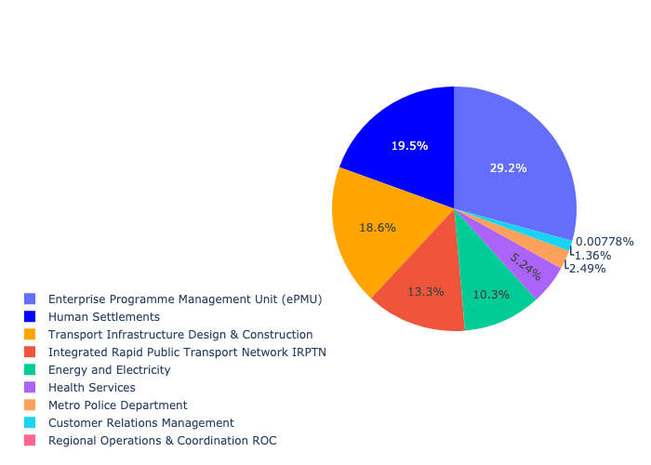

Table 5.86: Summary - Ward 86

|  |  |
| --- | --- |
| Item | Description |
| Total Capital Demand for Ward 86 - All Years | R515,111,604 Rank: 28 (1 = Highest) |
| Total Capital Demand for Ward 86 - MTREF | R515,111,604 Rank: 14 (1 = Highest) |
| Financial Years in which capital requirements are listed for Ward 86 | 2022, 2023, 2024, 2025, 2026, 2027, 2028, 2029 and 2030 |
| Financial Year with highest capital demand for Ward 86 | Capital 2022 |
| Ward 86 intersecting feature used | Works Location |
| Total number of projects intersecting with Ward 86 | 16 Rank: 29 (1 = Highest) |

## Ward 87

Figure 5.173: Ward 87 Funding Requests

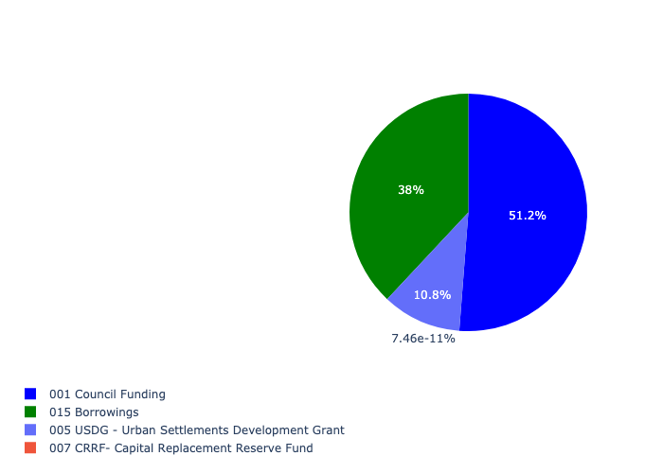

Figure 5.174: Ward 87 Departmental Requests

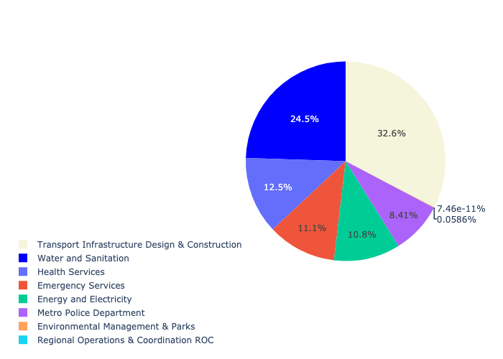

Table 5.87: Summary - Ward 87

|  |  |
| --- | --- |
| Item | Description |
| Total Capital Demand for Ward 87 - All Years | R498,776,949 Rank: 30 (1 = Highest) |
| Total Capital Demand for Ward 87 - MTREF | R498,776,949 Rank: 33 (1 = Highest) |
| Financial Years in which capital requirements are listed for Ward 87 | 2022, 2023, 2024, 2025, 2026, 2027, 2028, 2029, 2030 and 2031 |
| Financial Year with highest capital demand for Ward 87 | Capital 2024 |
| Ward 87 intersecting feature used | Works Location |
| Total number of projects intersecting with Ward 87 | 17 Rank: 22 (1 = Highest) |

## Ward 88

Figure 5.175: Ward 88 Funding Requests

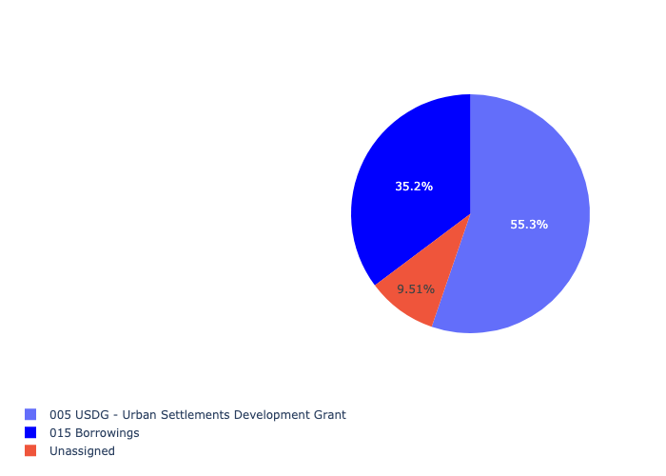

Figure 5.176: Ward 88 Departmental Requests

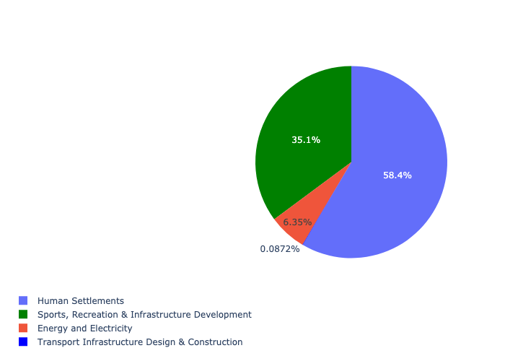

Table 5.88: Summary - Ward 88

|  |  |
| --- | --- |
| Item | Description |
| Total Capital Demand for Ward 88 - All Years | R210,553,024 Rank: 60 (1 = Highest) |
| Total Capital Demand for Ward 88 - MTREF | R210,553,024 Rank: 47 (1 = Highest) |
| Financial Years in which capital requirements are listed for Ward 88 | 2022, 2023, 2024, 2025, 2026, 2027, 2028, 2029, 2030 and 2031 |
| Financial Year with highest capital demand for Ward 88 | Capital 2023 |
| Ward 88 intersecting feature used | Works Location |
| Total number of projects intersecting with Ward 88 | 6 Rank: 88 (1 = Highest) |

## Ward 89

Figure 5.177: Ward 89 Funding Requests

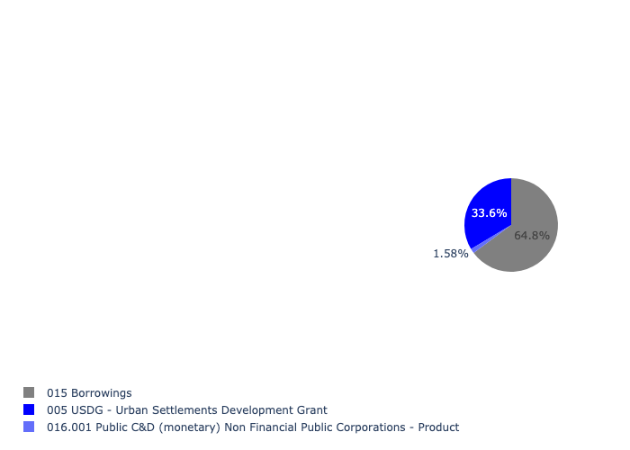

Figure 5.178: Ward 89 Departmental Requests

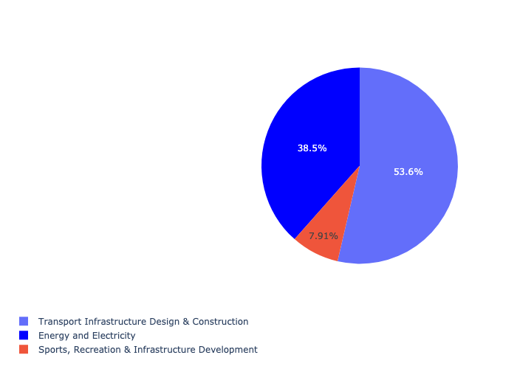

Table 5.89: Summary - Ward 89

|  |  |
| --- | --- |
| Item | Description |
| Total Capital Demand for Ward 89 - All Years | R711,953,482 Rank: 18 (1 = Highest) |
| Total Capital Demand for Ward 89 - MTREF | R711,953,482 Rank: 48 (1 = Highest) |
| Financial Years in which capital requirements are listed for Ward 89 | 2022, 2023, 2024, 2025, 2026, 2027, 2028, 2029 and 2030 |
| Financial Year with highest capital demand for Ward 89 | Capital 2028 |
| Ward 89 intersecting feature used | Works Location |
| Total number of projects intersecting with Ward 89 | 8 Rank: 67 (1 = Highest) |

## Ward 90

Figure 5.179: Ward 90 Funding Requests

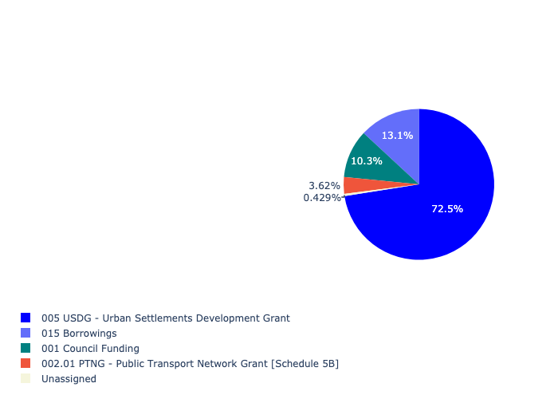

Figure 5.180: Ward 90 Departmental Requests

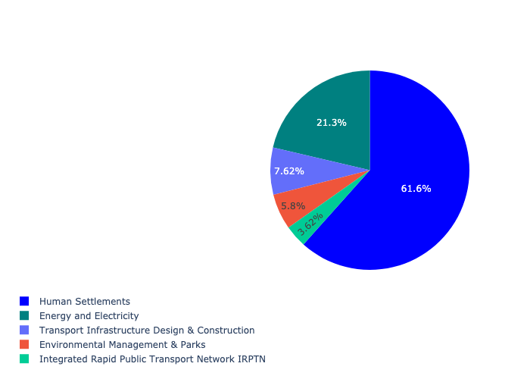

Table 5.90: Summary - Ward 90

|  |  |
| --- | --- |
| Item | Description |
| Total Capital Demand for Ward 90 - All Years | R378,110,896 Rank: 41 (1 = Highest) |
| Total Capital Demand for Ward 90 - MTREF | R378,110,896 Rank: 23 (1 = Highest) |
| Financial Years in which capital requirements are listed for Ward 90 | 2022, 2023, 2024, 2025, 2026, 2027, 2028, 2029 and 2030 |
| Financial Year with highest capital demand for Ward 90 | Capital 2024 |
| Ward 90 intersecting feature used | Works Location |
| Total number of projects intersecting with Ward 90 | 16 Rank: 29 (1 = Highest) |

## Ward 91

Figure 5.181: Ward 91 Funding Requests

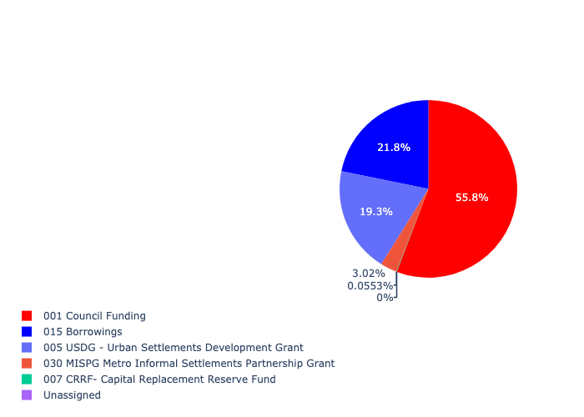

Figure 5.182: Ward 91 Departmental Requests

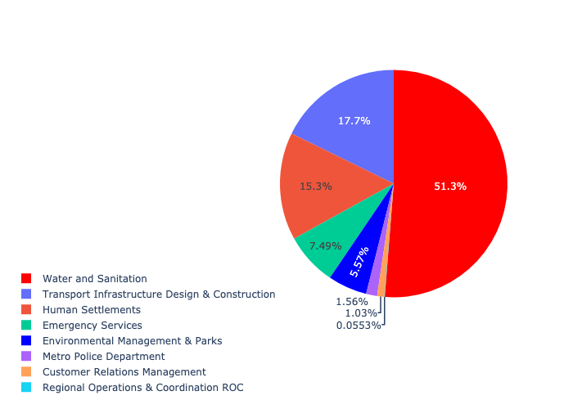

Table 5.91: Summary - Ward 91

|  |  |
| --- | --- |
| Item | Description |
| Total Capital Demand for Ward 91 - All Years | R811,592,741 Rank: 16 (1 = Highest) |
| Total Capital Demand for Ward 91 - MTREF | R811,592,741 Rank: 15 (1 = Highest) |
| Financial Years in which capital requirements are listed for Ward 91 | 2022, 2023, 2024, 2025, 2026, 2027, 2028, 2029 and 2030 |
| Financial Year with highest capital demand for Ward 91 | Capital 2023 |
| Ward 91 intersecting feature used | Works Location |
| Total number of projects intersecting with Ward 91 | 30 Rank: 6 (1 = Highest) |

## Ward 92

Figure 5.183: Ward 92 Funding Requests

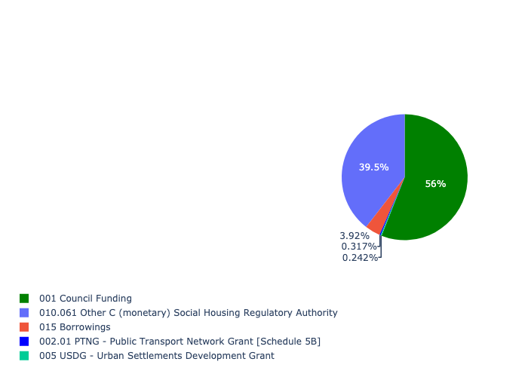

Figure 5.184: Ward 92 Departmental Requests

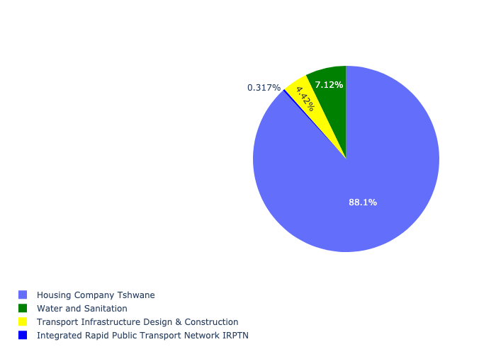

Table 5.92: Summary - Ward 92

|  |  |
| --- | --- |
| Item | Description |
| Total Capital Demand for Ward 92 - All Years | R157,159,266 Rank: 69 (1 = Highest) |
| Total Capital Demand for Ward 92 - MTREF | R157,159,266 Rank: 49 (1 = Highest) |
| Financial Years in which capital requirements are listed for Ward 92 | 2022, 2023, 2024, 2025, 2026, 2027, 2028, 2029 and 2030 |
| Financial Year with highest capital demand for Ward 92 | Capital 2023 |
| Ward 92 intersecting feature used | Works Location |
| Total number of projects intersecting with Ward 92 | 12 Rank: 45 (1 = Highest) |

## Ward 93

Figure 5.185: Ward 93 Funding Requests

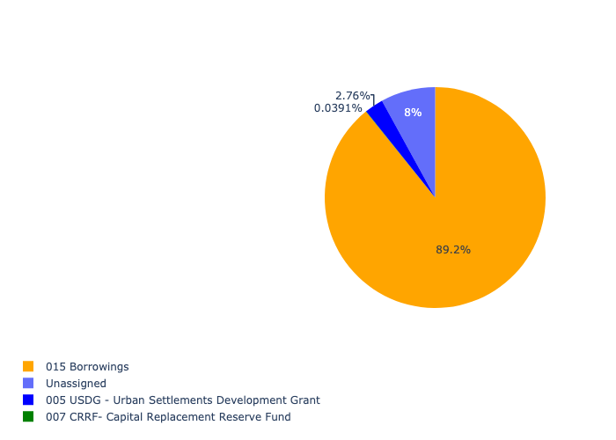

Figure 5.186: Ward 93 Departmental Requests

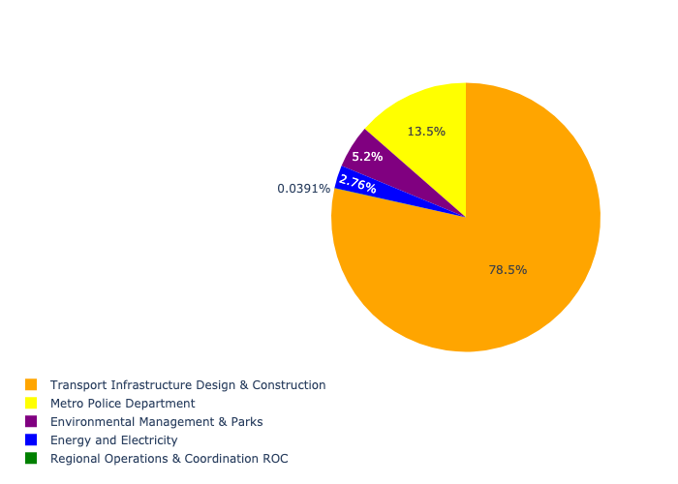

Table 5.93: Summary - Ward 93

|  |  |
| --- | --- |
| Item | Description |
| Total Capital Demand for Ward 93 - All Years | R67,314,042 Rank: 88 (1 = Highest) |
| Total Capital Demand for Ward 93 - MTREF | R67,314,042 Rank: 84 (1 = Highest) |
| Financial Years in which capital requirements are listed for Ward 93 | 2022, 2023, 2024, 2025, 2026, 2027, 2028, 2029 and 2030 |
| Financial Year with highest capital demand for Ward 93 | Capital 2024 |
| Ward 93 intersecting feature used | Works Location |
| Total number of projects intersecting with Ward 93 | 9 Rank: 61 (1 = Highest) |

## Ward 94

Figure 5.187: Ward 94 Funding Requests

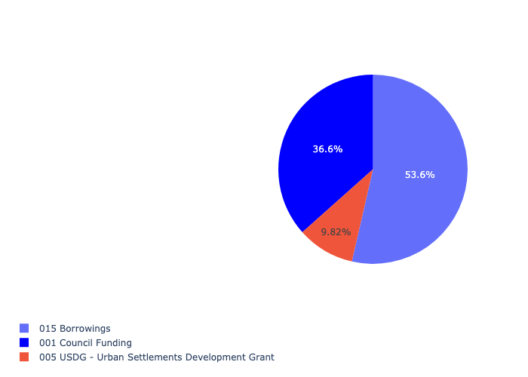

Figure 5.188: Ward 94 Departmental Requests

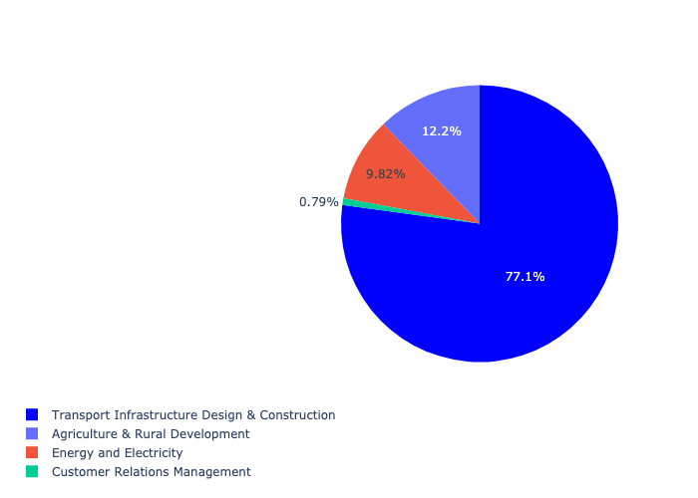

Table 5.94: Summary - Ward 94

|  |  |
| --- | --- |
| Item | Description |
| Total Capital Demand for Ward 94 - All Years | R126,618,784 Rank: 75 (1 = Highest) |
| Total Capital Demand for Ward 94 - MTREF | R126,618,784 Rank: 65 (1 = Highest) |
| Financial Years in which capital requirements are listed for Ward 94 | 2022, 2023, 2024, 2025, 2026, 2027, 2028, 2029 and 2030 |
| Financial Year with highest capital demand for Ward 94 | Capital 2023 |
| Ward 94 intersecting feature used | Works Location |
| Total number of projects intersecting with Ward 94 | 8 Rank: 67 (1 = Highest) |

## Ward 95

Figure 5.189: Ward 95 Funding Requests



Figure 5.190: Ward 95 Departmental Requests

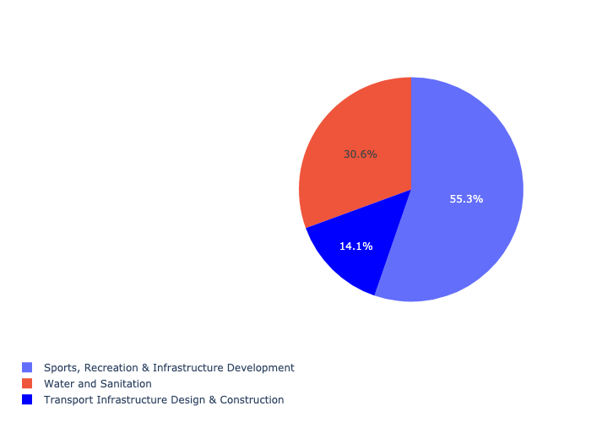

Table 5.95: Summary - Ward 95

|  |  |
| --- | --- |
| Item | Description |
| Total Capital Demand for Ward 95 - All Years | R276,546,075 Rank: 51 (1 = Highest) |
| Total Capital Demand for Ward 95 - MTREF | R276,546,075 Rank: 57 (1 = Highest) |
| Financial Years in which capital requirements are listed for Ward 95 | 2022, 2023, 2024, 2025, 2026, 2027, 2028, 2029, 2030 and 2031 |
| Financial Year with highest capital demand for Ward 95 | Capital 2027 |
| Ward 95 intersecting feature used | Works Location |
| Total number of projects intersecting with Ward 95 | 7 Rank: 77 (1 = Highest) |

## Ward 96

Figure 5.191: Ward 96 Funding Requests

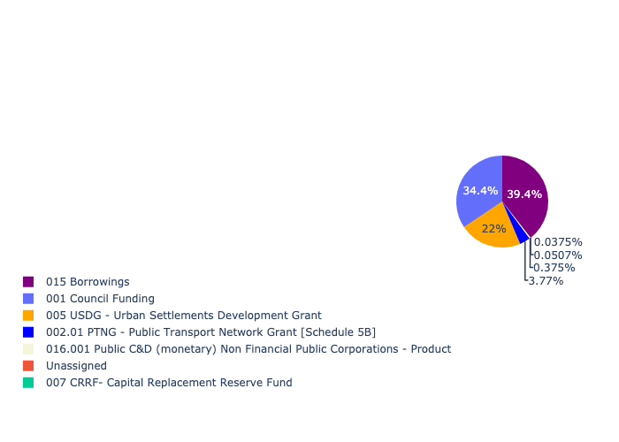

Figure 5.192: Ward 96 Departmental Requests

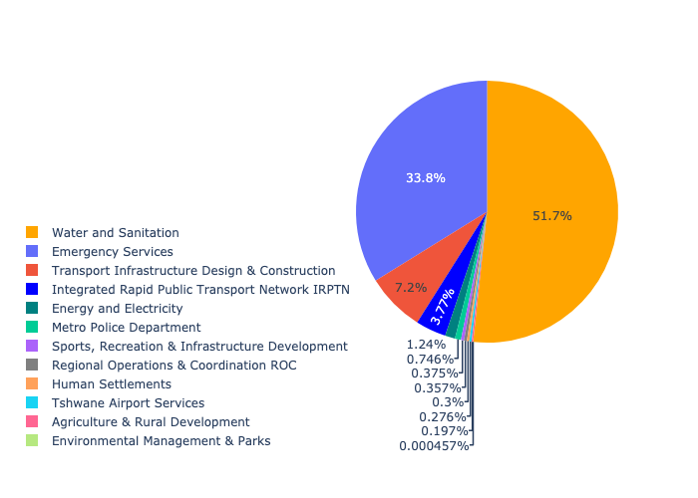

Table 5.96: Summary - Ward 96

|  |  |
| --- | --- |
| Item | Description |
| Total Capital Demand for Ward 96 - All Years | R5,160,755,906 Rank: 1 (1 = Highest) |
| Total Capital Demand for Ward 96 - MTREF | R5,160,755,906 Rank: 3 (1 = Highest) |
| Financial Years in which capital requirements are listed for Ward 96 | 2022, 2023, 2024, 2025, 2026, 2027, 2028, 2029, 2030, 2031, 2032, 2033 and 2034 |
| Financial Year with highest capital demand for Ward 96 | Capital 2028 |
| Ward 96 intersecting feature used | Works Location |
| Total number of projects intersecting with Ward 96 | 47 Rank: 3 (1 = Highest) |

## Ward 97

Figure 5.193: Ward 97 Funding Requests

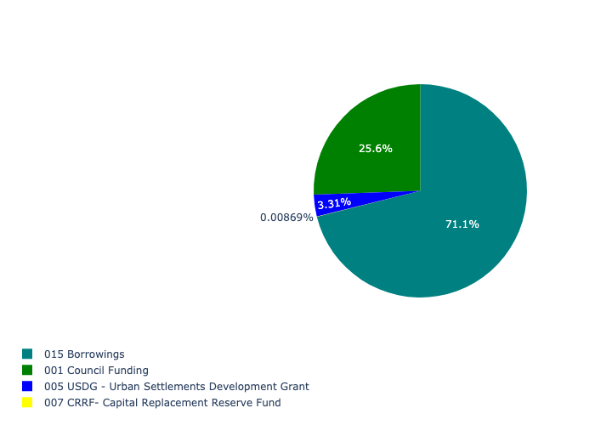

Figure 5.194: Ward 97 Departmental Requests

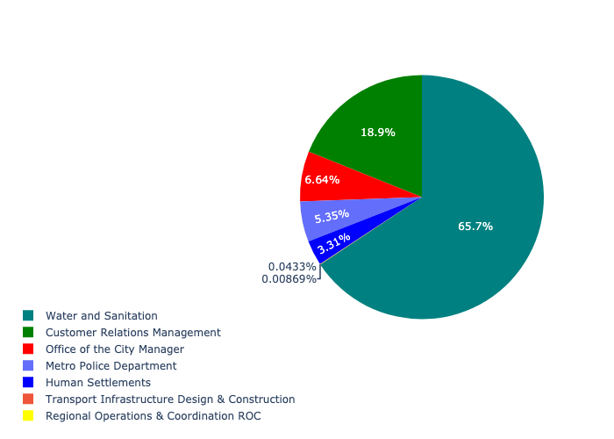

Table 5.97: Summary - Ward 97

|  |  |
| --- | --- |
| Item | Description |
| Total Capital Demand for Ward 97 - All Years | R49,883,377 Rank: 96 (1 = Highest) |
| Total Capital Demand for Ward 97 - MTREF | R49,883,377 Rank: 86 (1 = Highest) |
| Financial Years in which capital requirements are listed for Ward 97 | 2022, 2023, 2024, 2025, 2026 and 2027 |
| Financial Year with highest capital demand for Ward 97 | Capital 2024 |
| Ward 97 intersecting feature used | Works Location |
| Total number of projects intersecting with Ward 97 | 15 Rank: 34 (1 = Highest) |

## Ward 98

Figure 5.195: Ward 98 Funding Requests

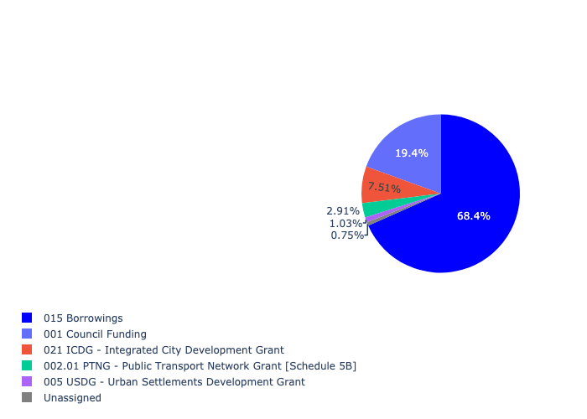

Figure 5.196: Ward 98 Departmental Requests

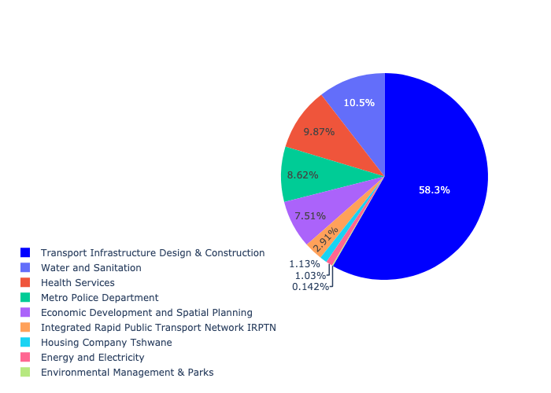

Table 5.98: Summary - Ward 98

|  |  |
| --- | --- |
| Item | Description |
| Total Capital Demand for Ward 98 - All Years | R1,134,182,491 Rank: 11 (1 = Highest) |
| Total Capital Demand for Ward 98 - MTREF | R1,134,182,491 Rank: 7 (1 = Highest) |
| Financial Years in which capital requirements are listed for Ward 98 | 2022, 2023, 2024, 2025, 2026, 2027, 2028, 2029, 2030 and 2031 |
| Financial Year with highest capital demand for Ward 98 | Capital 2023 |
| Ward 98 intersecting feature used | Works Location |
| Total number of projects intersecting with Ward 98 | 32 Rank: 5 (1 = Highest) |

## Ward 99

Figure 5.197: Ward 99 Funding Requests

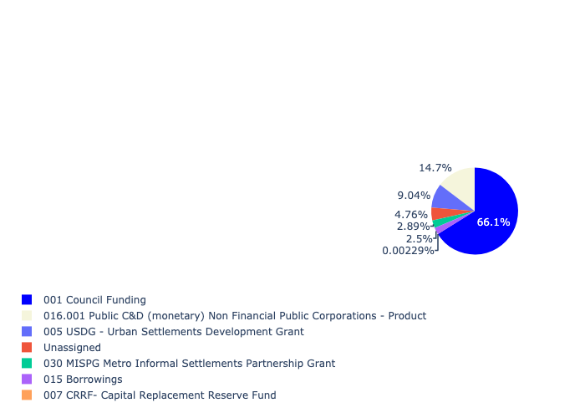

Figure 5.198: Ward 99 Departmental Requests

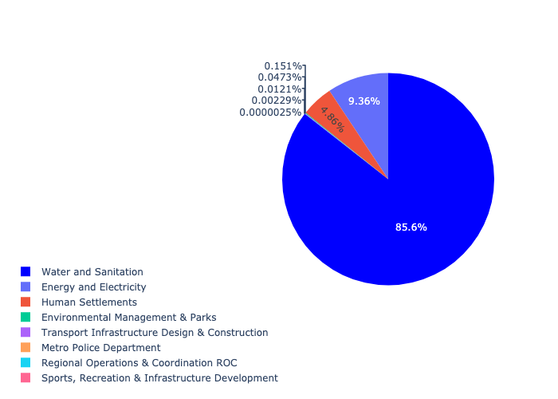

Table 5.99: Summary - Ward 99

|  |  |
| --- | --- |
| Item | Description |
| Total Capital Demand for Ward 99 - All Years | R1,505,784,122 Rank: 6 (1 = Highest) |
| Total Capital Demand for Ward 99 - MTREF | R1,505,784,122 Rank: 12 (1 = Highest) |
| Financial Years in which capital requirements are listed for Ward 99 | 2022, 2023, 2024, 2025, 2026, 2027, 2028, 2029 and 2030 |
| Financial Year with highest capital demand for Ward 99 | Capital 2025 |
| Ward 99 intersecting feature used | Works Location |
| Total number of projects intersecting with Ward 99 | 21 Rank: 12 (1 = Highest) |

## Ward 100

Figure 5.199: Ward 100 Funding Requests

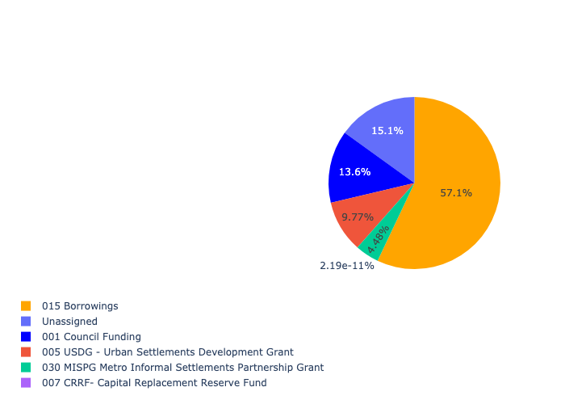

Figure 5.200: Ward 100 Departmental Requests

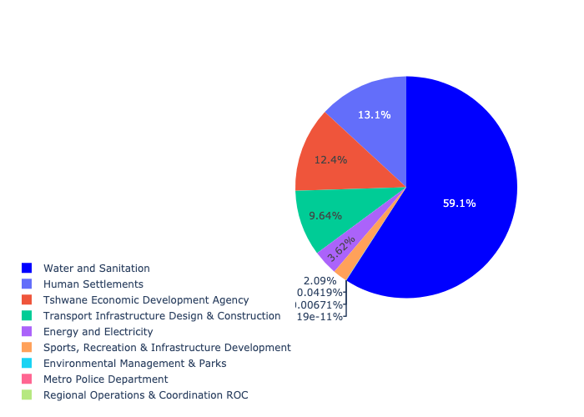

Table 5.100: Summary - Ward 100

|  |  |
| --- | --- |
| Item | Description |
| Total Capital Demand for Ward 100 - All Years | R2,527,768,871 Rank: 3 (1 = Highest) |
| Total Capital Demand for Ward 100 - MTREF | R2,527,768,871 Rank: 2 (1 = Highest) |
| Financial Years in which capital requirements are listed for Ward 100 | 2022, 2023, 2024, 2025, 2026, 2027, 2028, 2029 and 2030 |
| Financial Year with highest capital demand for Ward 100 | Capital 2022 |
| Ward 100 intersecting feature used | Works Location |
| Total number of projects intersecting with Ward 100 | 39 Rank: 4 (1 = Highest) |

## Ward 101

Figure 5.201: Ward 101 Funding Requests

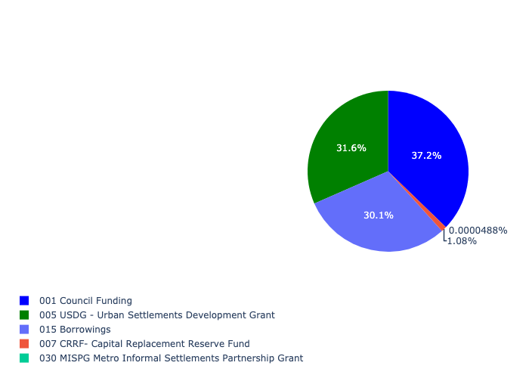

Figure 5.202: Ward 101 Departmental Requests

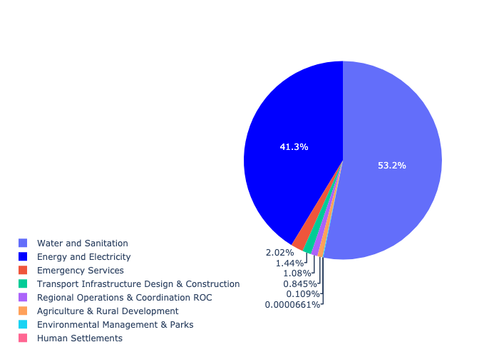

Table 5.101: Summary - Ward 101

|  |  |
| --- | --- |
| Item | Description |
| Total Capital Demand for Ward 101 - All Years | R1,020,034,681 Rank: 12 (1 = Highest) |
| Total Capital Demand for Ward 101 - MTREF | R1,020,034,681 Rank: 10 (1 = Highest) |
| Financial Years in which capital requirements are listed for Ward 101 | 2022, 2023, 2024, 2025, 2026, 2027, 2028, 2029 and 2030 |
| Financial Year with highest capital demand for Ward 101 | Capital 2024 |
| Ward 101 intersecting feature used | Works Location |
| Total number of projects intersecting with Ward 101 | 19 Rank: 17 (1 = Highest) |

## Ward 102

Figure 5.203: Ward 102 Funding Requests

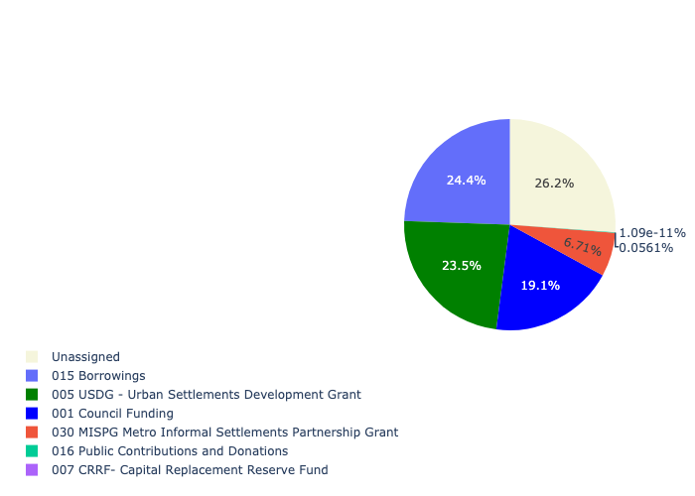

Figure 5.204: Ward 102 Departmental Requests

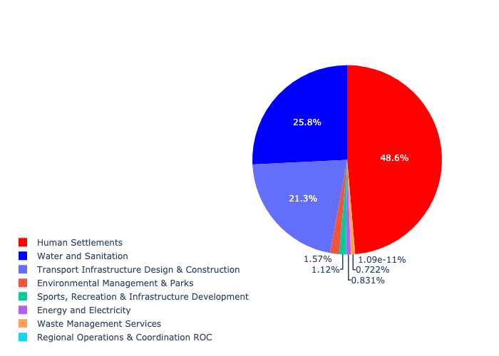

Table 5.102: Summary - Ward 102

|  |  |
| --- | --- |
| Item | Description |
| Total Capital Demand for Ward 102 - All Years | R1,768,549,639 Rank: 4 (1 = Highest) |
| Total Capital Demand for Ward 102 - MTREF | R1,768,549,639 Rank: 4 (1 = Highest) |
| Financial Years in which capital requirements are listed for Ward 102 | 2022, 2023, 2024, 2025, 2026, 2027, 2028, 2029 and 2030 |
| Financial Year with highest capital demand for Ward 102 | Capital 2023 |
| Ward 102 intersecting feature used | Works Location |
| Total number of projects intersecting with Ward 102 | 26 Rank: 9 (1 = Highest) |

## Ward 103

Figure 5.205: Ward 103 Funding Requests

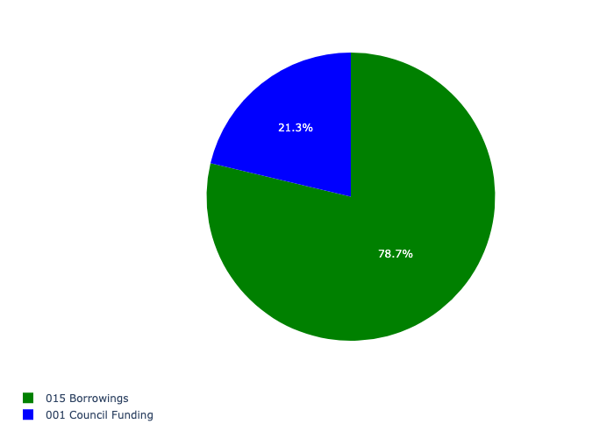

Figure 5.206: Ward 103 Departmental Requests

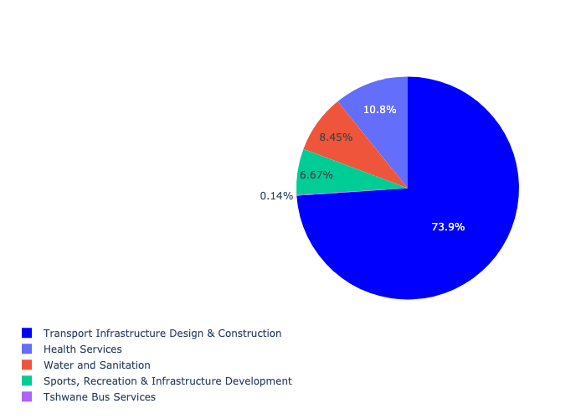

Table 5.103: Summary - Ward 103

|  |  |
| --- | --- |
| Item | Description |
| Total Capital Demand for Ward 103 - All Years | R561,385,174 Rank: 25 (1 = Highest) |
| Total Capital Demand for Ward 103 - MTREF | R561,385,174 Rank: 34 (1 = Highest) |
| Financial Years in which capital requirements are listed for Ward 103 | 2022, 2023, 2024, 2025, 2026, 2027, 2028, 2029 and 2030 |
| Financial Year with highest capital demand for Ward 103 | Capital 2025 |
| Ward 103 intersecting feature used | Works Location |
| Total number of projects intersecting with Ward 103 | 10 Rank: 55 (1 = Highest) |

## Ward 104

Figure 5.207: Ward 104 Funding Requests

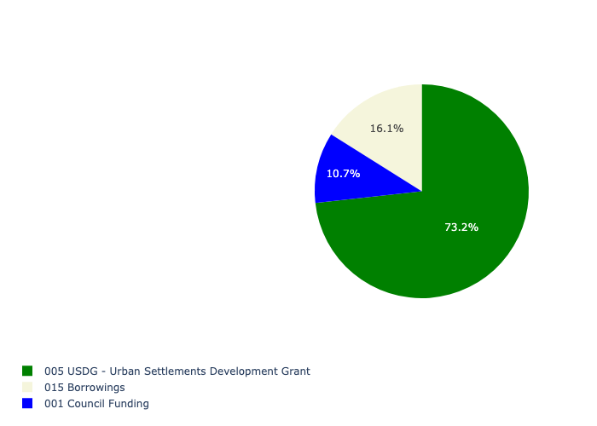

Figure 5.208: Ward 104 Departmental Requests

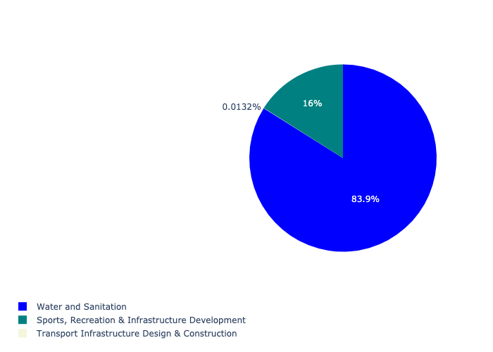

Table 5.104: Summary - Ward 104

|  |  |
| --- | --- |
| Item | Description |
| Total Capital Demand for Ward 104 - All Years | R373,949,245 Rank: 42 (1 = Highest) |
| Total Capital Demand for Ward 104 - MTREF | R373,949,245 Rank: 27 (1 = Highest) |
| Financial Years in which capital requirements are listed for Ward 104 | 2022, 2023, 2024, 2025, 2026 and 2027 |
| Financial Year with highest capital demand for Ward 104 | Capital 2023 |
| Ward 104 intersecting feature used | Works Location |
| Total number of projects intersecting with Ward 104 | 4 Rank: 98 (1 = Highest) |

## Ward 105

Figure 5.209: Ward 105 Funding Requests

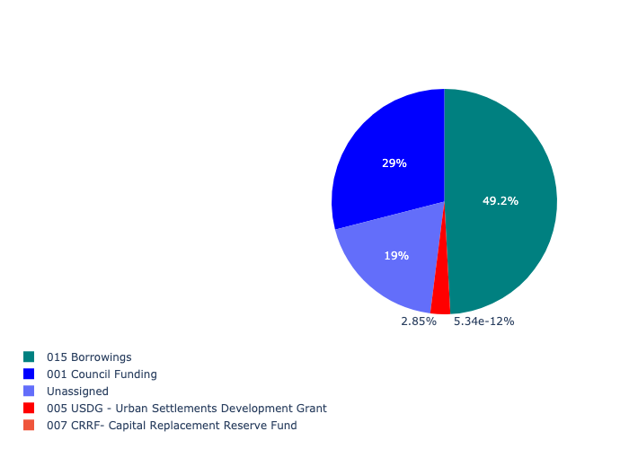

Figure 5.210: Ward 105 Departmental Requests

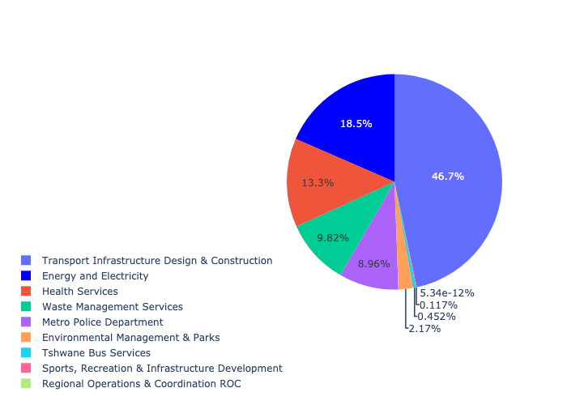

Table 5.105: Summary - Ward 105

|  |  |
| --- | --- |
| Item | Description |
| Total Capital Demand for Ward 105 - All Years | R446,032,749 Rank: 32 (1 = Highest) |
| Total Capital Demand for Ward 105 - MTREF | R446,032,749 Rank: 43 (1 = Highest) |
| Financial Years in which capital requirements are listed for Ward 105 | 2022, 2023, 2024, 2025, 2026, 2027, 2028, 2029 and 2030 |
| Financial Year with highest capital demand for Ward 105 | Capital 2025 |
| Ward 105 intersecting feature used | Works Location |
| Total number of projects intersecting with Ward 105 | 20 Rank: 14 (1 = Highest) |

## Ward 106

Figure 5.211: Ward 106 Funding Requests

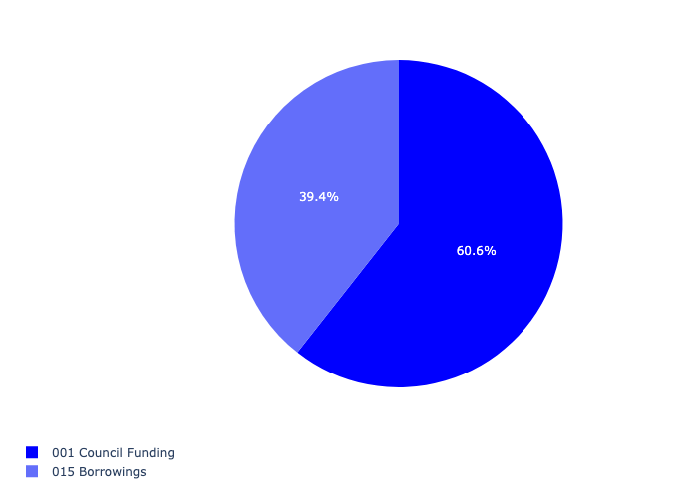

Figure 5.212: Ward 106 Departmental Requests

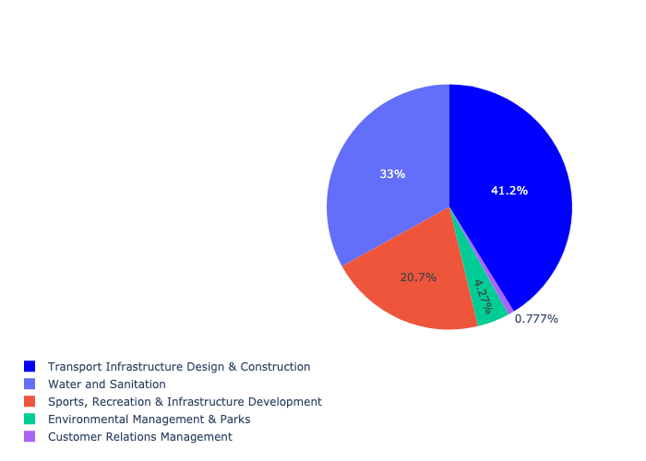

Table 5.106: Summary - Ward 106

|  |  |
| --- | --- |
| Item | Description |
| Total Capital Demand for Ward 106 - All Years | R248,891,258 Rank: 53 (1 = Highest) |
| Total Capital Demand for Ward 106 - MTREF | R248,891,258 Rank: 75 (1 = Highest) |
| Financial Years in which capital requirements are listed for Ward 106 | 2022, 2023, 2024, 2025, 2026, 2027, 2028, 2029 and 2030 |
| Financial Year with highest capital demand for Ward 106 | Capital 2026 |
| Ward 106 intersecting feature used | Works Location |
| Total number of projects intersecting with Ward 106 | 12 Rank: 45 (1 = Highest) |

## Ward 107

Figure 5.213: Ward 107 Funding Requests

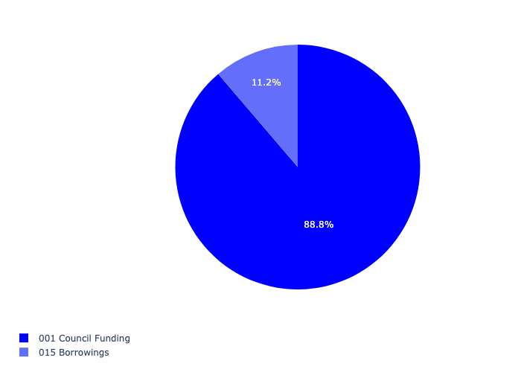

Figure 5.214: Ward 107 Departmental Requests

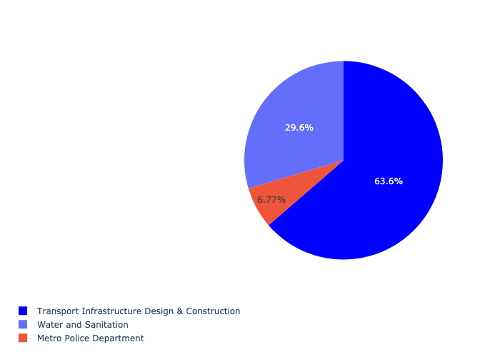

Table 5.107: Summary - Ward 107

|  |  |
| --- | --- |
| Item | Description |
| Total Capital Demand for Ward 107 - All Years | R173,696,124 Rank: 66 (1 = Highest) |
| Total Capital Demand for Ward 107 - MTREF | R173,696,124 Rank: 89 (1 = Highest) |
| Financial Years in which capital requirements are listed for Ward 107 | 2022, 2023, 2024, 2025, 2026, 2027, 2028, 2029 and 2030 |
| Financial Year with highest capital demand for Ward 107 | Capital 2030 |
| Ward 107 intersecting feature used | Works Location |
| Total number of projects intersecting with Ward 107 | 6 Rank: 88 (1 = Highest) |